September 2023, Newsletter
Hello, Silver Shells Homeowners!

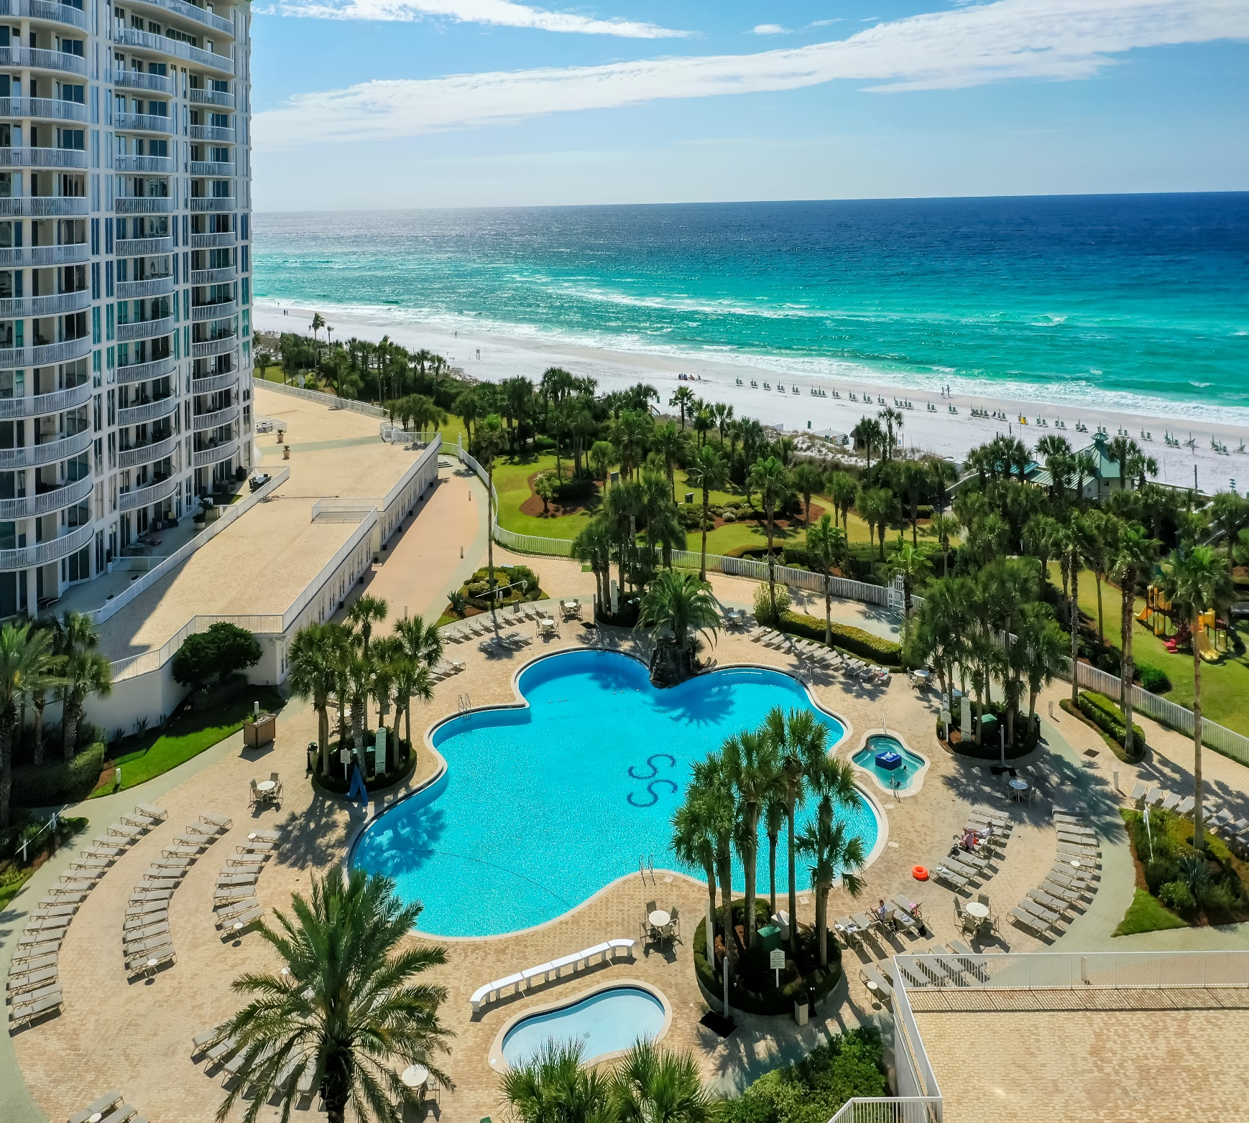

Pool/Beach monitors are checking for wristbands multiple times a day and are escorting trespassers off our beach daily.

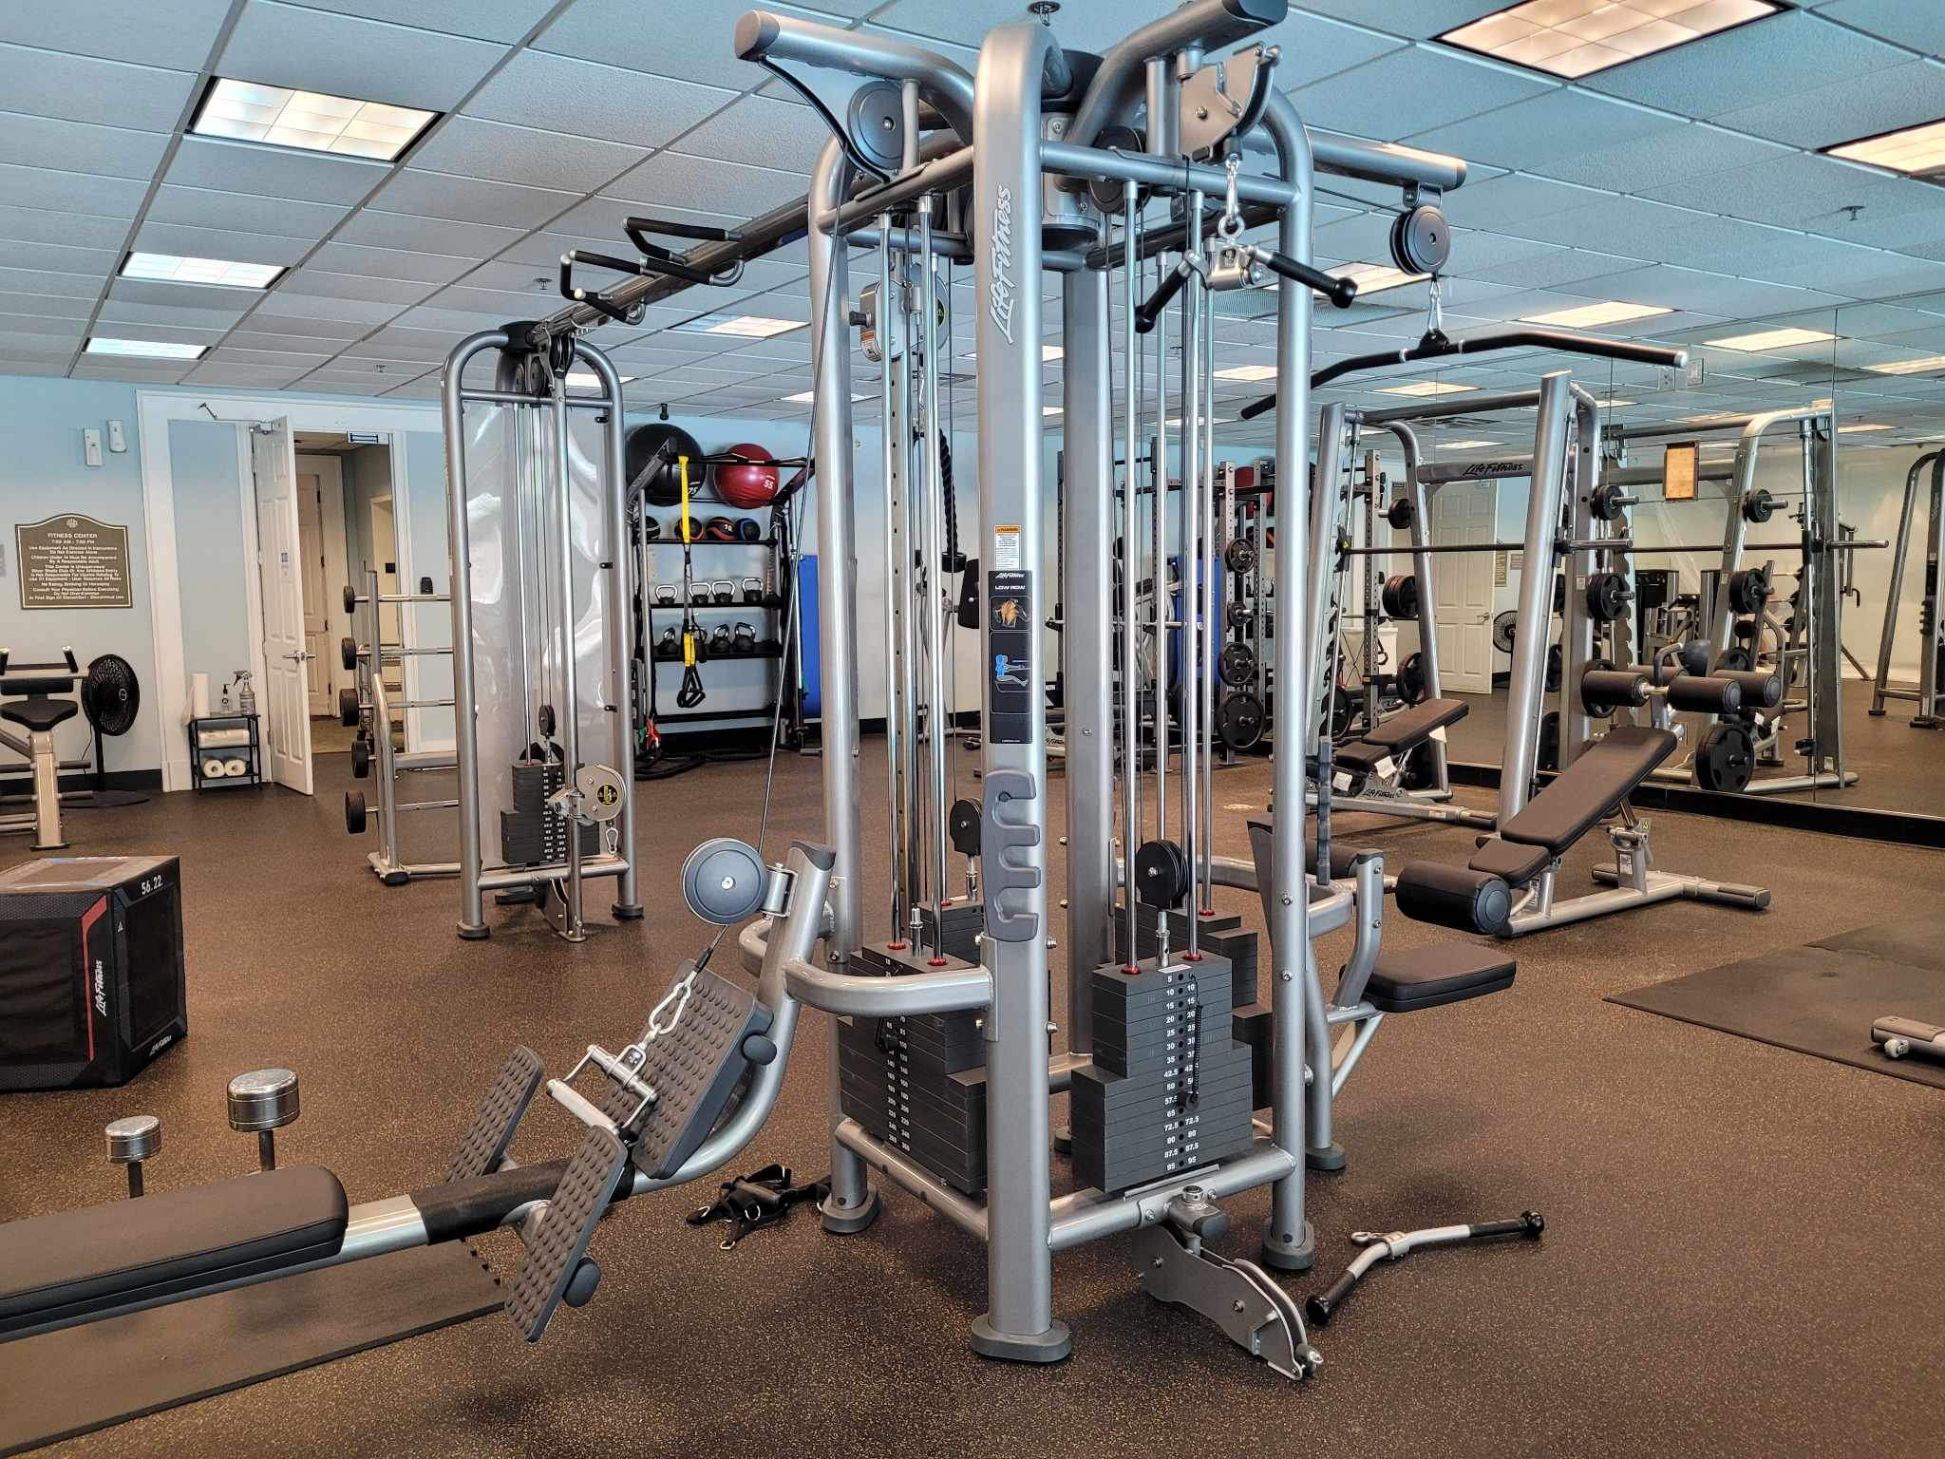
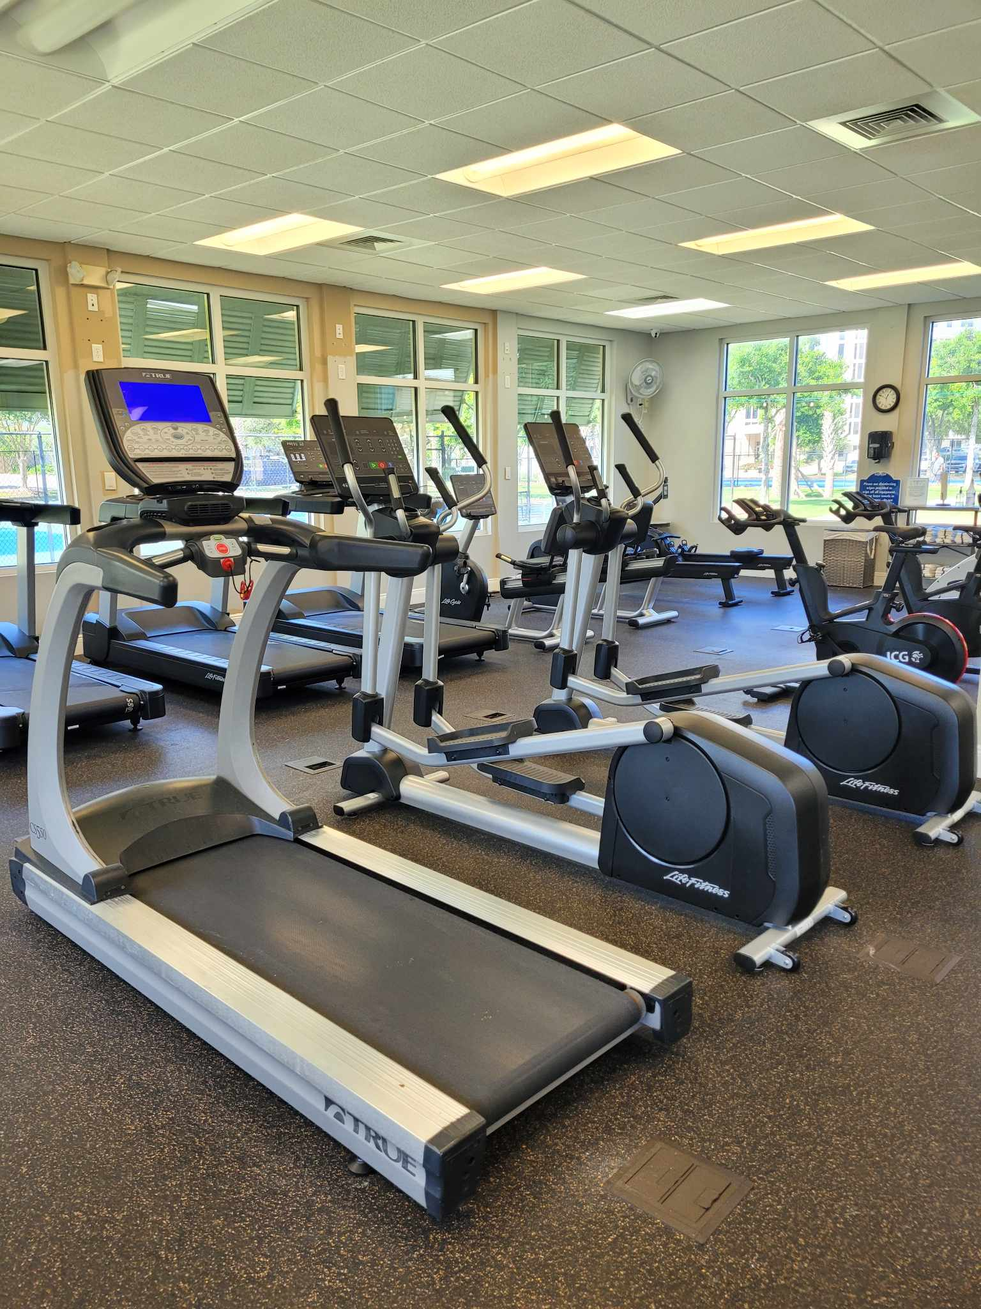
The new equipment has been a great improvement to the Clubhouse, guests and owners are really enjoying it.

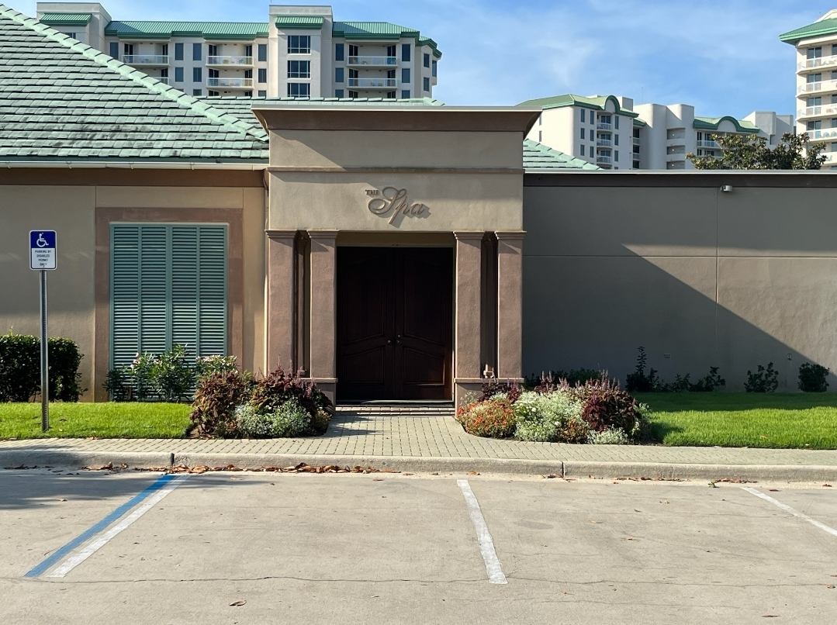

The Spa is open! Darlene Miller is the new owner and she is offering Silver Shells Home Owners special discounts. Jessica Jones is the new spa director, call 850-337-5107 to find out more.

Bayshore Roofing has completed the Clubhouse roof project. Valcourt will start the exterior painting this month.

Tennis, Pickle Ball and Basketball court resurfacing is underway.

The office space above the Cardio room has been rented out to a commercial firm. This was a decision to enhance the club’s revenue.

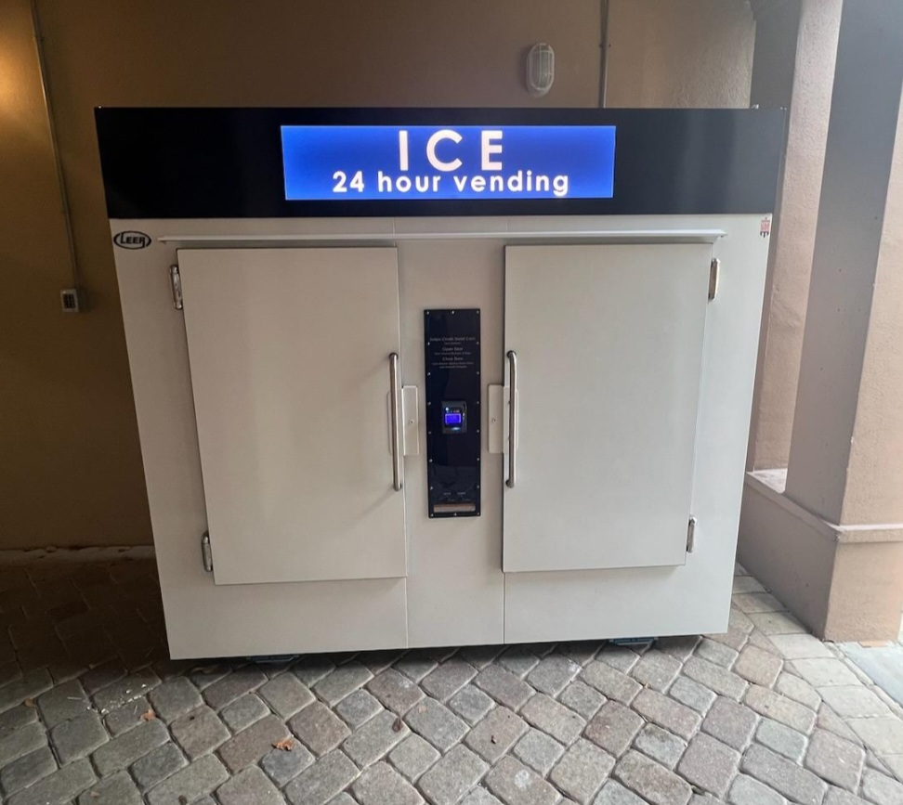

We now have an Ice vending machine located at the Southside Spa entrance. A 7-pound bag is $4.70 including tax. The machine accepts credit or debit cards. The master association earns a small share of each bag.

The Sandbar has been hopping this summer, especially on band nights. It is really a great place to enjoy music, food, and beverages while taking in the beautiful views of the Gulf and beach.
As always, for your benefit, wristbands are required to be worn or on your person by Guests and Owners at the Indoor/Outdoor and Lagoon Pool, Fitness Center, Basketball and Tennis Courts, and Beach. In your bag or at your table are not acceptable.

We appreciate your cooperation!
It is helpful enforcing rules with guests when homeowners lead the way and set the example—thank you for doing so! If you do not have the new 2023 red and white wristbands, please ask your building manager or maintenance supervisor for the new ones.

Clubhouse
The code 9234* is to access the weight room, you now gain access to the cardio room with your key fob/card. As a reminder, the weight and cardio center do not open until 6am and closes at 9 pm. The indoor/outdoor pool opens at 9am and closes at dusk. Wristbands are required to enter Clubhouse for owners and guests. The door to the weight center is on the south side of the building by the basketball court. The door to the cardio room is on the north side facing the main building.
We will do our best to keep you updated on the progress.
Have fun while you’re here!
Sincerely,
Eric Anderson, SSPOA, St. Barth, St. Croix and Owner's Club Manager
Josh Lee, SSPOA Director of Operations
Candace Coughlin, SSPOA Assistant General Manager

A message from your Master Association Board President:
We had a great summer Silver Shells. Things have slowed down as we go into the Labor Day Weekend. We’re looking forward to a glorious fall season.

