October 2023, Newsletter
Hello, Silver Shells Homeowners!

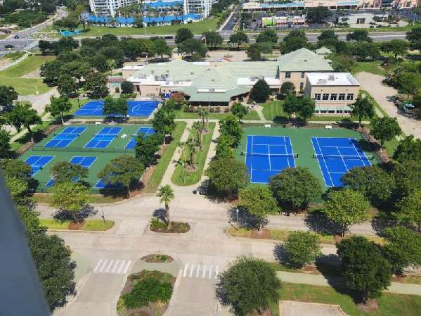

We hope you and your guests will enjoy the newly resurfaced tennis, pickleball and basketball courts. They are now operational. We have 2 tennis courts, 6 pickleball courts and 1 basketball court.

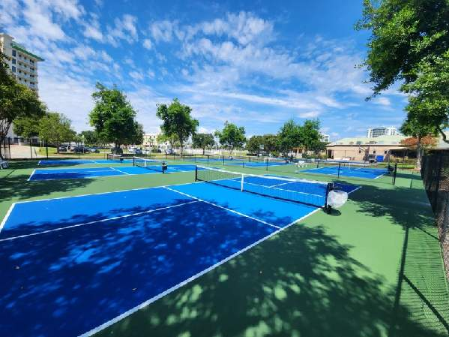
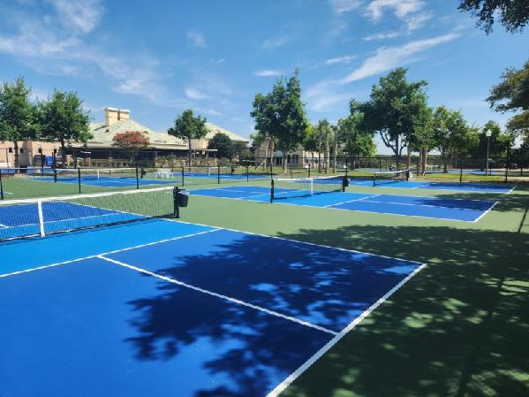
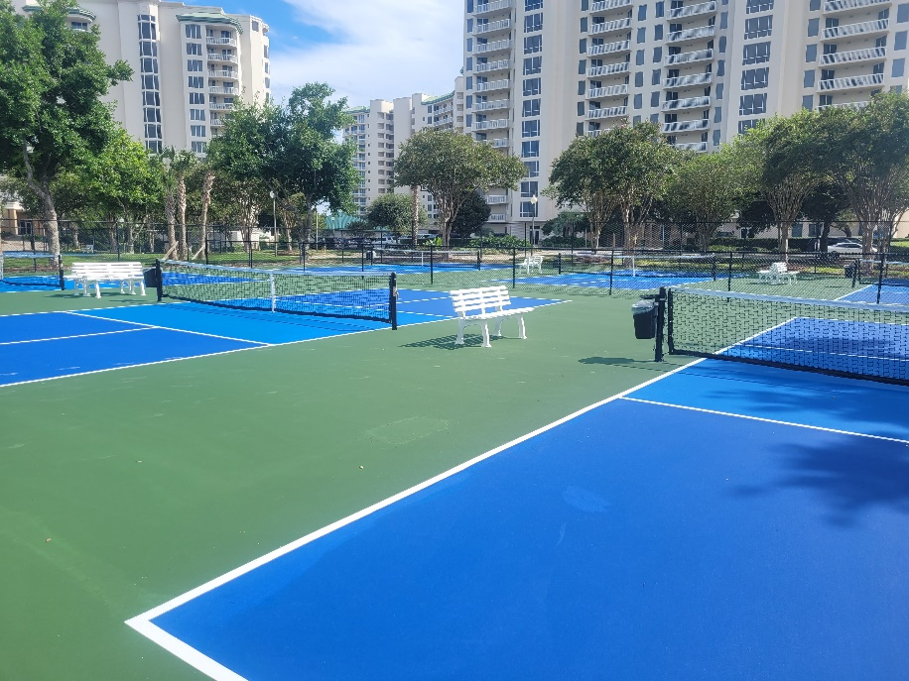

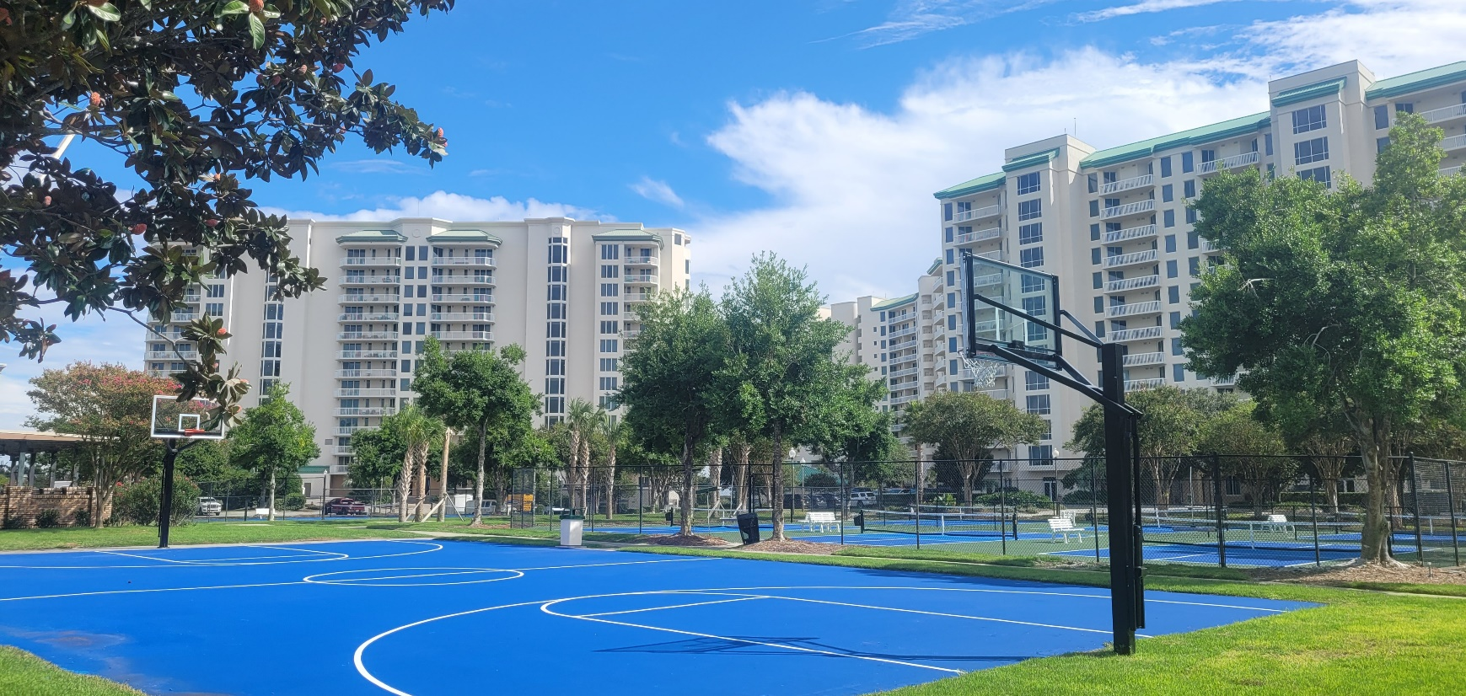

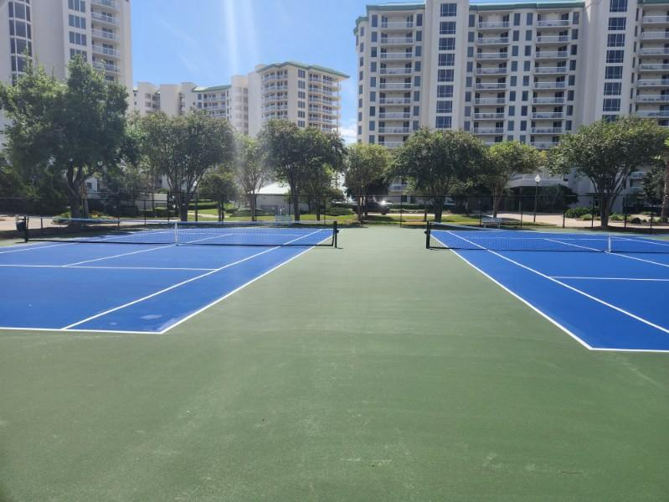

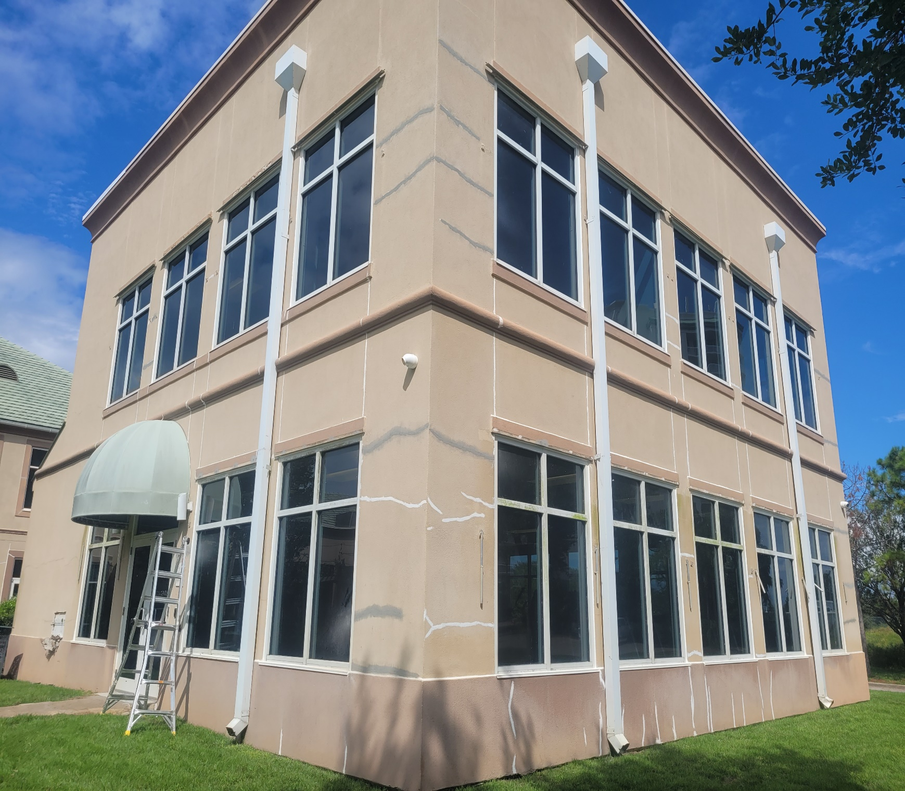

The painting and restoration project has begun on the Clubhouse and Cardio building.

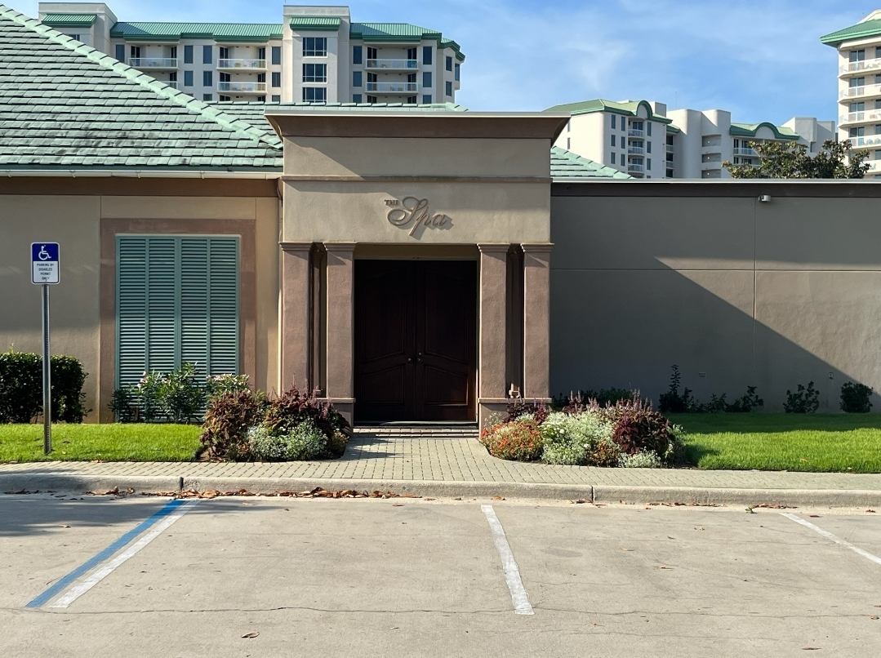
The Spa is open! Darlene Miller is the new owner, and she is offering Silver Shells Homeowners special discounts. Jessica Jones is the new spa director, call 850-337-5107 to find out more.

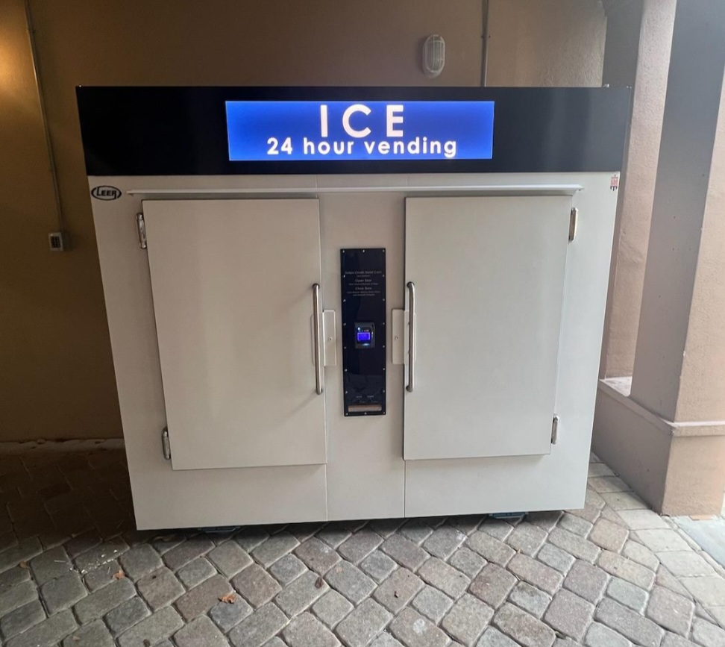

We now have an Ice vending machine located at the Southside Spa entrance. A 7-pound bag is $4.70 including tax. The machine accepts credit or debit cards. The master association earns a small share of each bag.

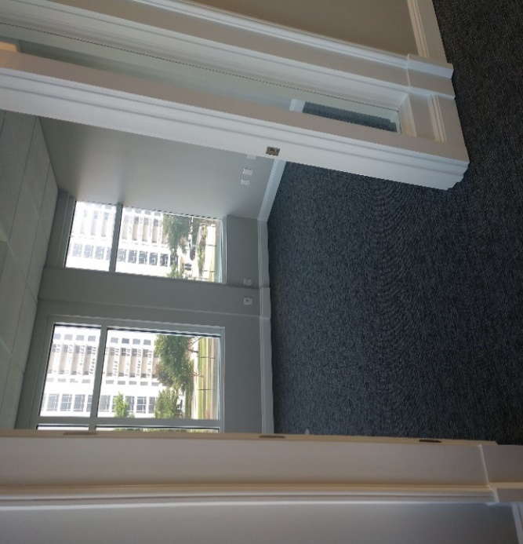

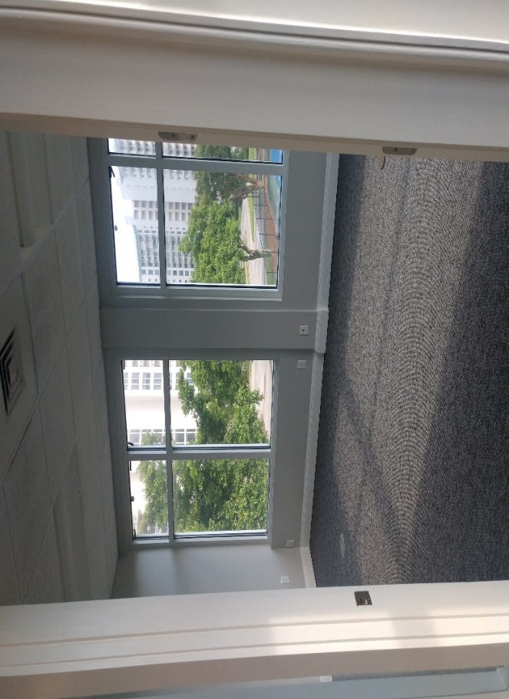
The office space above the Cardio room has been rented out to a commercial firm. This was a decision to enhance the club’s revenue. It has a new coat of paint, new carpet and the kitchenet has been completely updated.

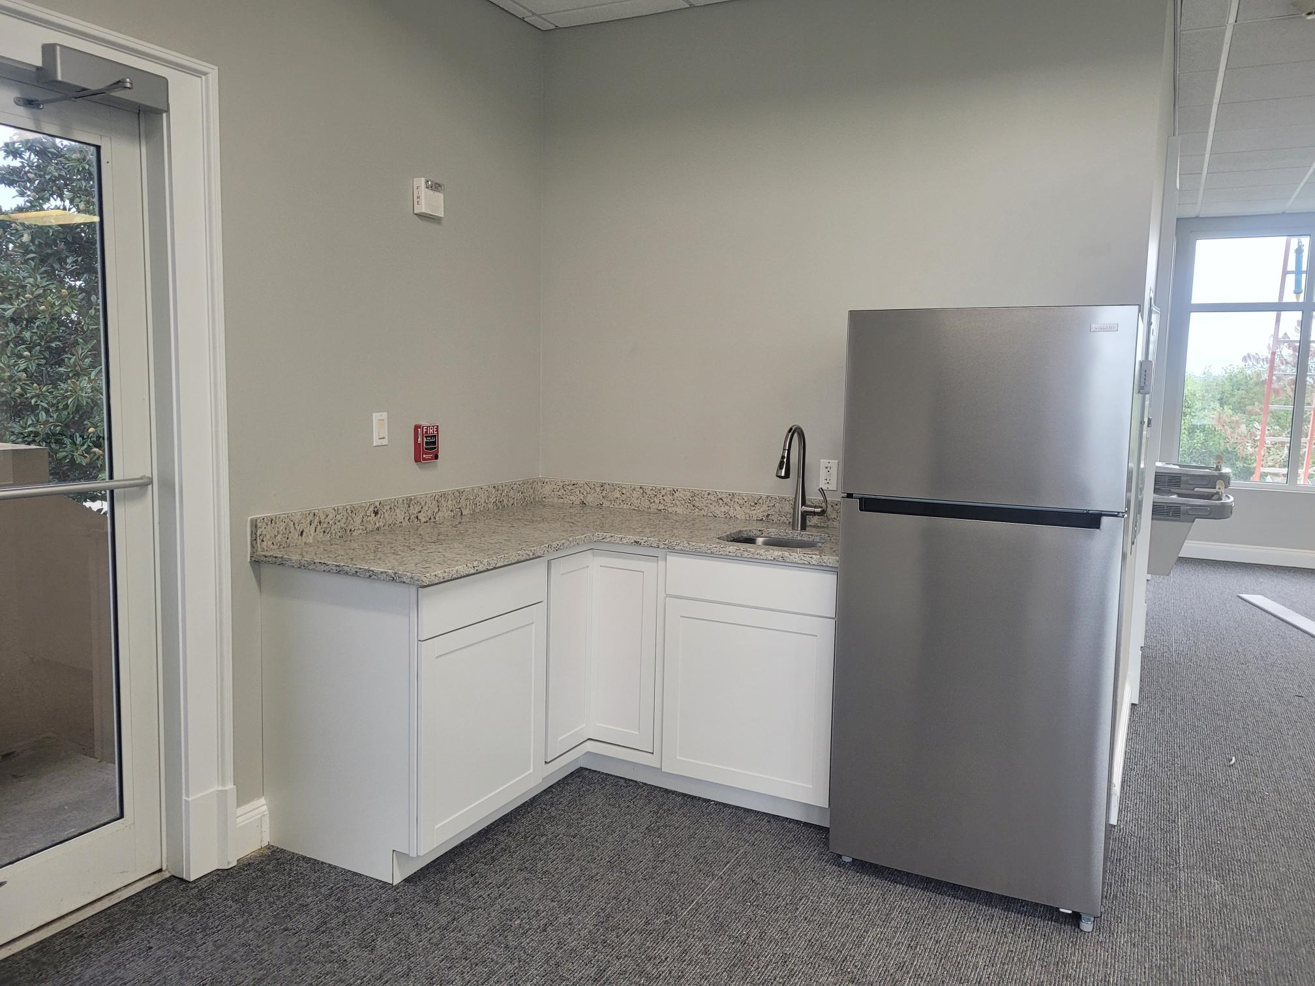

The Sandbar has been hopping this summer, especially on band nights. It will be closing soon for the season so please come and enjoy the last few Band nights of 2023.
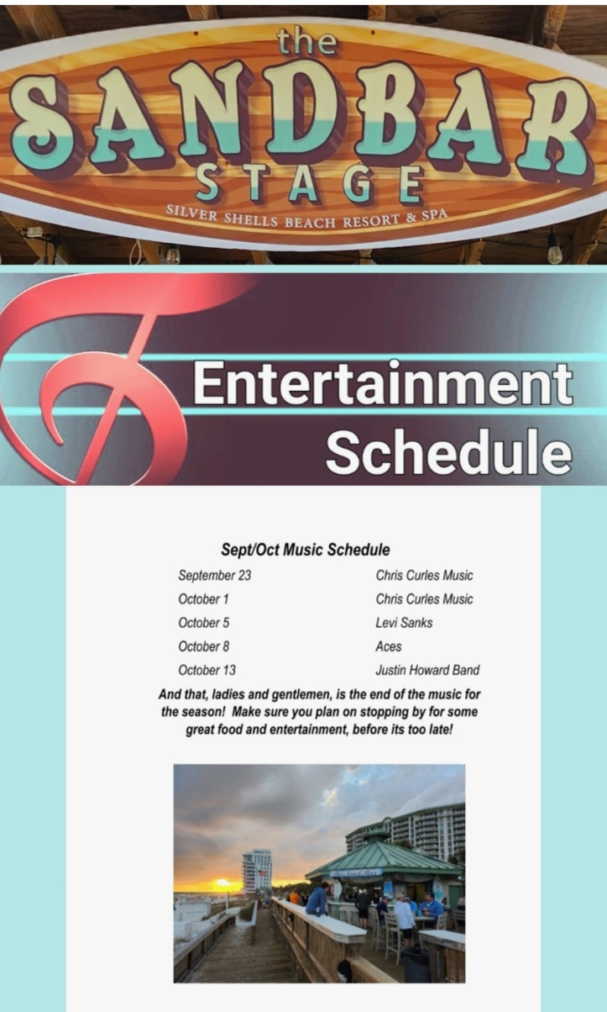
As always, for your benefit, wristbands are required to be worn or on your person by Guests and Owners at the Indoor/Outdoor and Lagoon Pool, Fitness Center, Basketball and Tennis Courts, and Beach. In your bag or at your table are not acceptable.

We appreciate your cooperation!
It is helpful enforcing rules with guests when homeowners lead the way and set the example—thank you for doing so! If you do not have the new 2023 red and white wristbands, please ask your building manager or maintenance supervisor for the new ones.

Clubhouse
The code 9234* is to access the weight room, you now gain access to the cardio room with your key fob/card. As a reminder, the weight and cardio center do not open until 6am and closes at 9 pm. The indoor/outdoor pool opens at 9am and closes at dusk. Wristbands are required to enter Clubhouse for owners and guests. The door to the weight center is on the south side of the building by the basketball court.
We will do our best to keep you updated on the progress.
Have fun while you’re here!
Sincerely,
Eric Anderson, SSPOA, St. Barth, St. Croix and Owner's Club Manager
Josh Lee, SSPOA Director of Operations
Candace Coughlin, SSPOA Assistant General Manager

A message from your Master Association Board President:

What a great time to be in Destin at Silver Shells. Thank you for all the positive and constructive feedback about the landscaping, courts, fitness equipment, and greenbelt. The work, and the fun, never stops at Silver Shells. Enjoy it all!

