December 2023, Newsletter
Hello, Silver Shells Homeowners!
The 2023 Annual Social turned out great—to those who could not make it, we hope to see you next year. We hope everyone finds themselves healthy and happy for this holiday season.

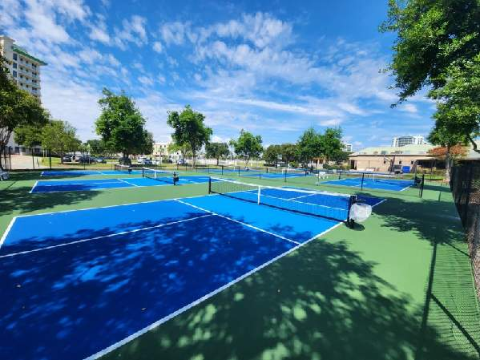
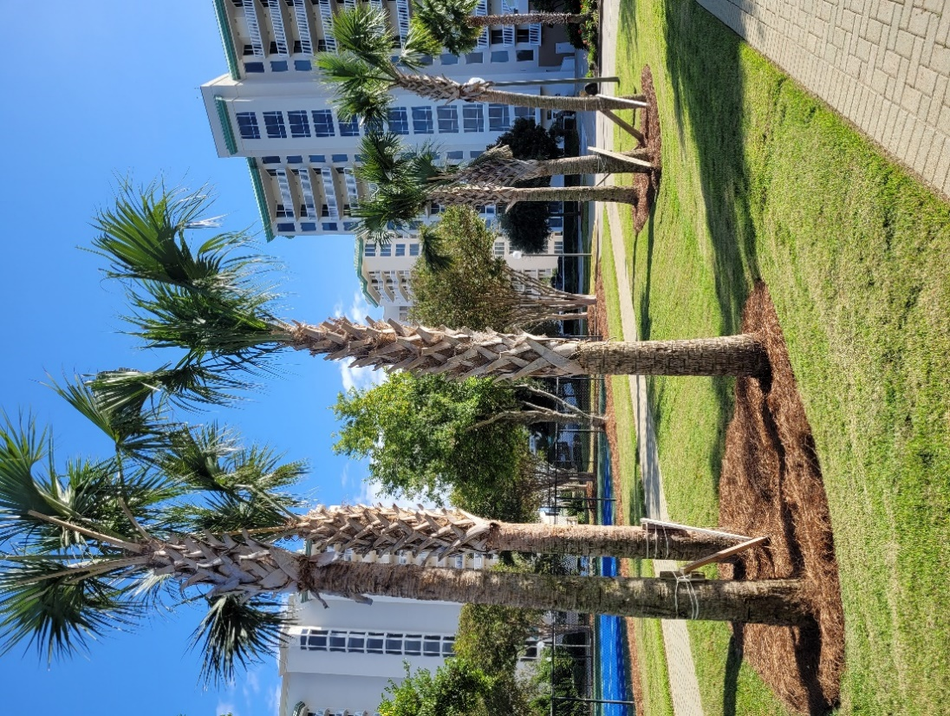

The Clubhouse restoration and painting is still in progress.
Before and during.
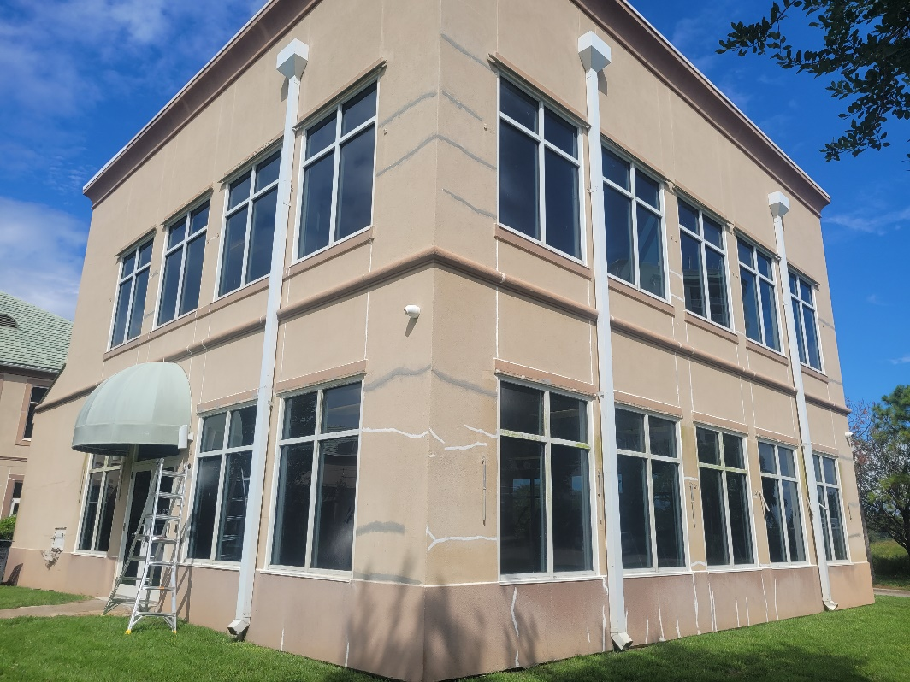

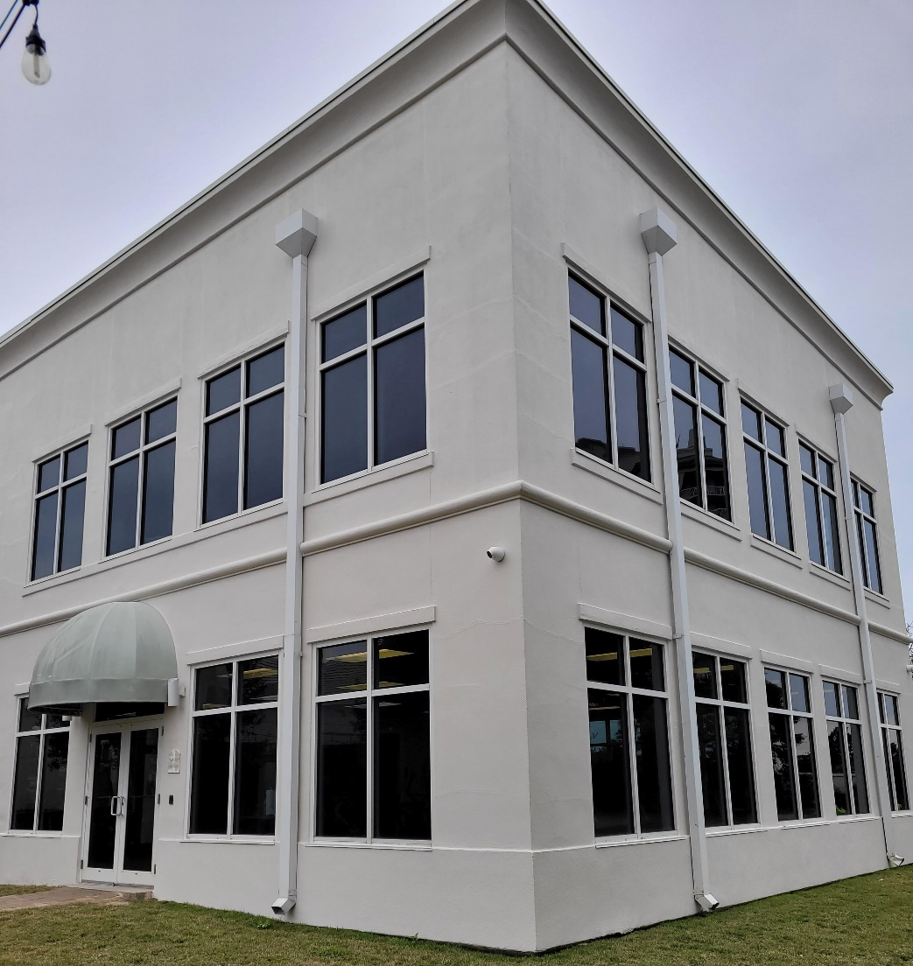

Before and after

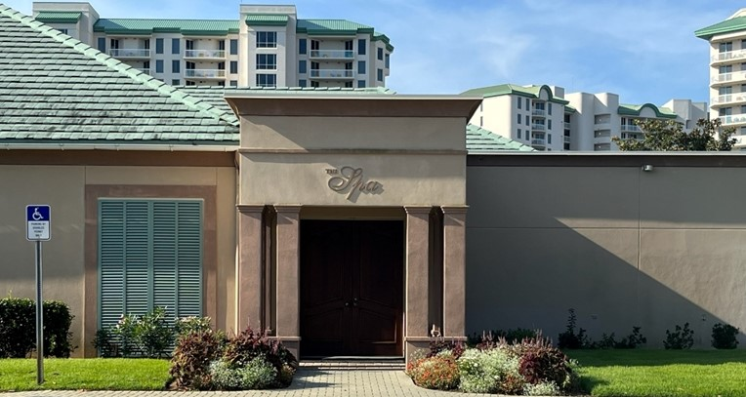

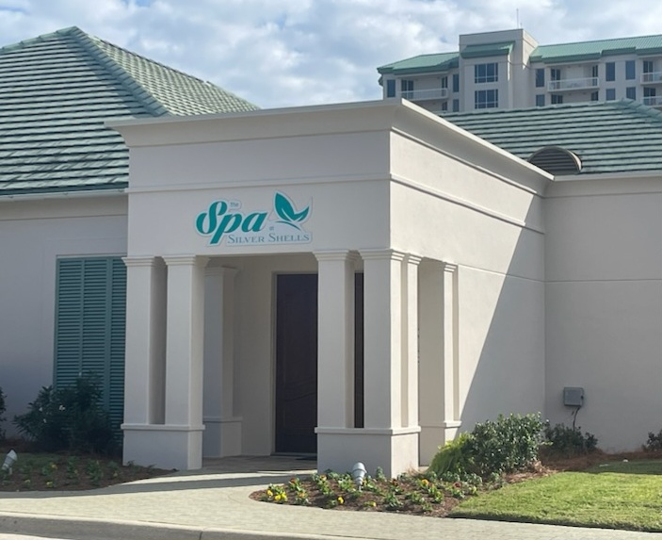

The Spa is open! Darlene Miller is the new owner—she is offering Silver Shells Homeowners special discounts. Jessica Jones is the new spa director, call 850-337-5107 to find out more.
Silver Shells Master Association Staff
Josh Lee Candace Coughlin
Director of Operations Asst. General Manager
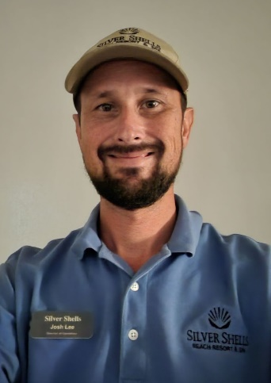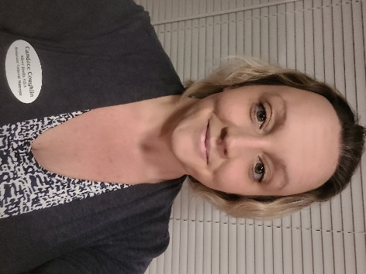

Maintenance Staff
Matt Goff Eric Price Herbert Baker Heath Najjar Morgan Lang
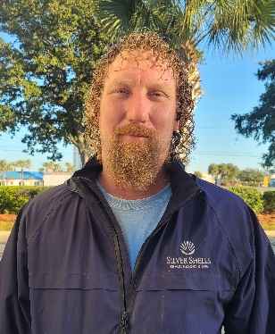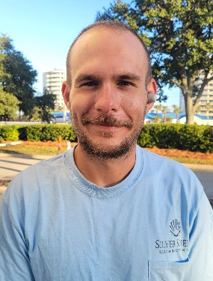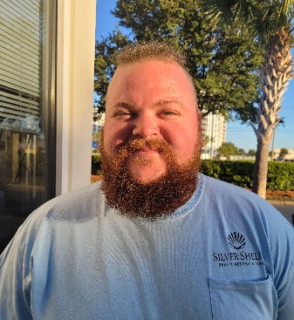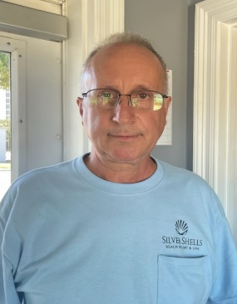

Courtesy Patrol Staff
Brandon Rushton Robert Swafford Clifford Bridgewater Terry salazar
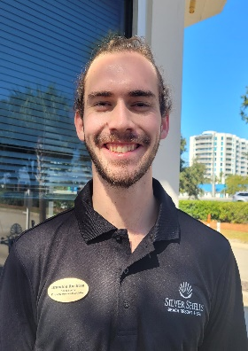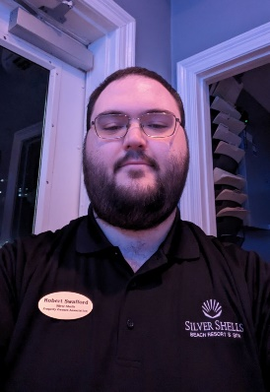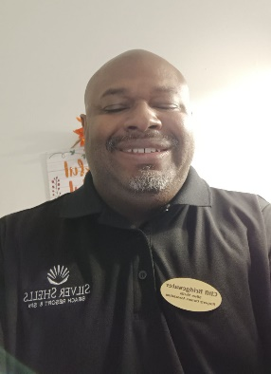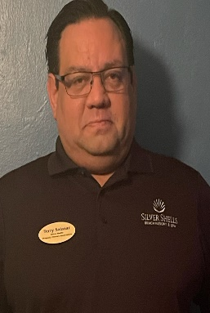

Calvin Rivera Trevor Batson
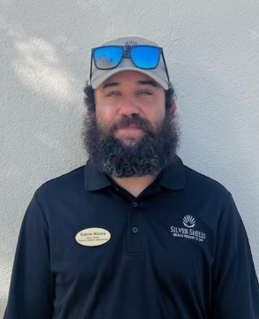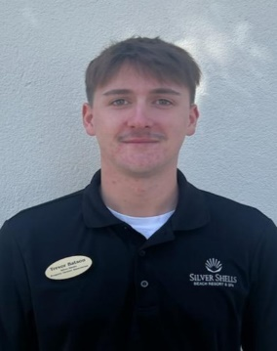

Dear Homeowners,
If you haven’t registered on the Silver Shells Master Association website, please do. You will find important information, documents, news and events. We will continue to add content relevant to your condo ownership…like financials!
https://silvershellsofdestin.com
As always, for your benefit, wristbands are required to be worn or visibly on your person by Guests and Owners at the Indoor/Outdoor and Lagoon Pool, Fitness Center, Basketball. Pickleball and Tennis Courts, and our Beach. In your bag or at your table are not acceptable.

We appreciate your cooperation!
It is helpful enforcing rules with guests when homeowners lead the way and set the best example—thank you for doing so!

Clubhouse
To gain access to the Weight and Cardio room you must have your key fob/card. As a reminder, the weight and cardio center does not open until 6 am and closes at 9 pm. The indoor/outdoor pool opens at 9 am and closes at dusk. Wristbands are required to enter Clubhouse for owners and guests. The door to the weight center is on the south side of the building by the basketball court.
We will do our best to keep you updated on the progress.
Have fun while you’re here!
Sincerely,
Eric Anderson, SSPOA, St. Barth, St. Croix and Owner's Club Manager
Josh Lee, SSPOA Director of Operations
Candace Coughlin, SSPOA Assistant General Manager

A message from your Master Association Board President:
The Master board is thankful for a hard-working and engaged Superior Management Staff, Eric, Josh, Candace and their maintenance and courtesy patrol staffs.
2023 was a fantastic year for Silver Shells…2024 looks to be exciting also. Owners, thank you for your concerns and feedback…hearing from you is always welcome!

