November 2023, Newsletter
Hello, Silver Shells Homeowners!
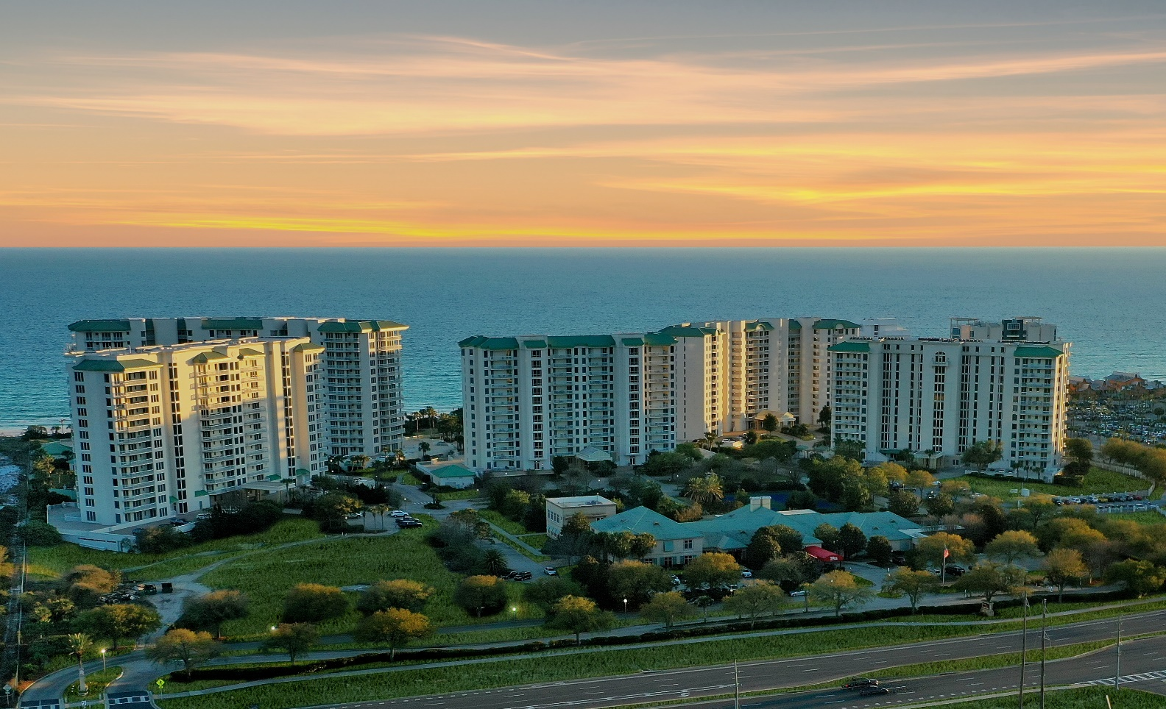

Don’t forget your 2023 Annual Owners Social to be held at
St. Croix on Friday, November 3rd at 5:30 p.m.
Please join your fellow owners for a fun evening of music, food,
drink and conversation.
Your 2023 Annual meeting will be held at St. Croix on
Saturday, Nov. 4th at 2:00 pm.
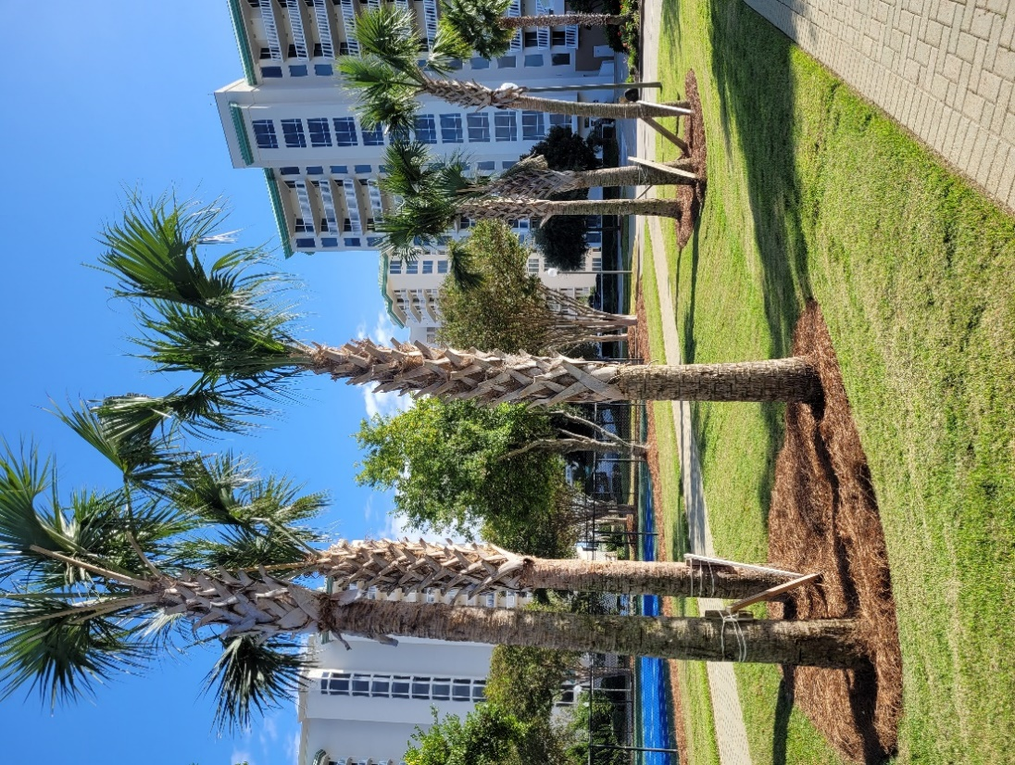
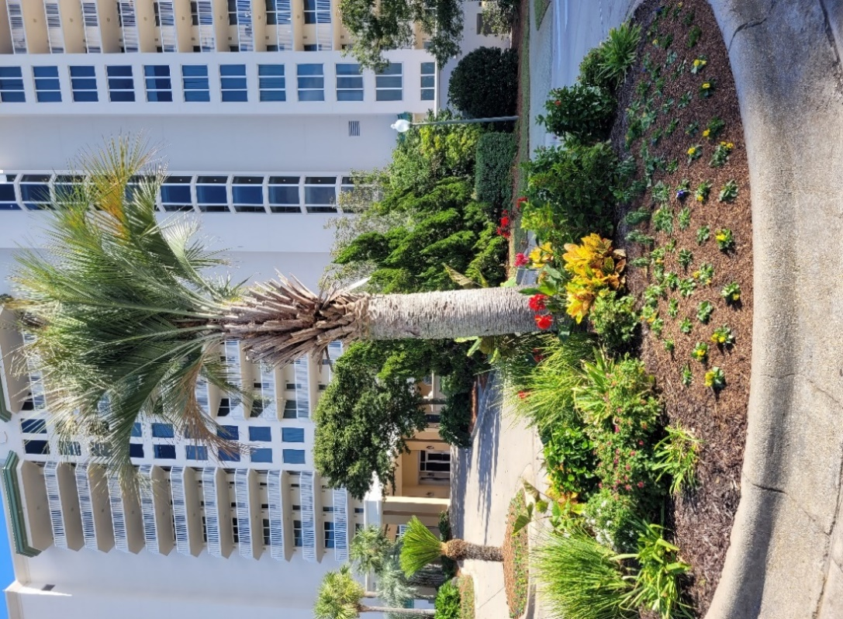
Property is looking beautiful with the newley installed pinestraw, planted flowers, and trimmed palm trees.
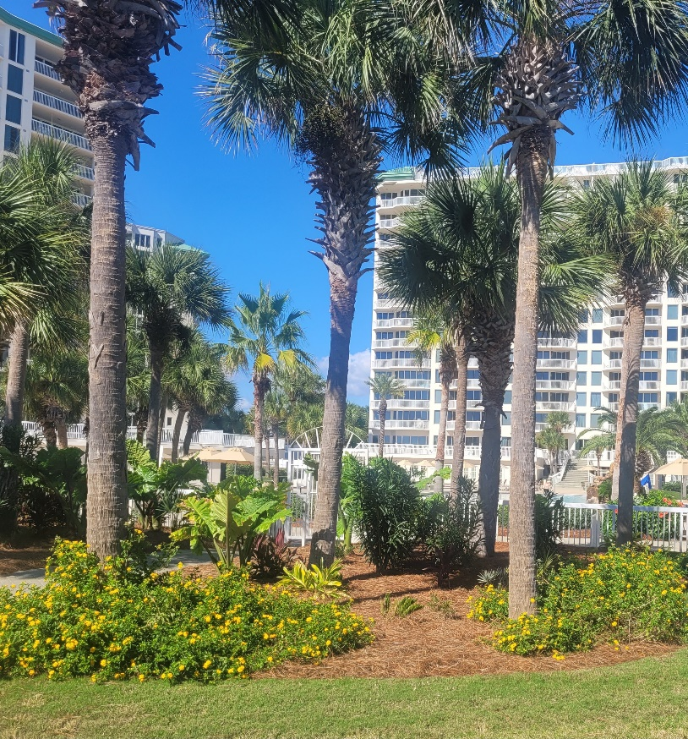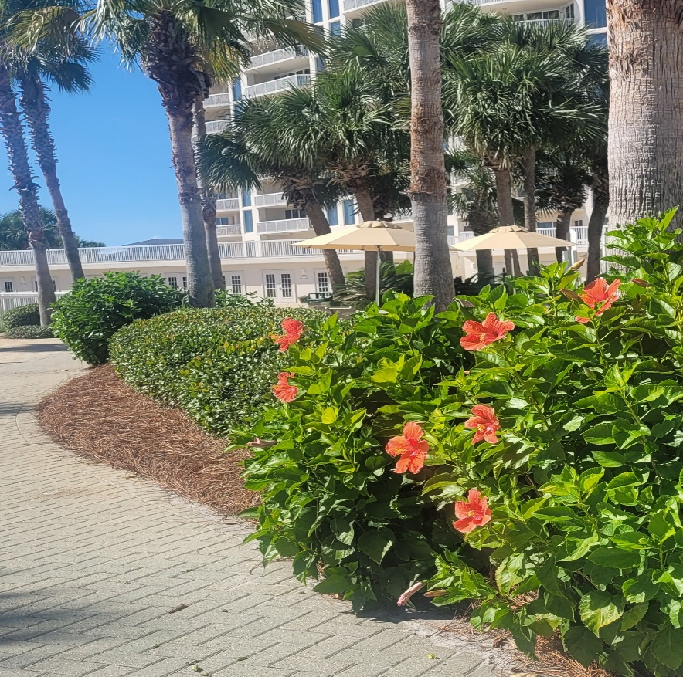
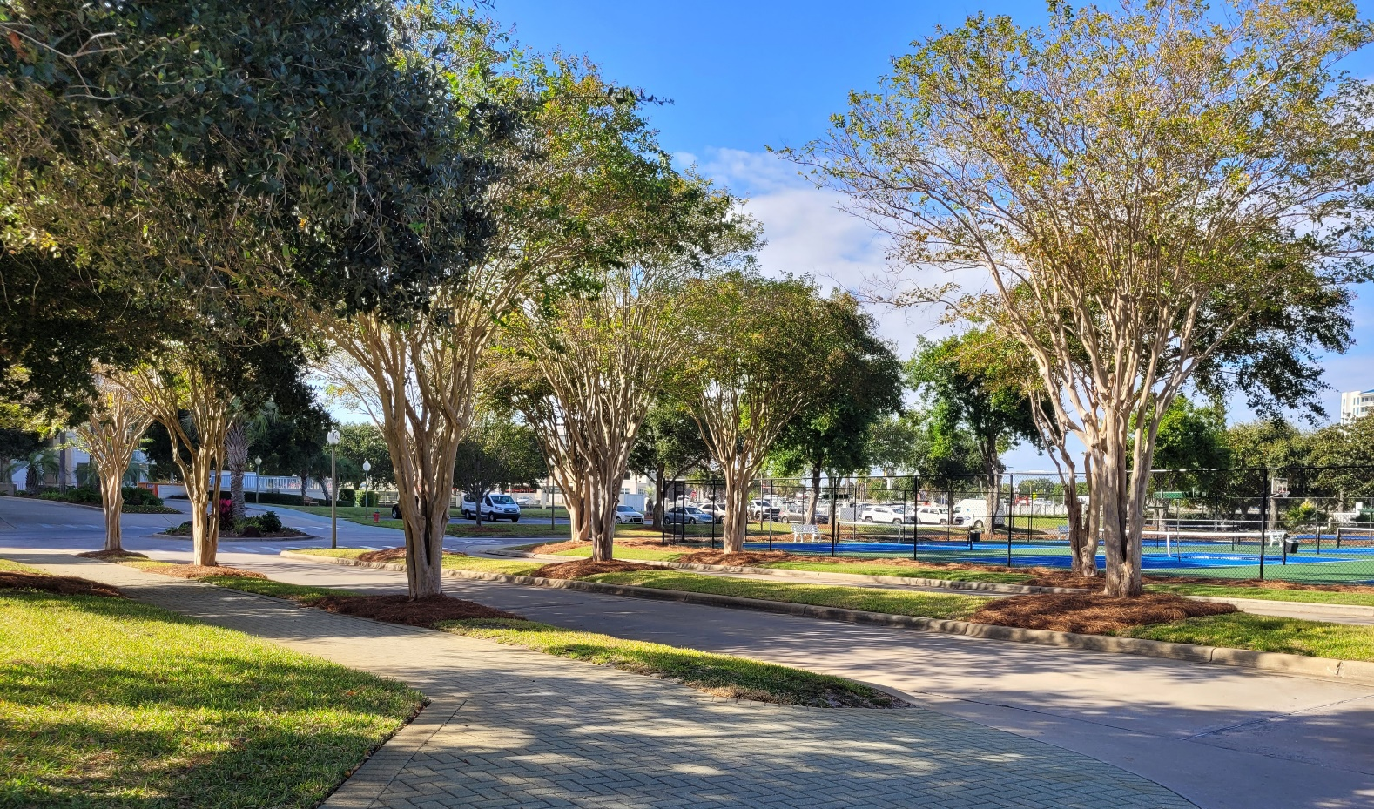
The pickleball courts have been very popular. We are getting great feedback; guests are saying it feels much more like a resort.
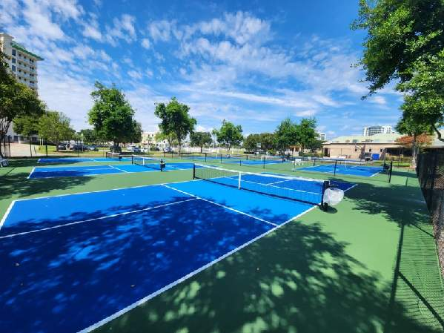

The Clubhouse painting and restoration project is going nicely the new paint color has given the building a much cleaner and modern look.
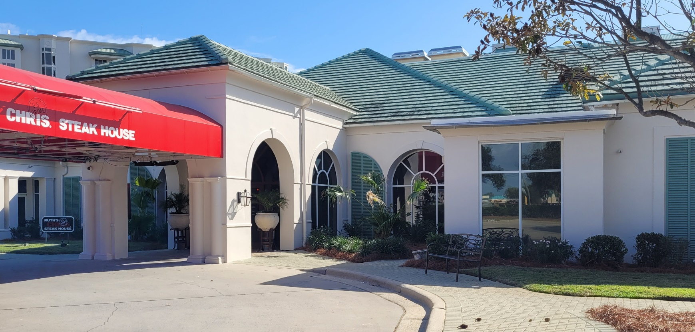
The Spa is open! Darlene Miller is the new owner, and she is offering Silver Shells Homeowners special discounts. Jessica Jones is the new spa director, call 850-337-5107 to find out more.
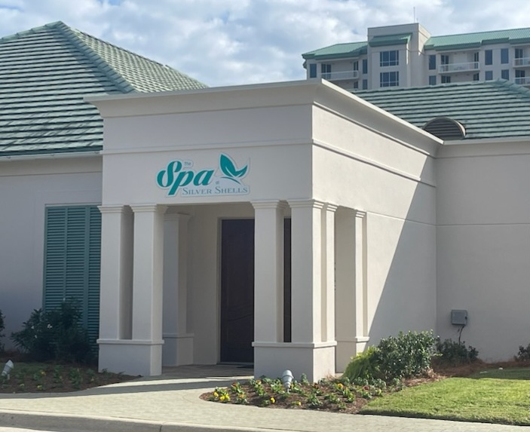
The Silver Shells Courtesy Patrol and Maintenance staff were given much more responsibility by taking on the Clubhouse and Beach. Everyone worked very hard keeping Silver Shells secure and maintained.
Josh Lee Candace Coughlin
Director of Operations Asst. General Manager
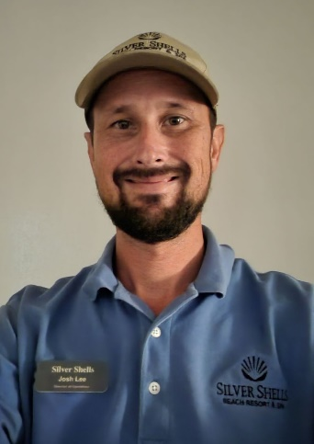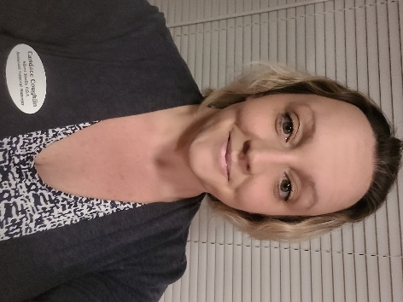

Maintenance Staff
Matt Goff Eric Price Herbert Baker Heath Najjar Morgan Lang
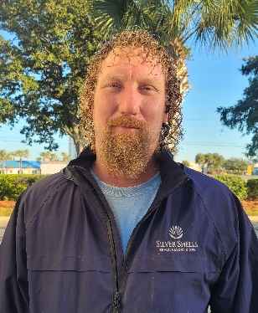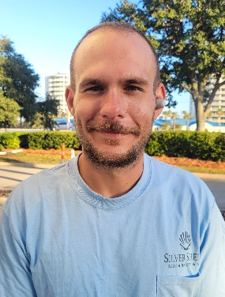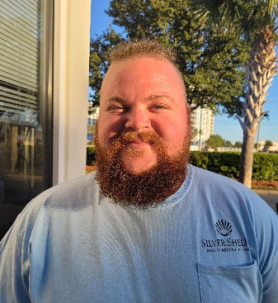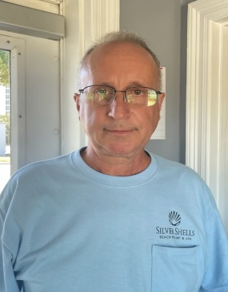

Courtesy Patrol Staff
Brandon Rushton Robert Swafford Clifford Bridgewater Terry salazar
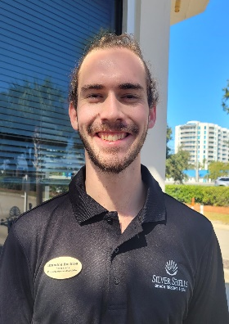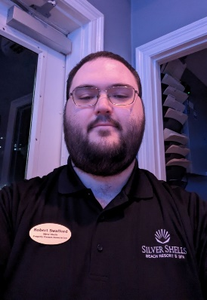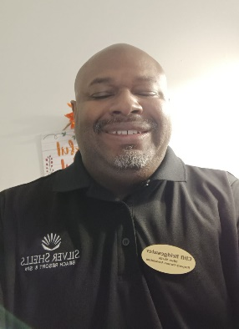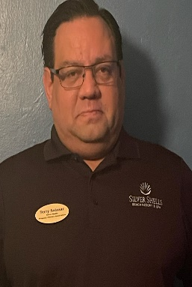

Calvin Rivera Trevor Batson
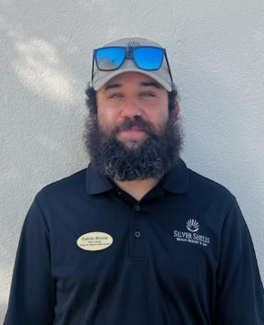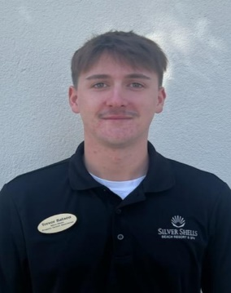

Dear Homeowners,
If you haven’t registered on the Silver Shells Master Association website, please do. You will find important information, documents, news and events.
https://silvershellsofdestin.com

As always, for your benefit, wristbands are required to be worn or on your person by Guests and Owners at the Indoor/Outdoor and Lagoon Pool, Fitness Center, Basketball and Tennis Courts, and Beach. In your bag or at your table are not acceptable.

We appreciate your cooperation!
It is helpful enforcing rules with guests when homeowners lead the way and set the example—thank you for doing so!

Clubhouse
The code 9234* is to access the weight room, you now gain access to the cardio room with your key fob/card. As a reminder, the weight and cardio center do not open until 6am and closes at 9 pm. The indoor/outdoor pool opens at 9am and closes at dusk. Wristbands are required to enter Clubhouse for owners and guests. The door to the weight center is on the south side of the building by the basketball court.
We will do our best to keep you updated on the progress.
Have fun while you’re here!
Sincerely,
Eric Anderson, SSPOA, St. Barth, St. Croix and Owner's Club Manager
Josh Lee, SSPOA Director of Operations
Candace Coughlin, SSPOA Assistant General Manager

A message from your Master Association Board President:

We are enjoying another magnificent Destin Fall.

Hope to see you at the owner’s social on Friday, Nov 3rd!

