June 1, 2023, Newsletter
Hello, Silver Shells Homeowners!
We have some great updates for you.
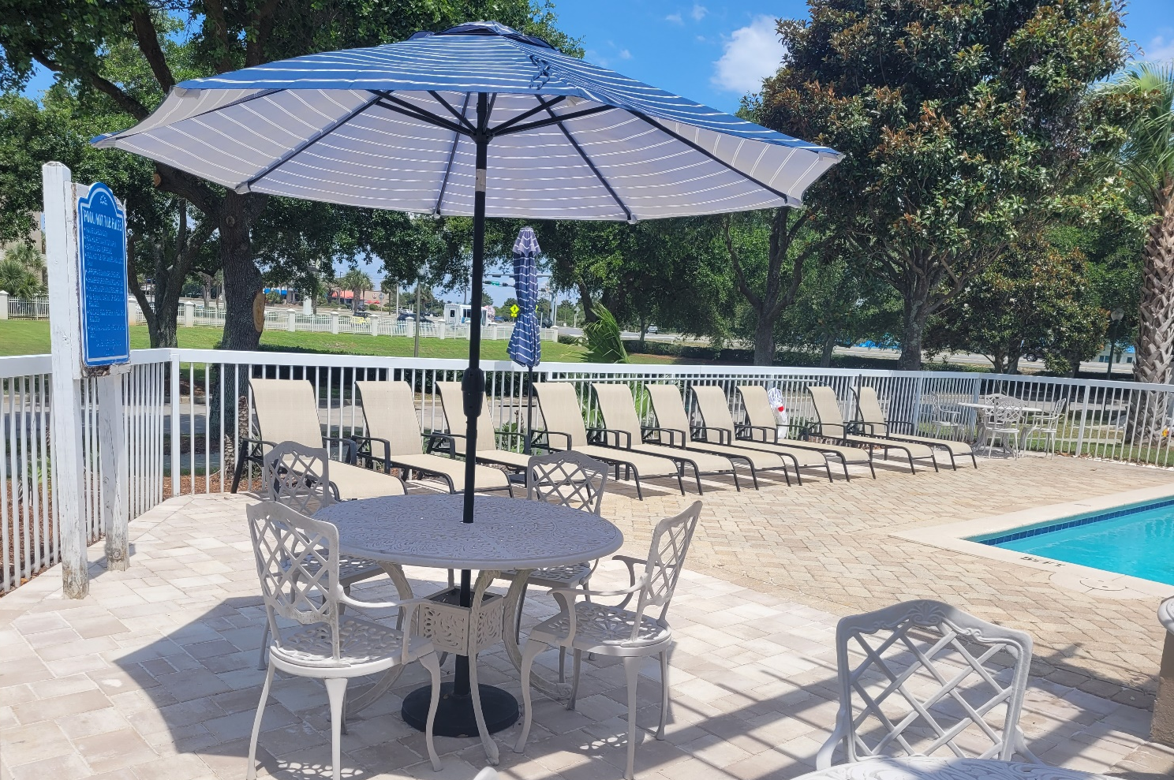

The Clubhouse property
The overgrown landscaping on our Indoor/Outdoor Pool Deck has been removed and replaced with pavers. Giving us much more deck area.
The roofing project is underway.
Pavers have been added to the back door area of Ruth Chris Steak House making it much more attractive.

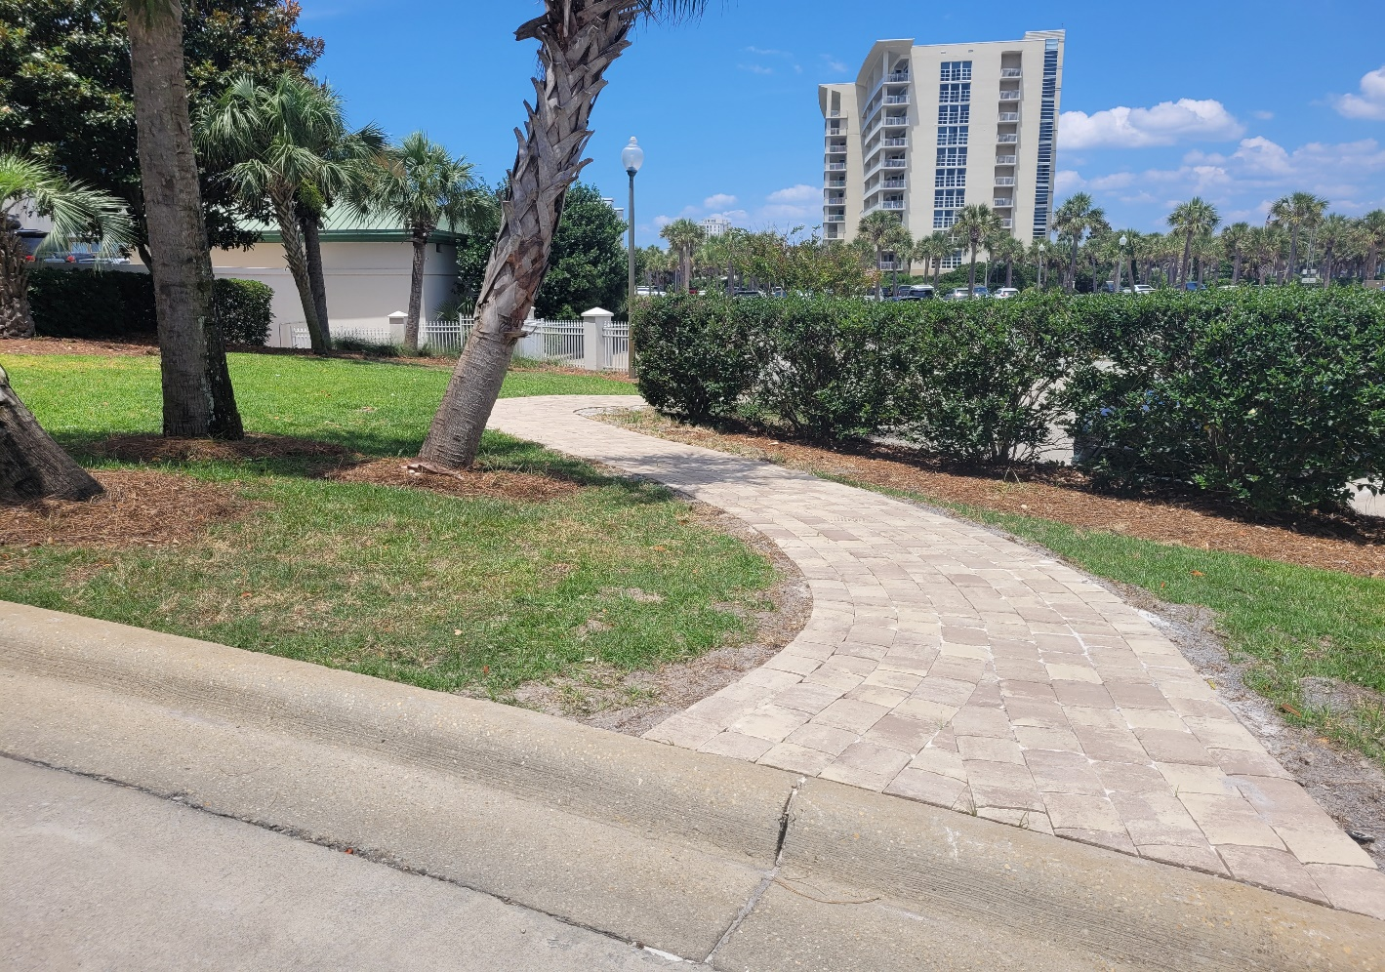
A beautiful paver sidewalk has been added leading from the St. Maarten overflow paking lot to the St. Maarten Drive. This area recived so much foot traffic it was destrying the grass.
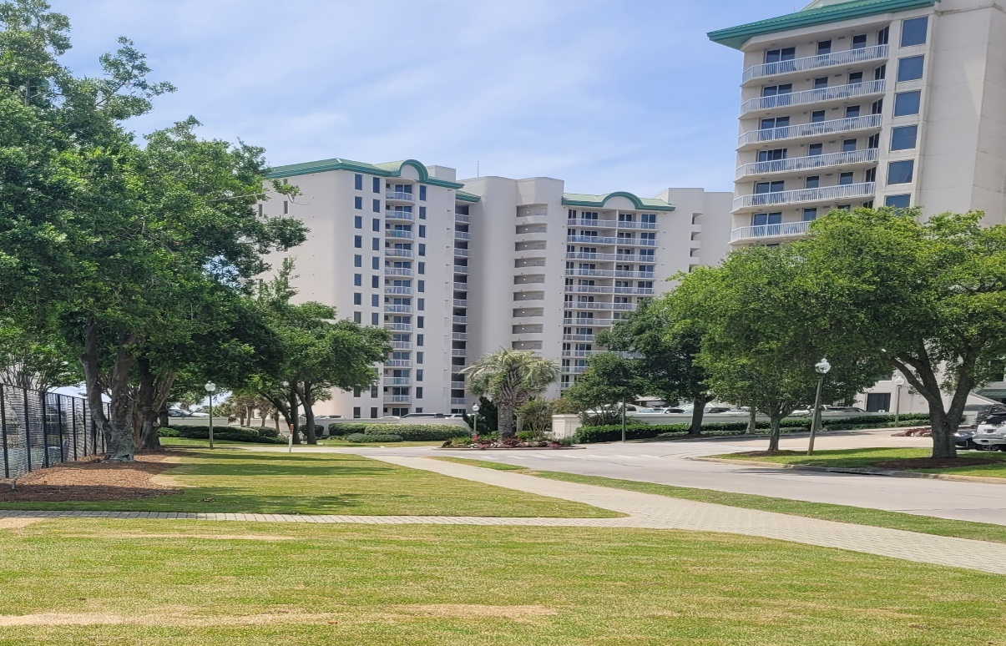
The new sod has been layed on the west side of the tennis courts along with the center island at the front of the property.
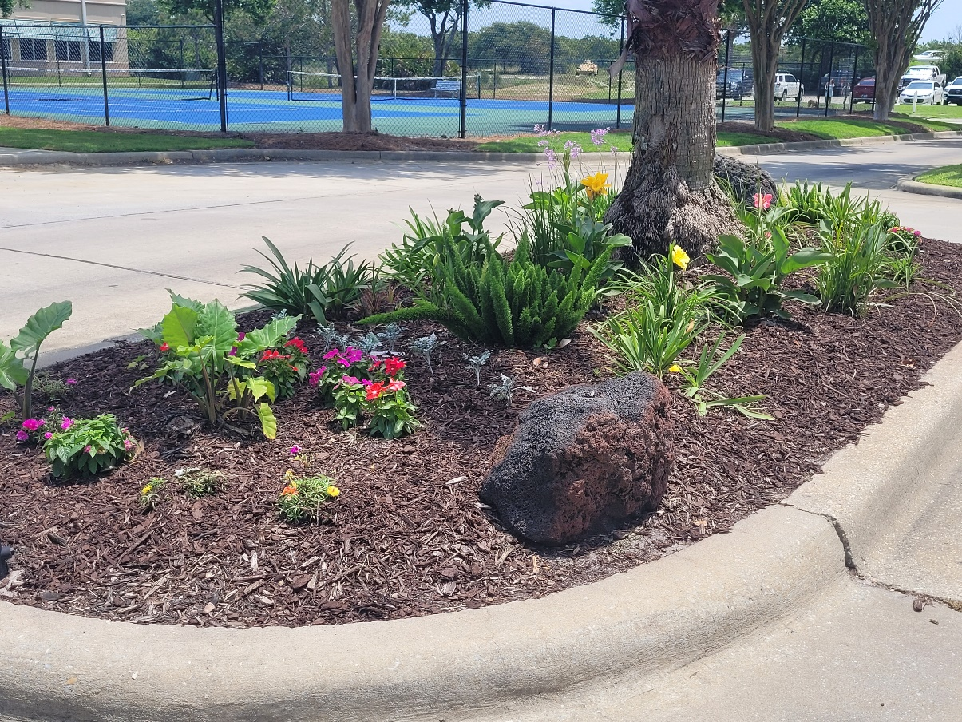
We want to give a big thank you to Mrs. Leslie Morris who donated her time and talent planting flowers to help make our islands look great.
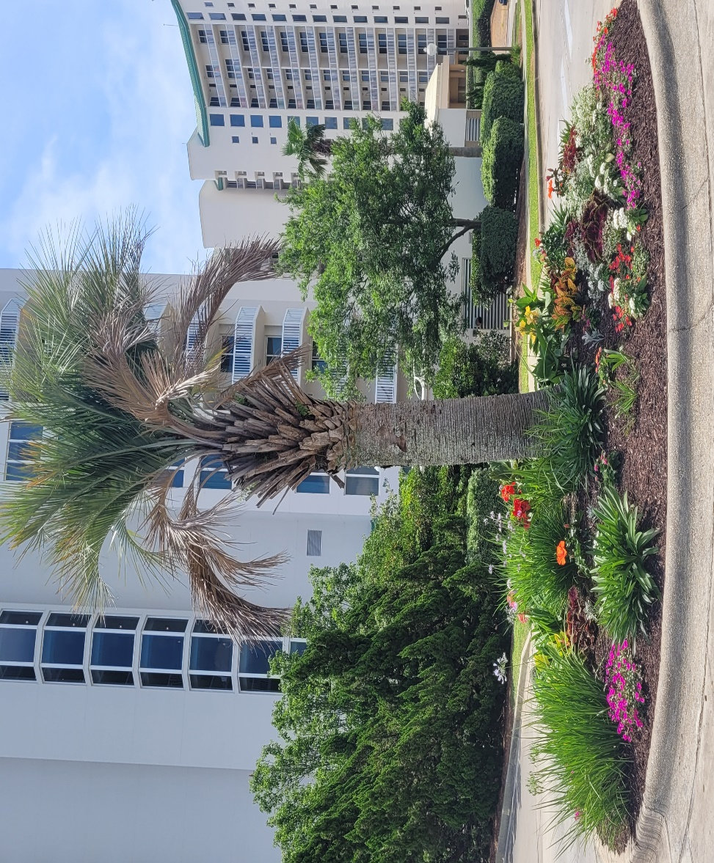

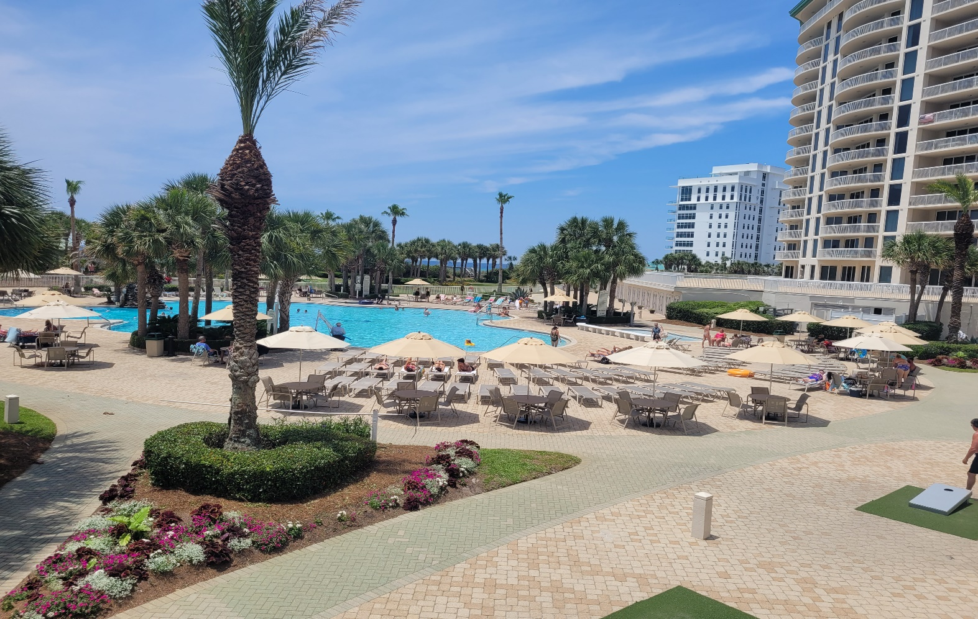
The Lagoon Pool has added 12 more tables and umbrellas to give you and your guests some much needed shade.
The Sandbar is really a great place to enjoy music, food and beverages while taking in the beautiful views of the gulf and beach.
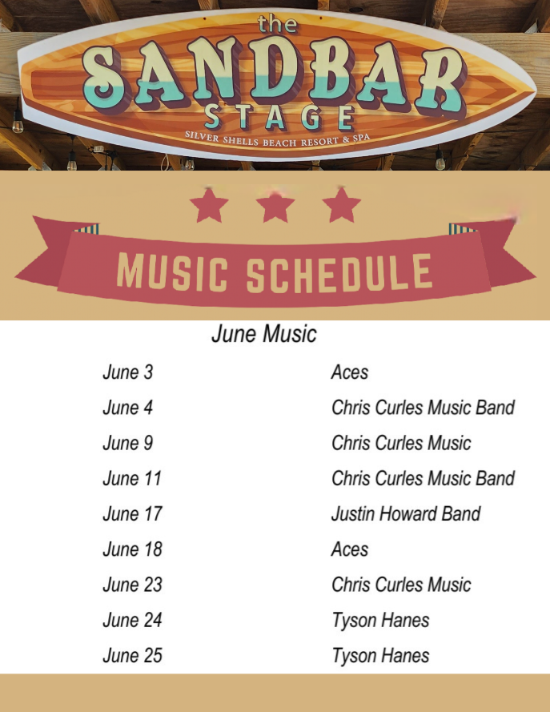
Pool/Beach monitors are checking for wristbands multiple times a day and are escorting trespassers off our beach daily.
As always, for your benefit, wristbands are required to be worn or on your person by Guests and Owners at the Indoor/Outdoor and Lagoon Pool, Fitness Center, Basketball and Tennis Courts, and Beach. In your bag or at your table are not acceptable. We appreciate your cooperation!
It is helpful enforcing rules with guests when homeowners lead the way and set the example—thank you for doing so! If you do not have the new 2023 red and white wristbands, please ask your building manager or maintenance supervisor for the new ones.

Clubhouse
The code 9234* is to access all Club buildings. As a reminder, the weight and cardio center do not open until 7am they close at 9pm. The indoor/outdoor pool opens at 9am and closes at dusk. Wristbands are required to enter for owners and guests. The door to the weight center is on the south side of the building by the basketball court. The door to the cardio room is on the north side facing the main building.
We will do our best to keep you updated on the progress.
Have fun while you’re here!
Sincerely,
Eric Anderson, SSPOA, St. Barth, St. Croix and Owner's Club Manager
Josh Lee, SSPOA Director of Operations
Candace Coughlin, SSPOA Assistant General Manager

A message from your Master Association Board President:
Have a great Silver Shells summer vacation!

