August 2023, Newsletter
Hello, Silver Shells Homeowners!

The new fitness equipment has arrived.
Our Cardio and Weight room now has brand new machines.

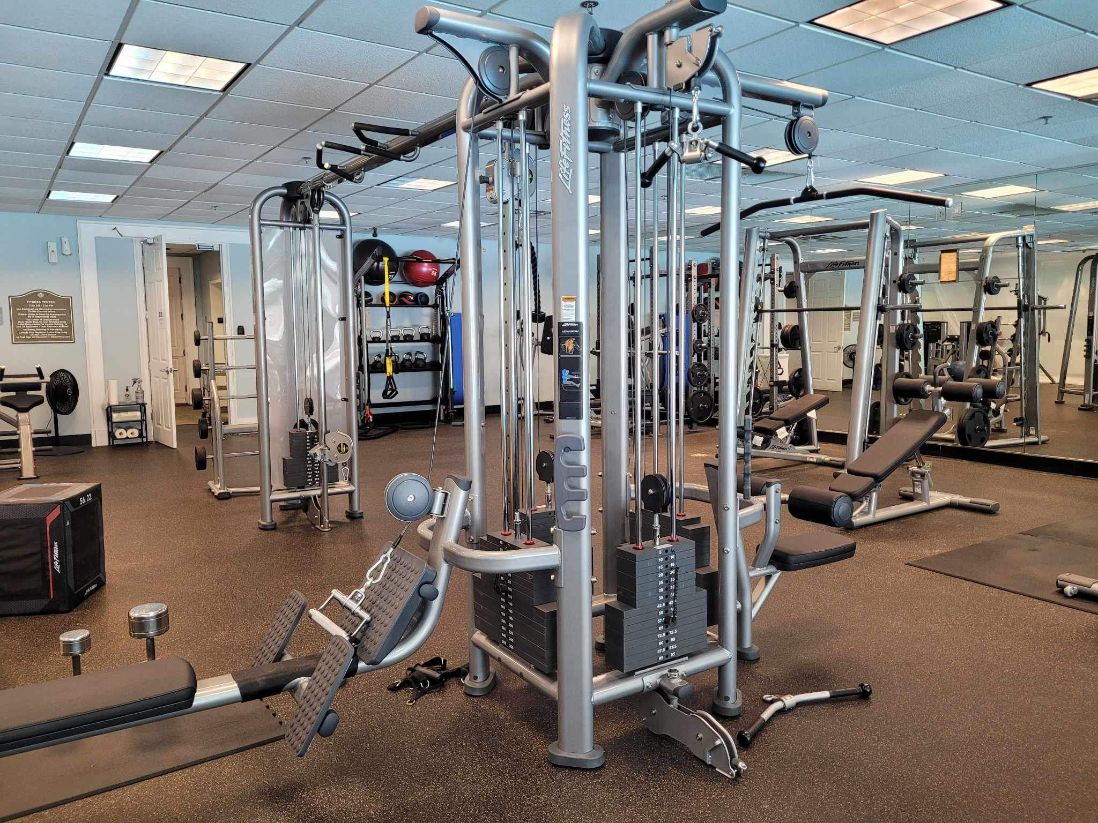

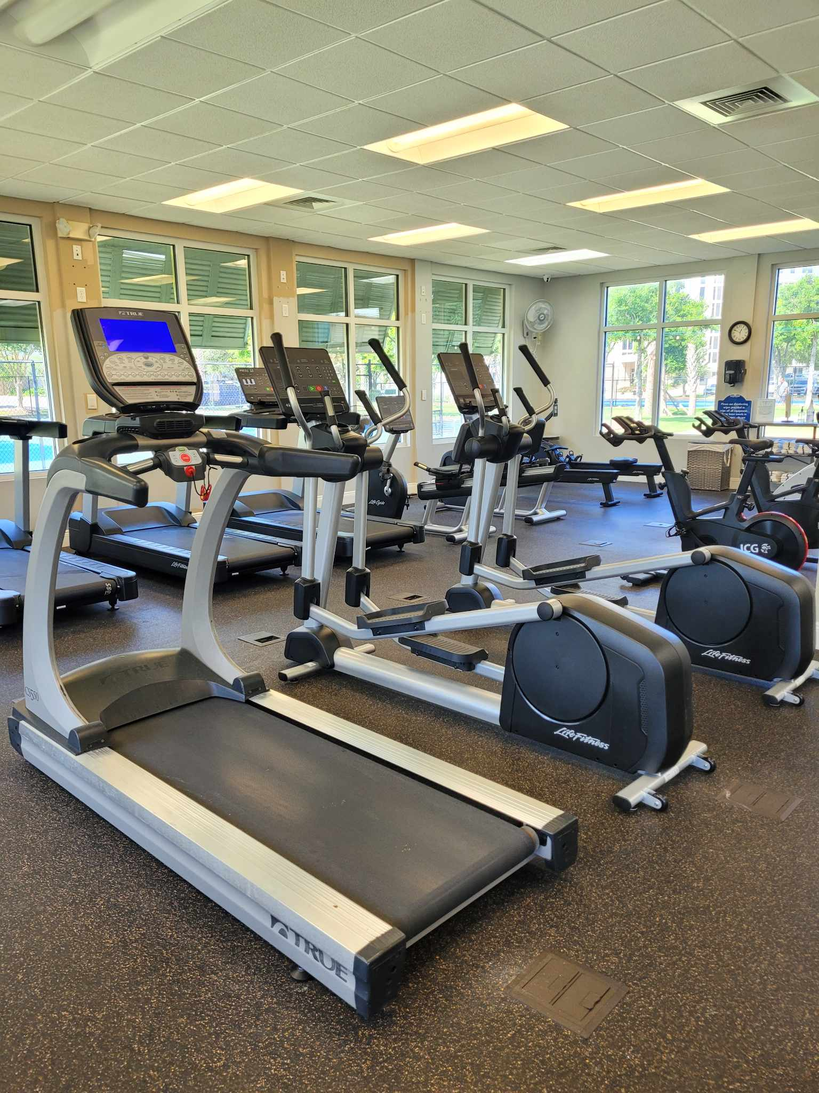

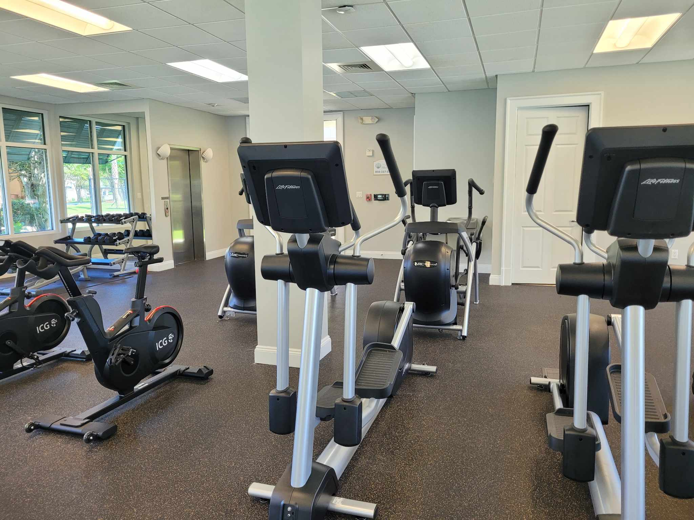

The Cardio room has brand new ellipticals and spin bikes.

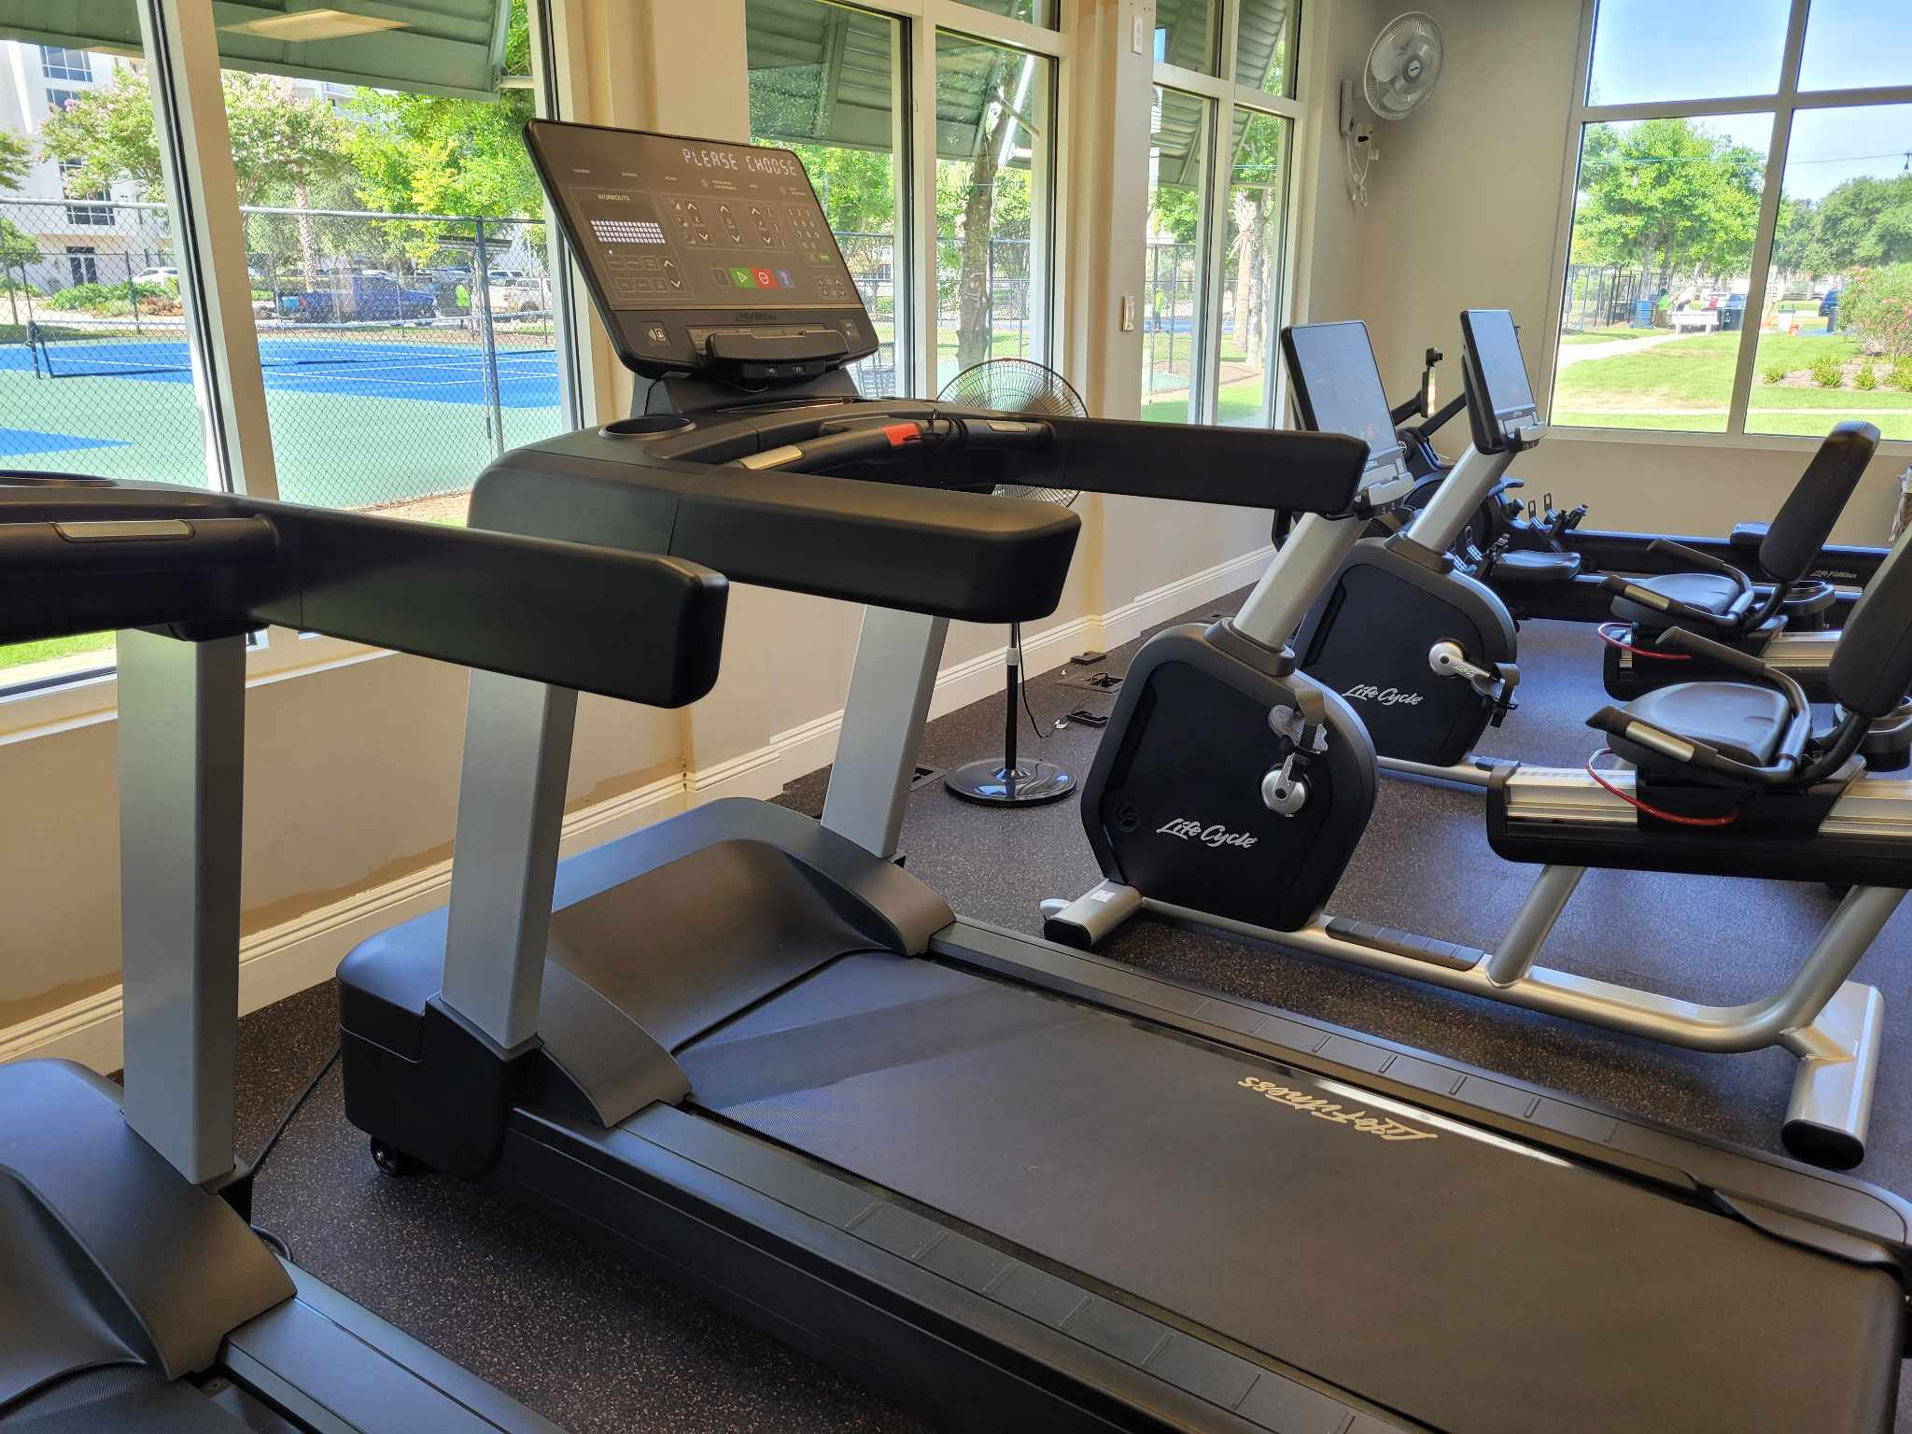

Check out the new treadmills!

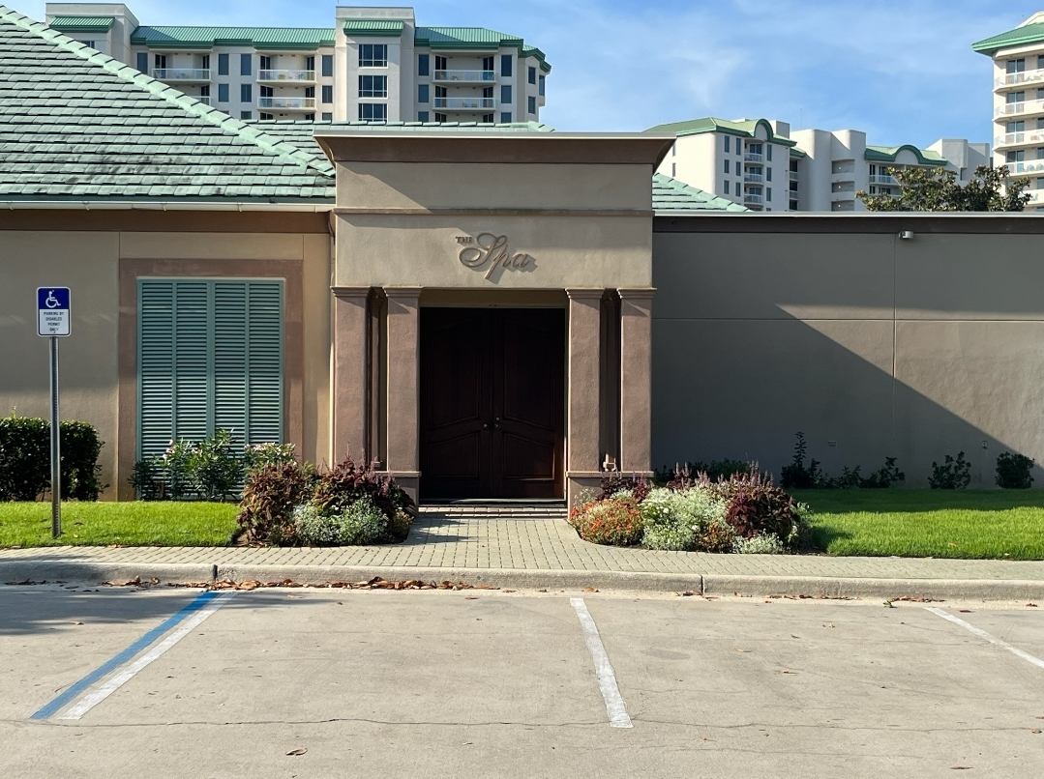
Darlene Miller is the new owner of The Silver Shells Spa. She is making some greatly needed improvements. The Spa is closed to make those improvements with a tentative opening on August 8th.

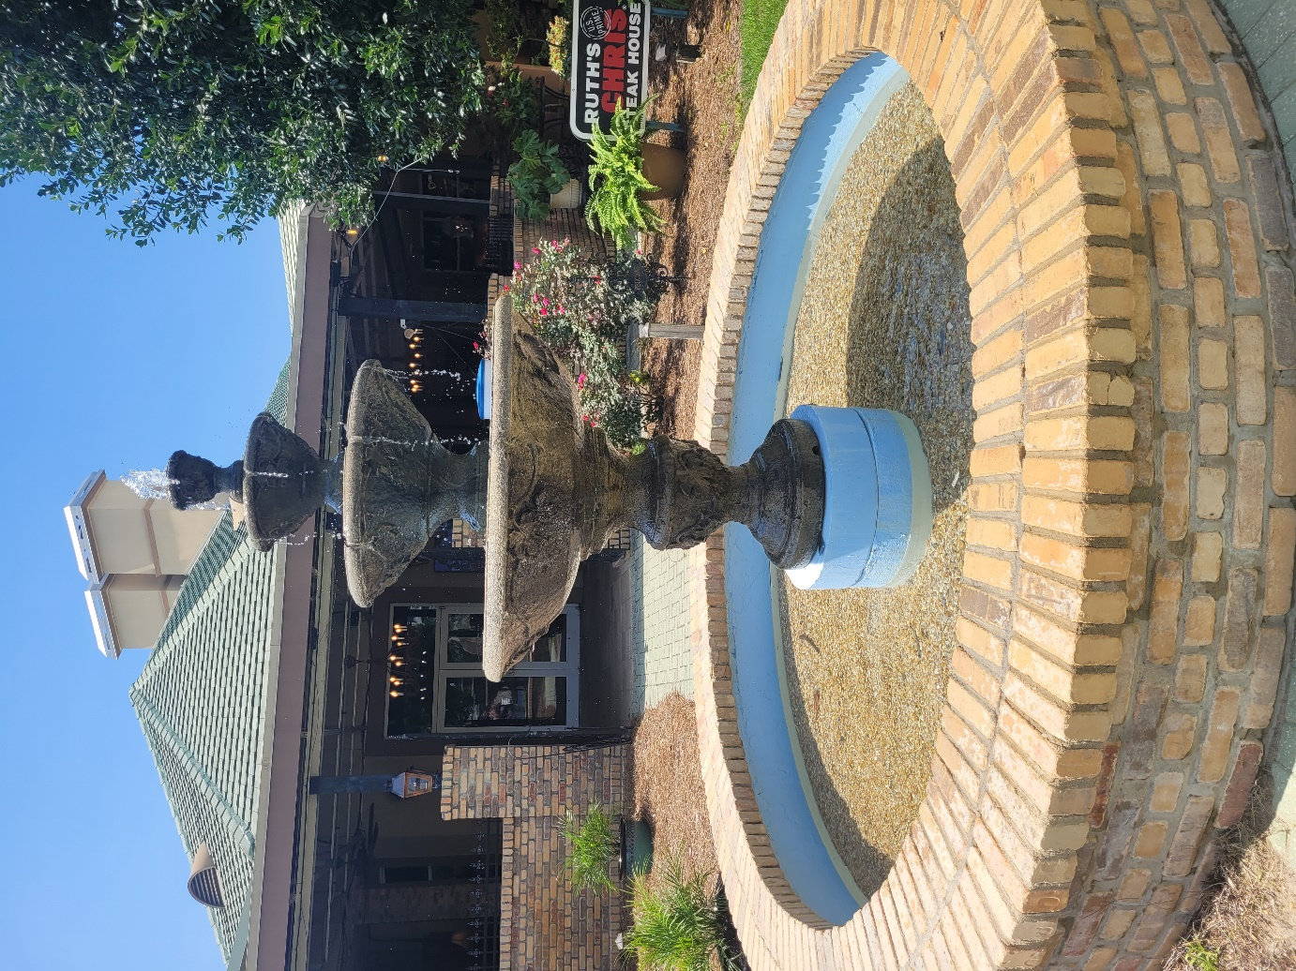

The fountain has a brand-new pump, gravel, and a fresh coat of paint.
The roofing project on the club is almost complete and the resurfacing of our courts is beginning.

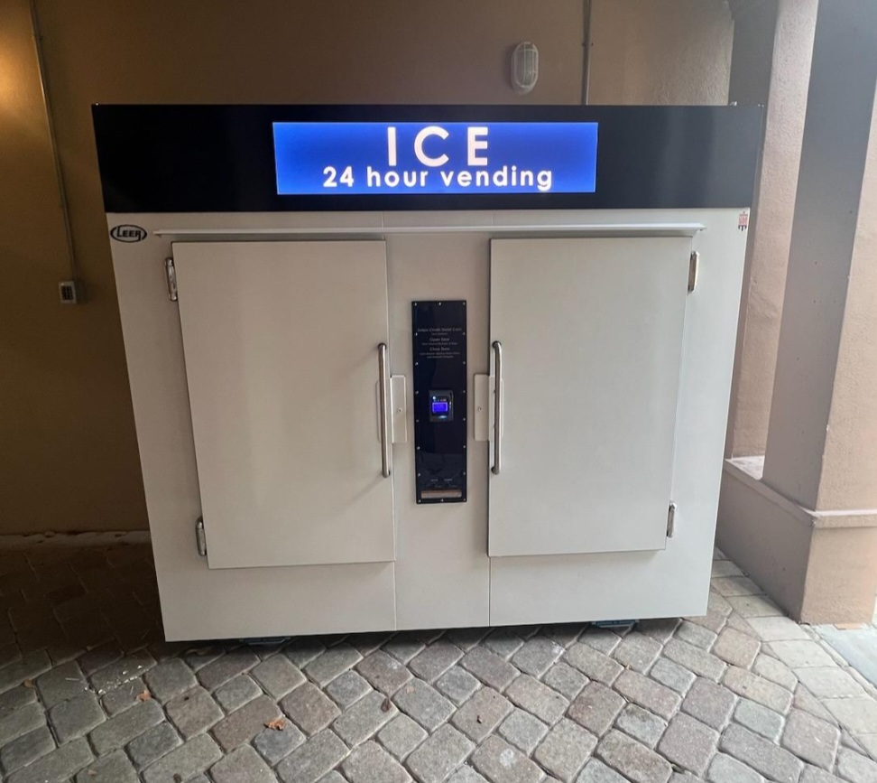

We now have an Ice vending machine located at the Southside Spa entrance. A 7-pound bag is $4.70 including tax. The machine accepts credit or debit cards. The master association earns a small share of each bag.

If you remember the paver path here was a big dip in the ground with uneven pavers. The ground was raised, and we now have a nice walkway between tennis courts.
We have new sod at the Northeast entrance, the island at the front of the property and over by the St. Lucia garage entrance. The palms on the property have been pruned.

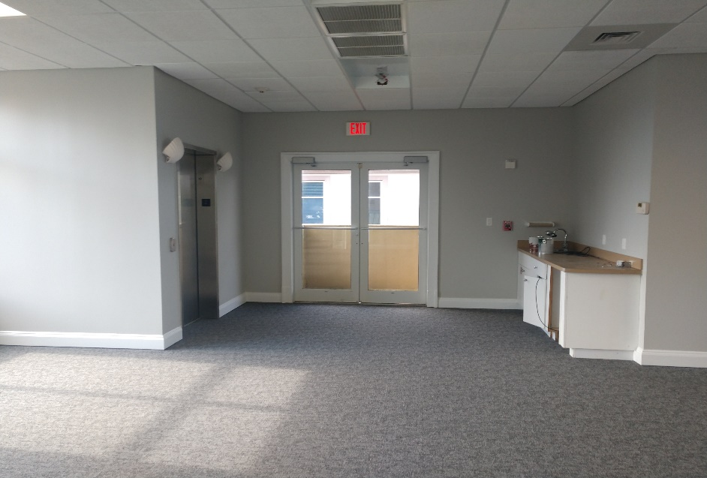
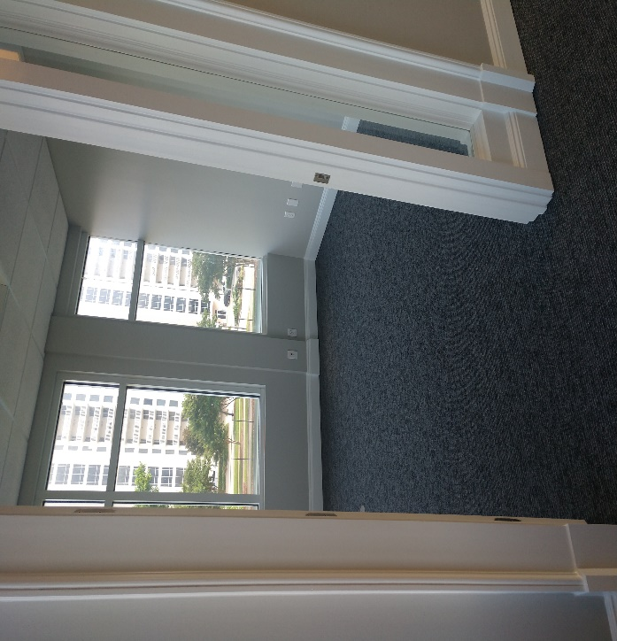
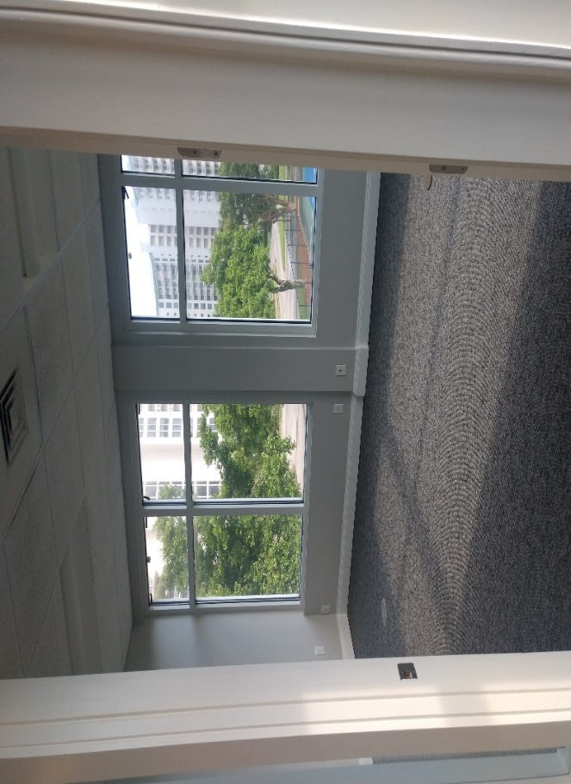
The upstairs of the Cardio Center has been cleaned out. It is freshly painted and has new carpet throughout; blinds will be added. The Master association intends to lease this space as a commercial office to increase club revenue to the association.

The Sandbar has been hopping this summer, especially on band nights. It is really a great place to enjoy music, food, and beverages while taking in the beautiful views of the Gulf and beach.
Try out the brand-new margarita machine!

Pool/Beach monitors are checking for wristbands multiple times a day and are escorting trespassers off our beach daily.
As always, for your benefit, wristbands are required to be worn or on your person by Guests and Owners at the Indoor/Outdoor and Lagoon Pool, Fitness Center, Basketball and Tennis Courts, and Beach. In your bag or at your table are not acceptable.
We appreciate your cooperation!
It is helpful enforcing rules with guests when homeowners lead the way and set the example—thank you for doing so! If you do not have the new 2023 red and white wristbands, please ask your building manager or maintenance supervisor for the new ones.

Clubhouse
The code 9234* is to access the weight room, you now gain access to the cardio room with your key fob/card. As a reminder, the weight and cardio center do not open until 6am and closes at 9 pm. The indoor/outdoor pool opens at 9am and closes at dusk. Wristbands are required to enter Clubhouse for owners and guests. The door to the weight center is on the south side of the building by the basketball court. The door to the cardio room is on the north side facing the main building.
We will do our best to keep you updated on the progress.
Have fun while you’re here!
Sincerely,
Eric Anderson, SSPOA, St. Barth, St. Croix and Owner's Club Manager
Josh Lee, SSPOA Director of Operations
Candace Coughlin, SSPOA Assistant General Manager

A message from your Master Association Board President:
Have a great Silver Shells summer vacation…every day here is better than the next one!

