February 2024, Newsletter

Silver Shells Homeowners!
We hope that the New Year has been good to you.
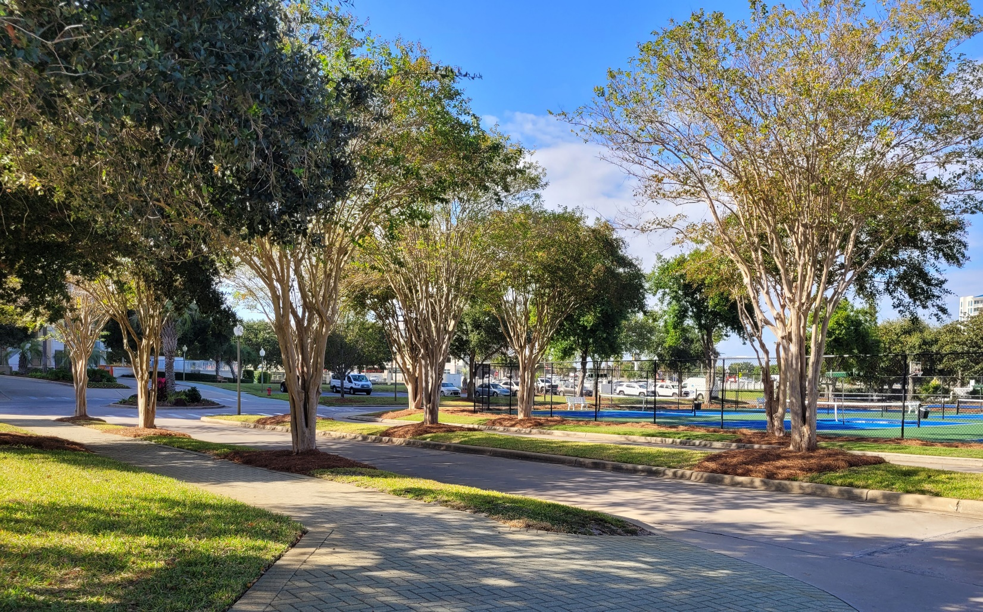

The Lagoon Pool resurfacing project began on January 4th. The schedule is to be complete by February 7th, weather permitting We did loose a number of workdays in January for rain and cold.

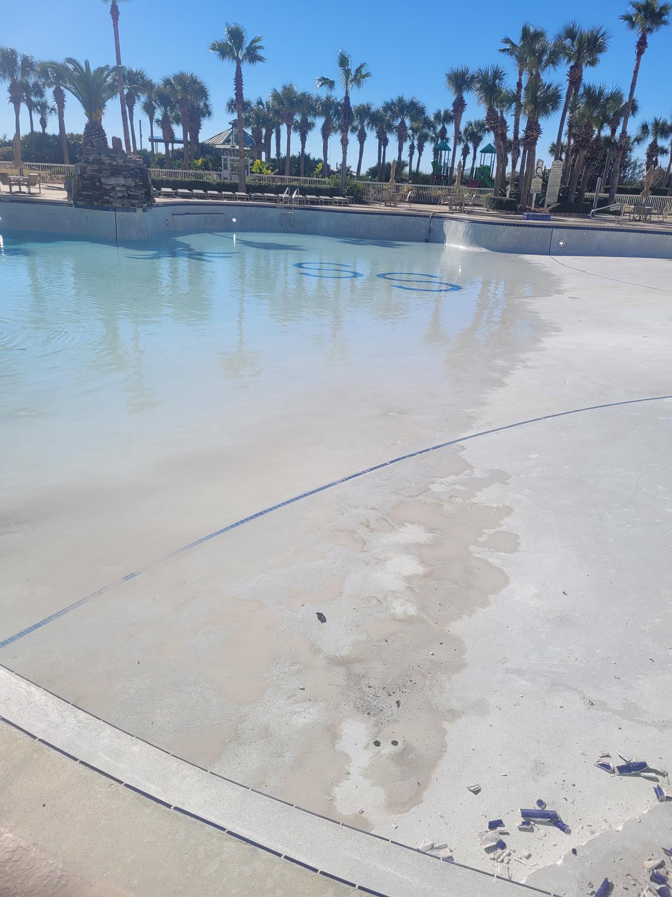

It took 5 days to drain our 218,000 gallon Lagoon Pool.

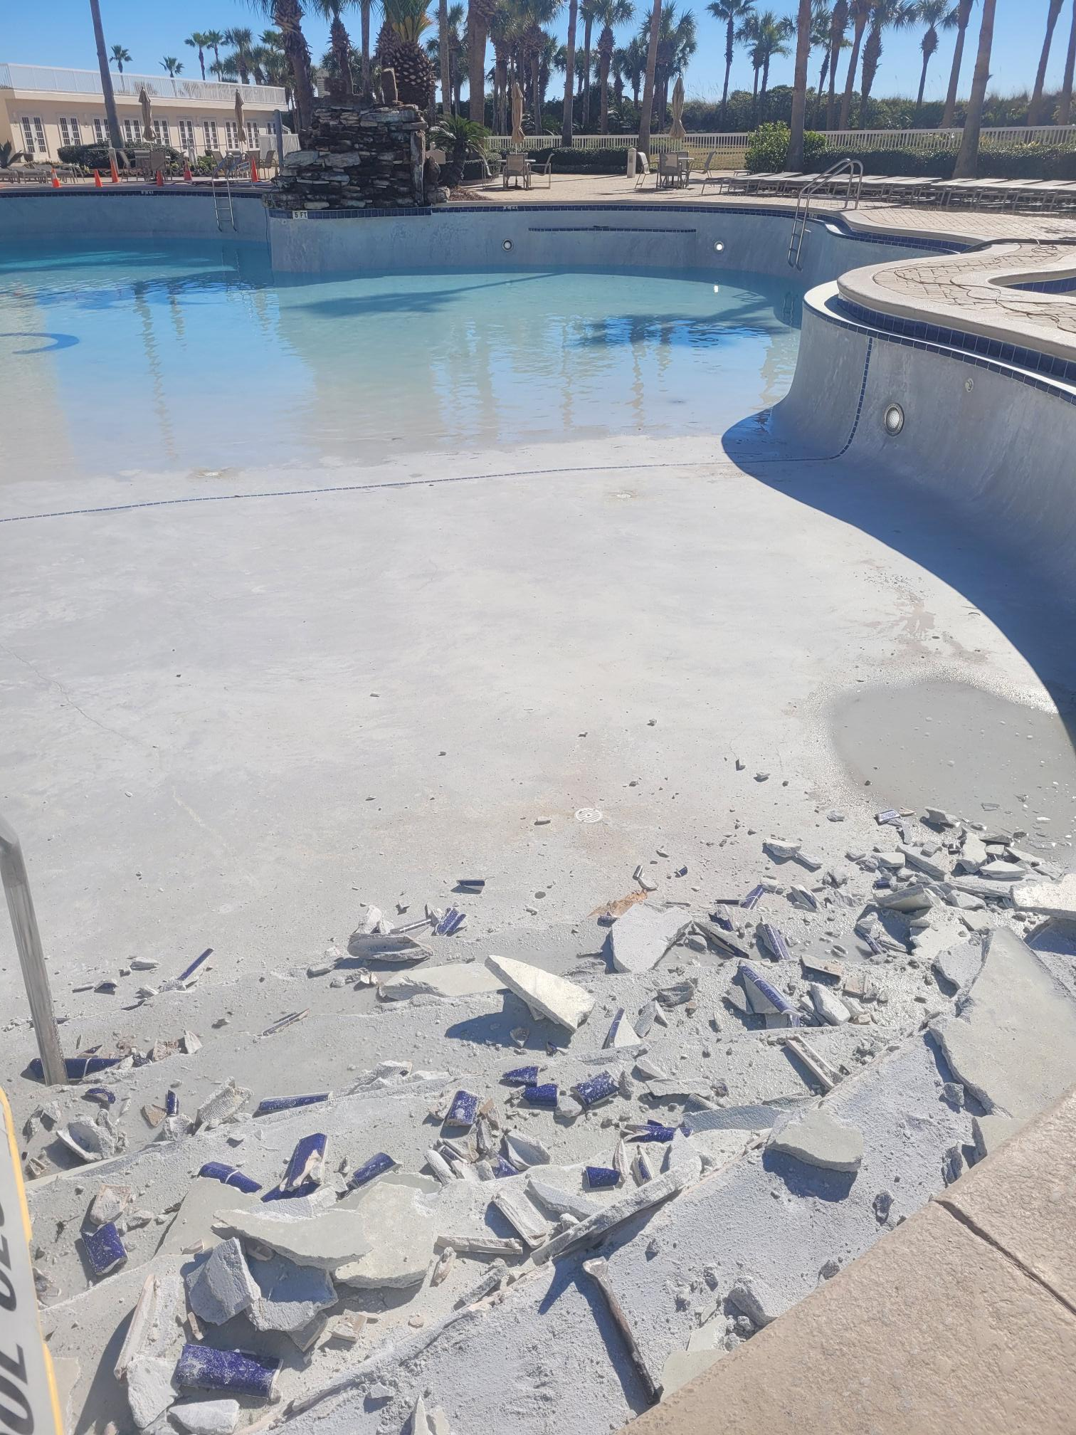

All the delaminated plaster had to be removed.
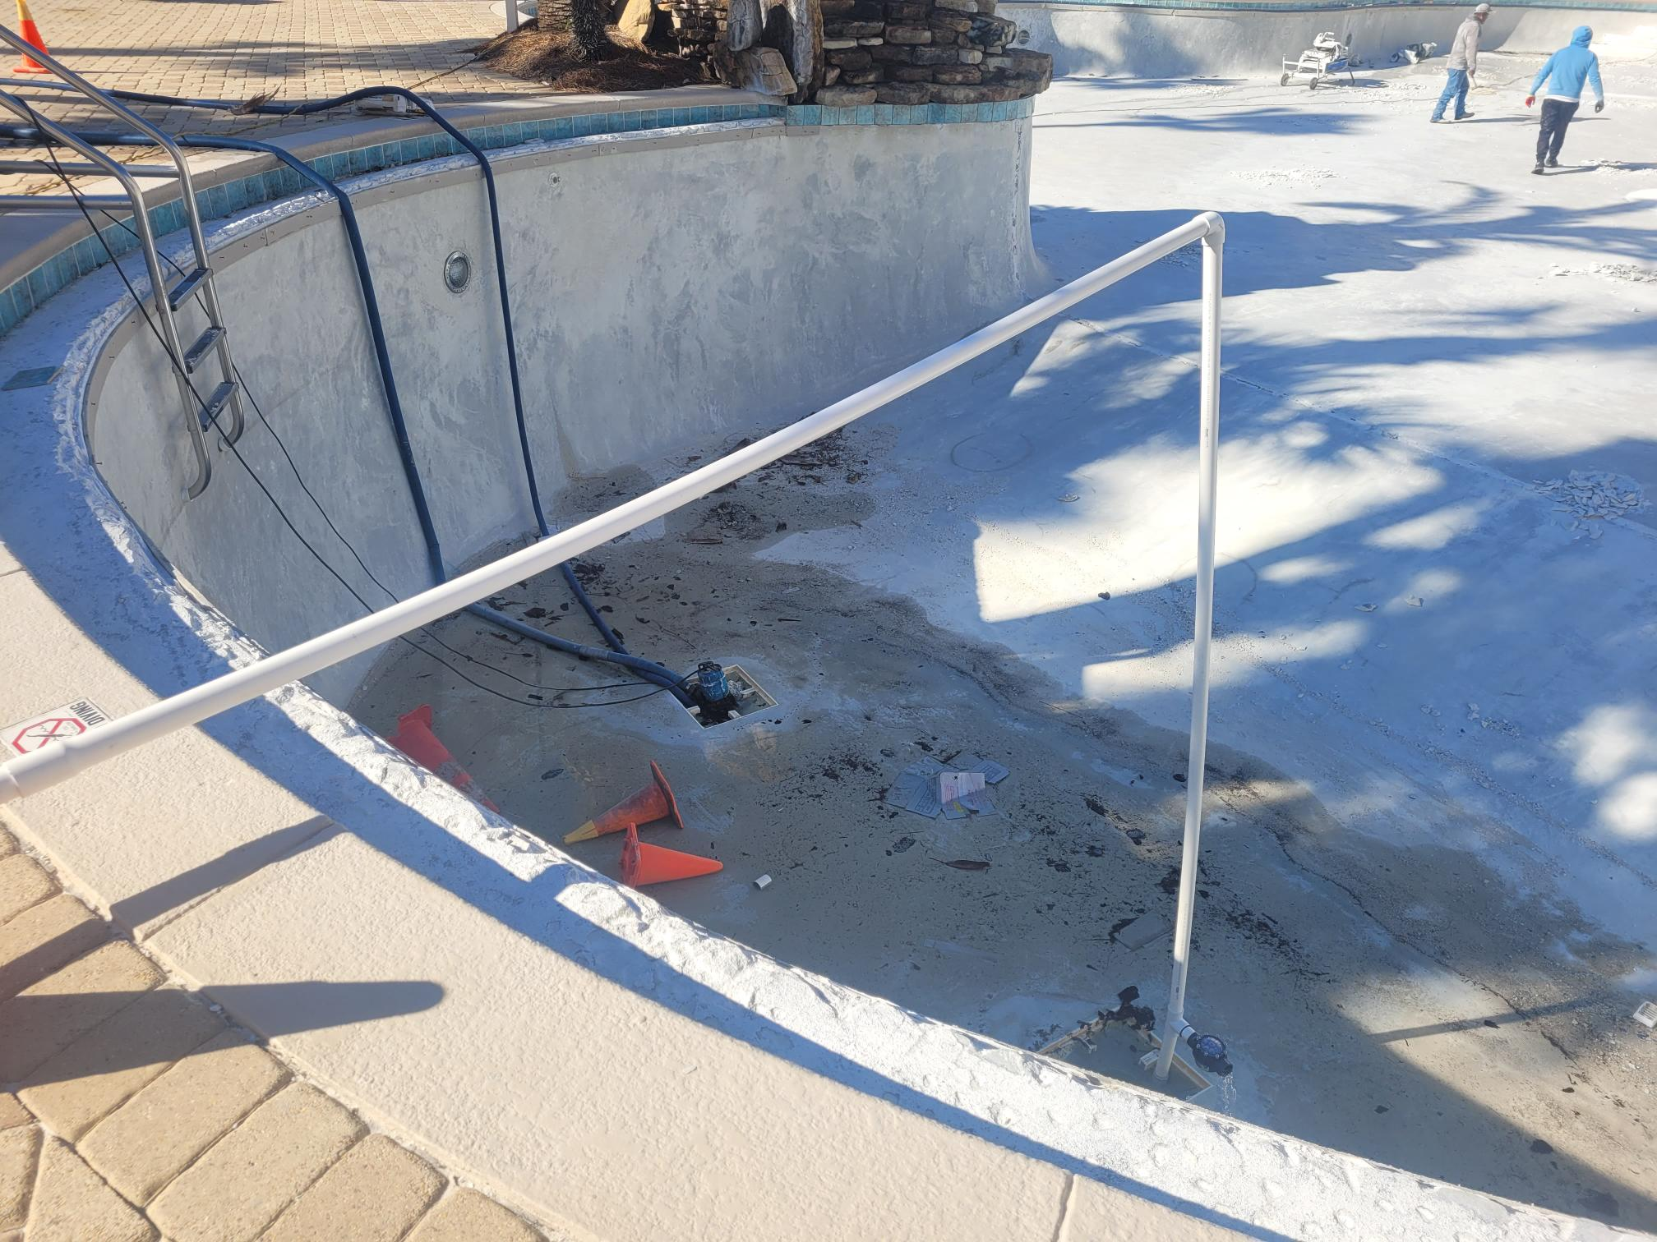
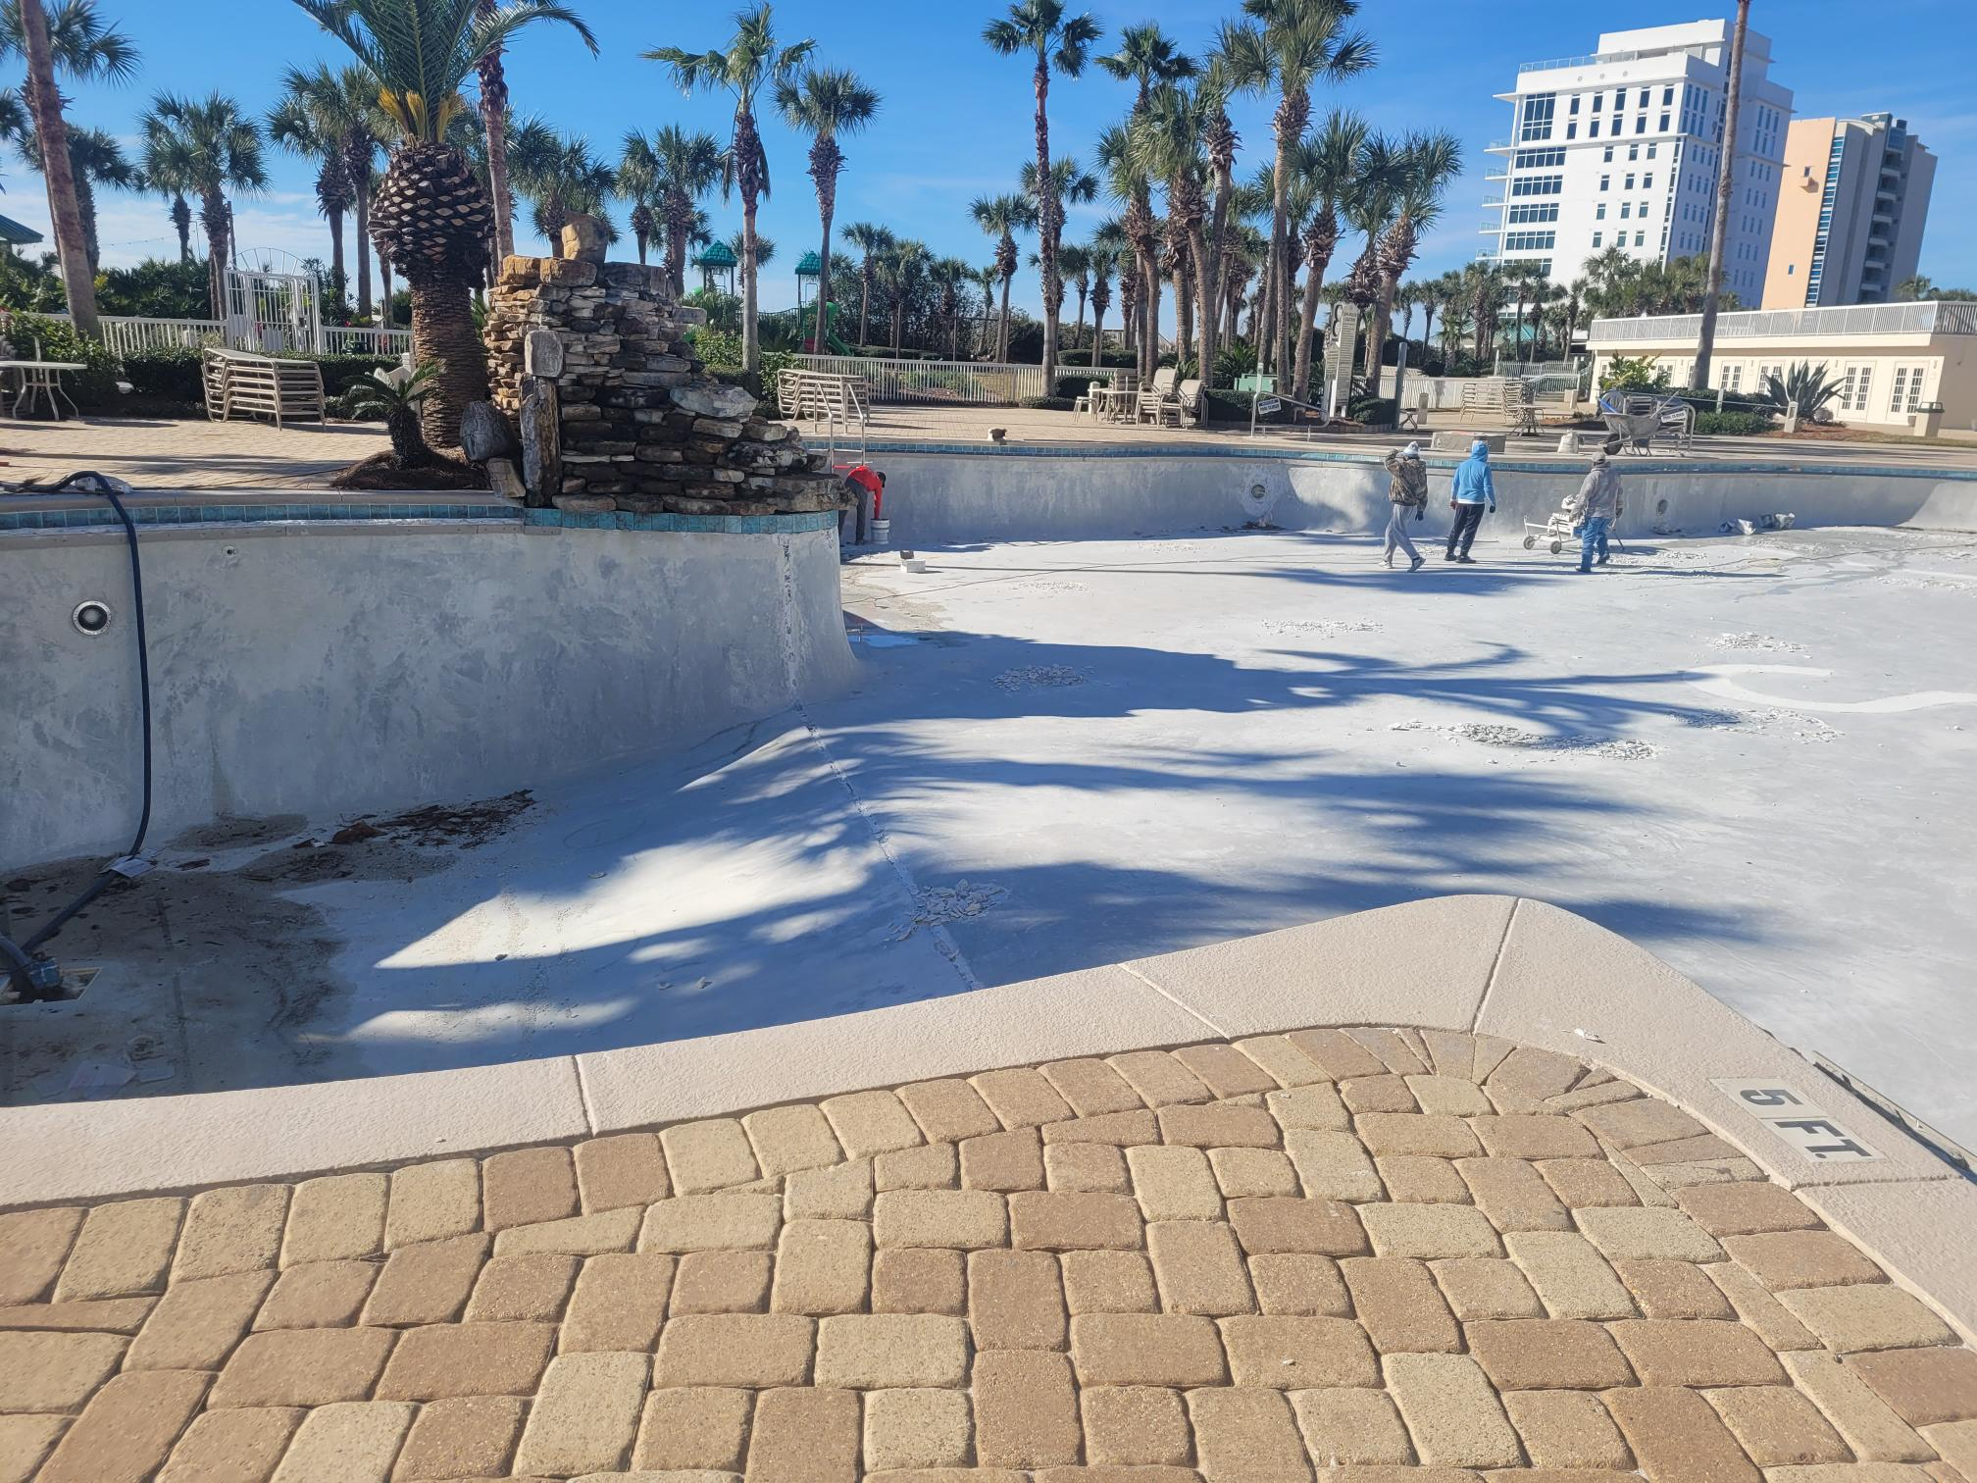

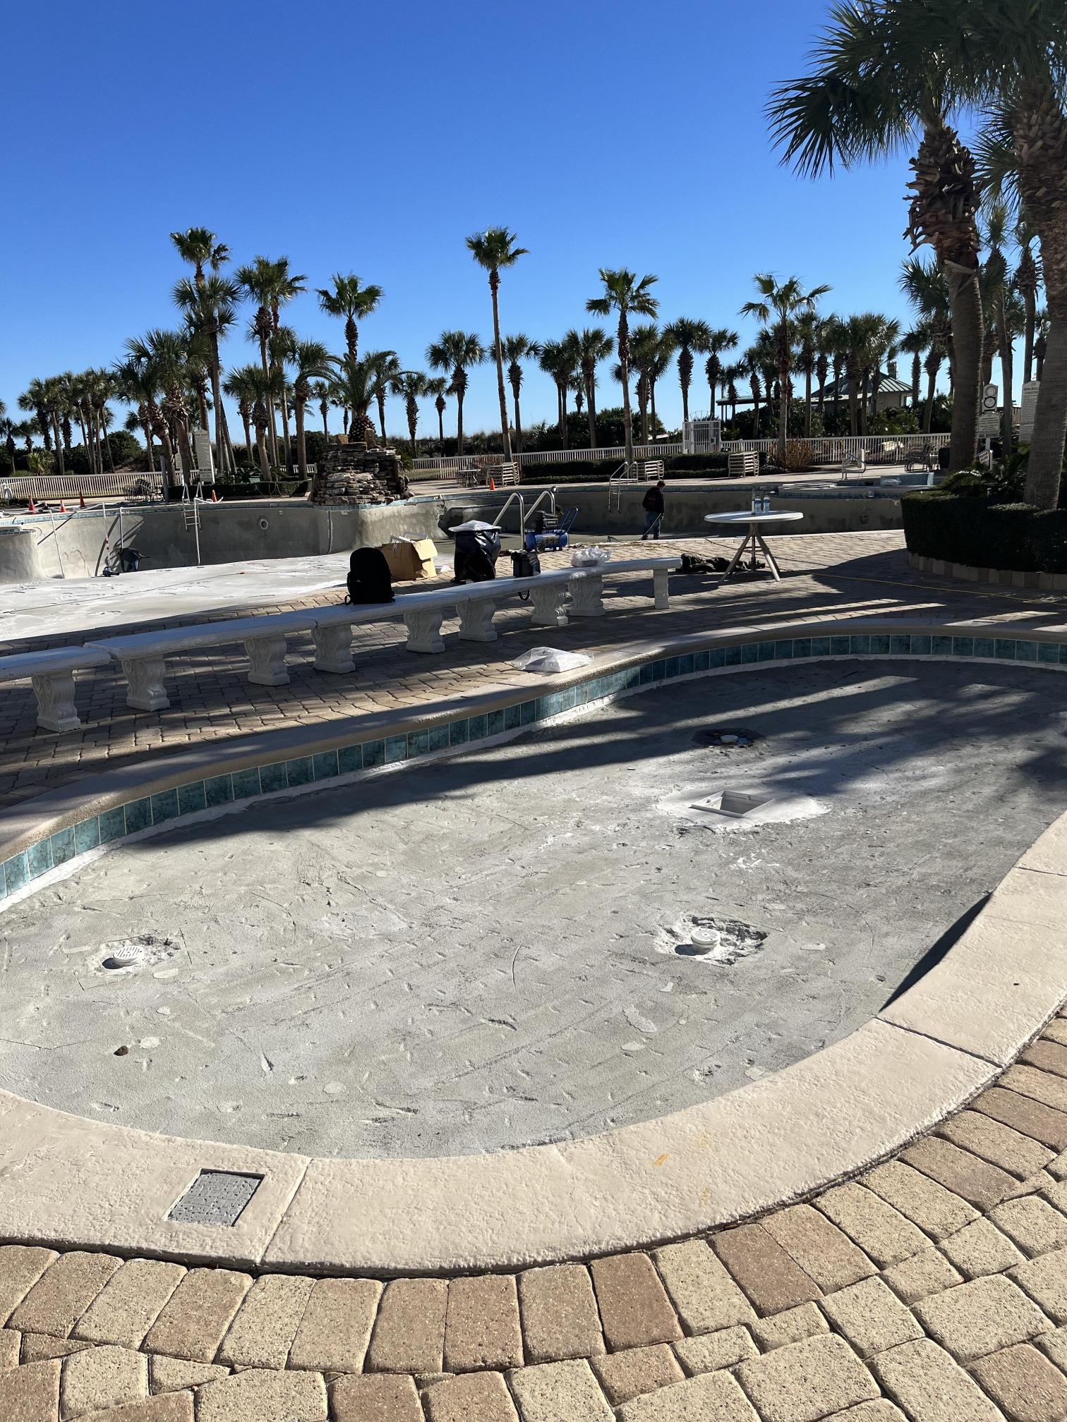

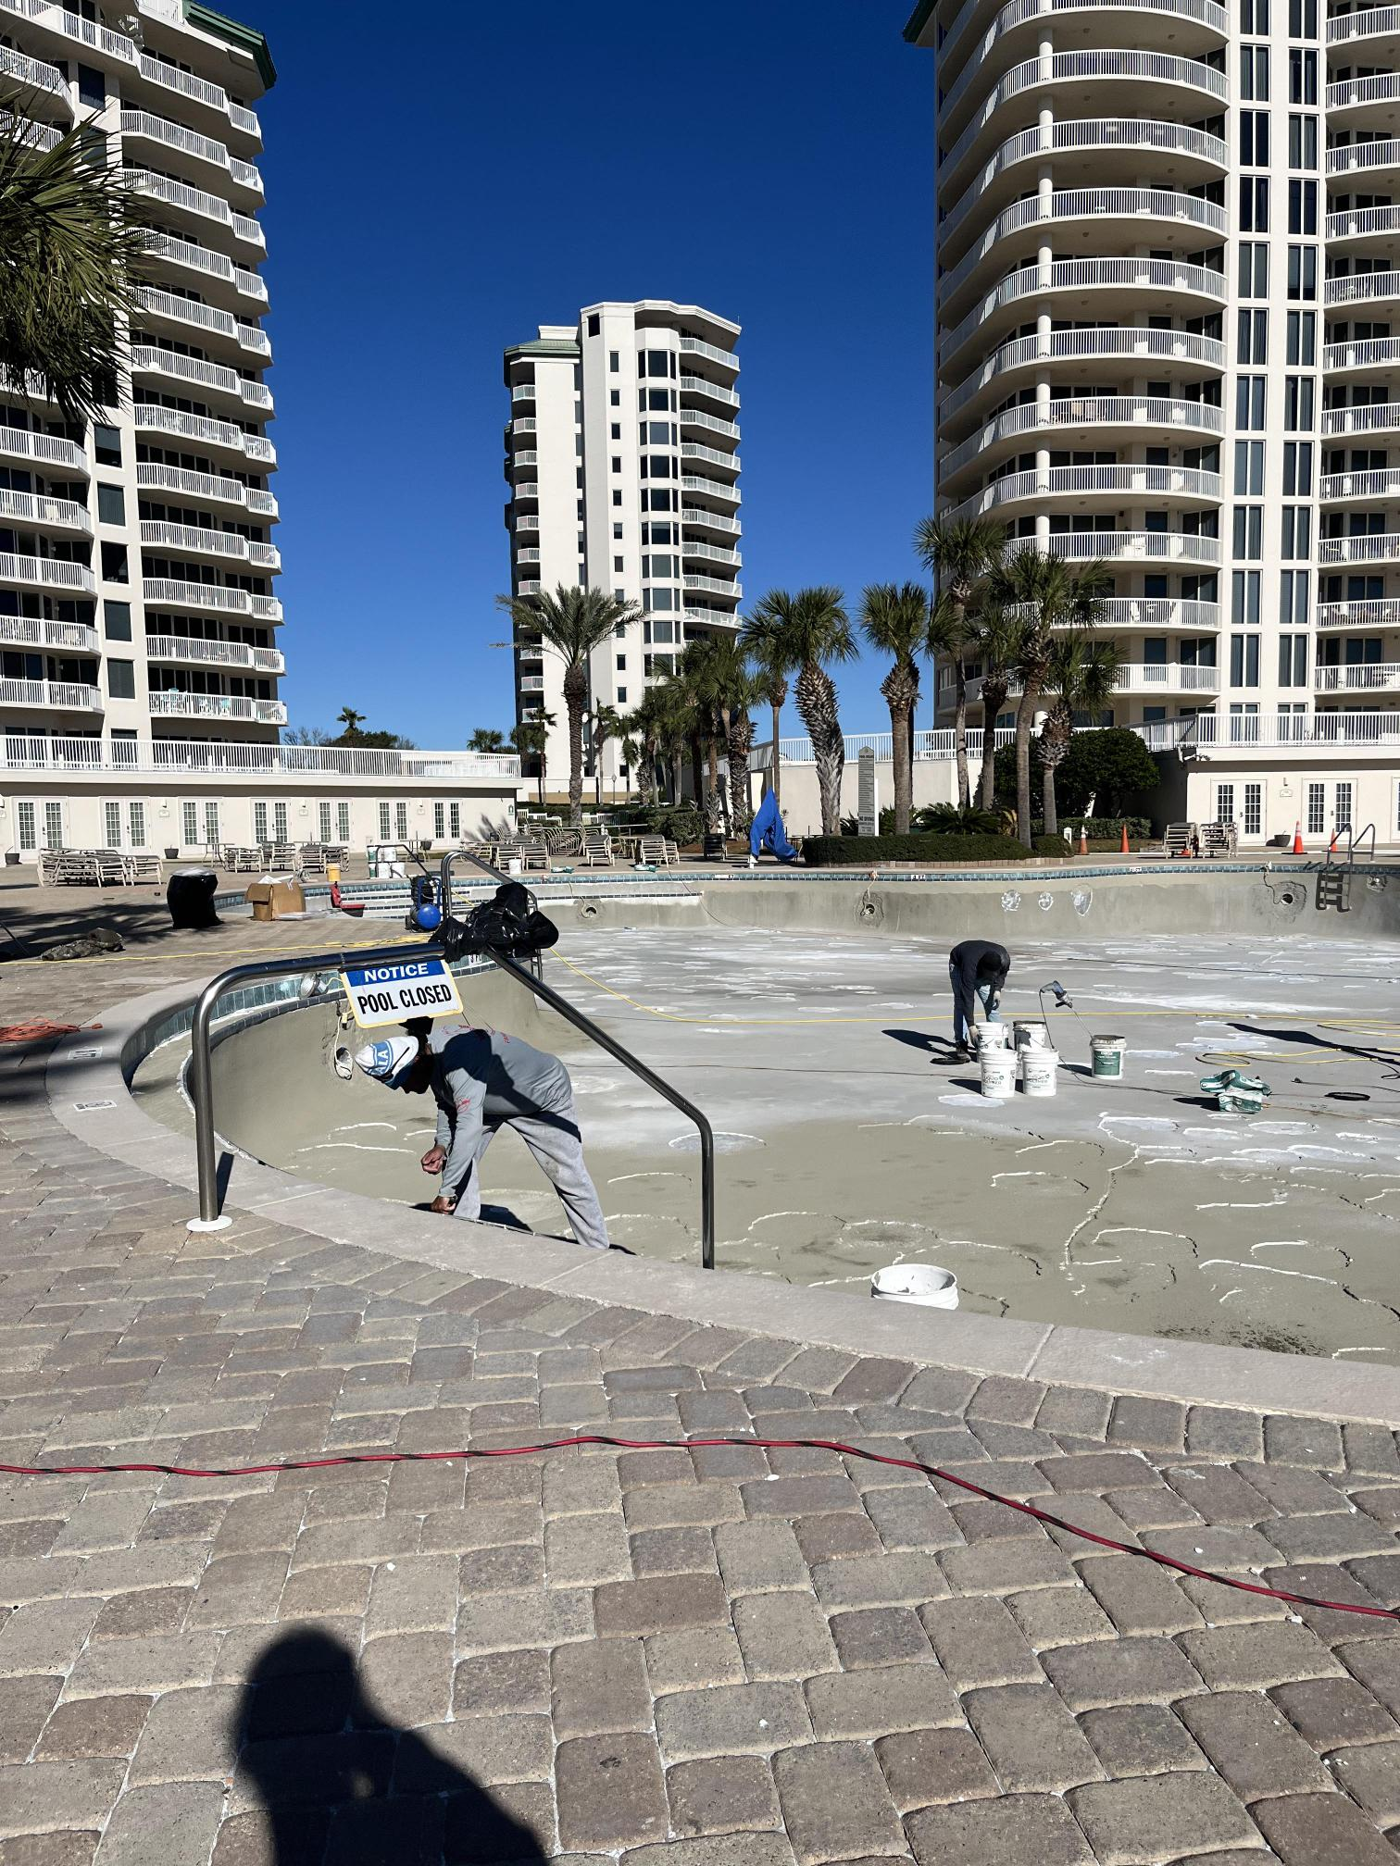

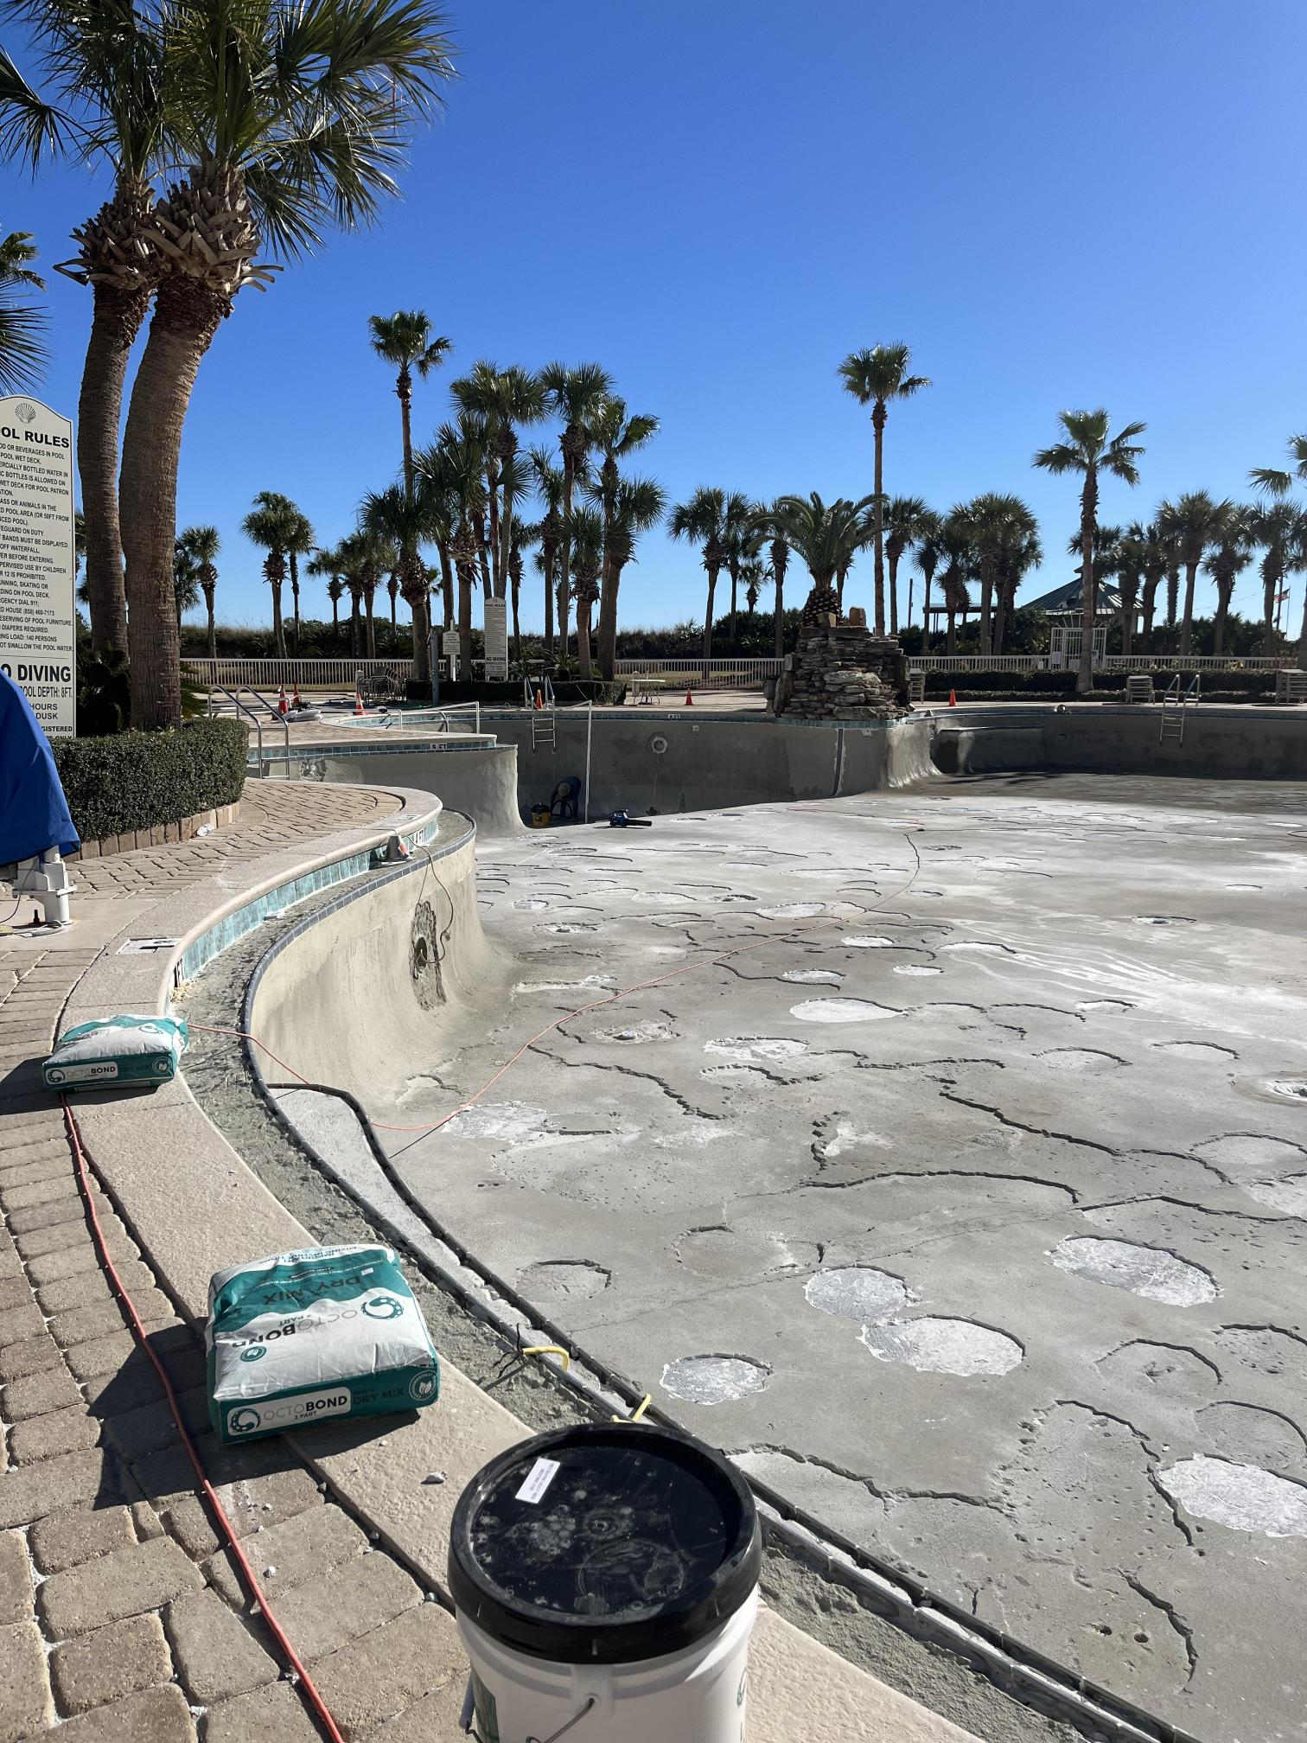

The Hot Tub

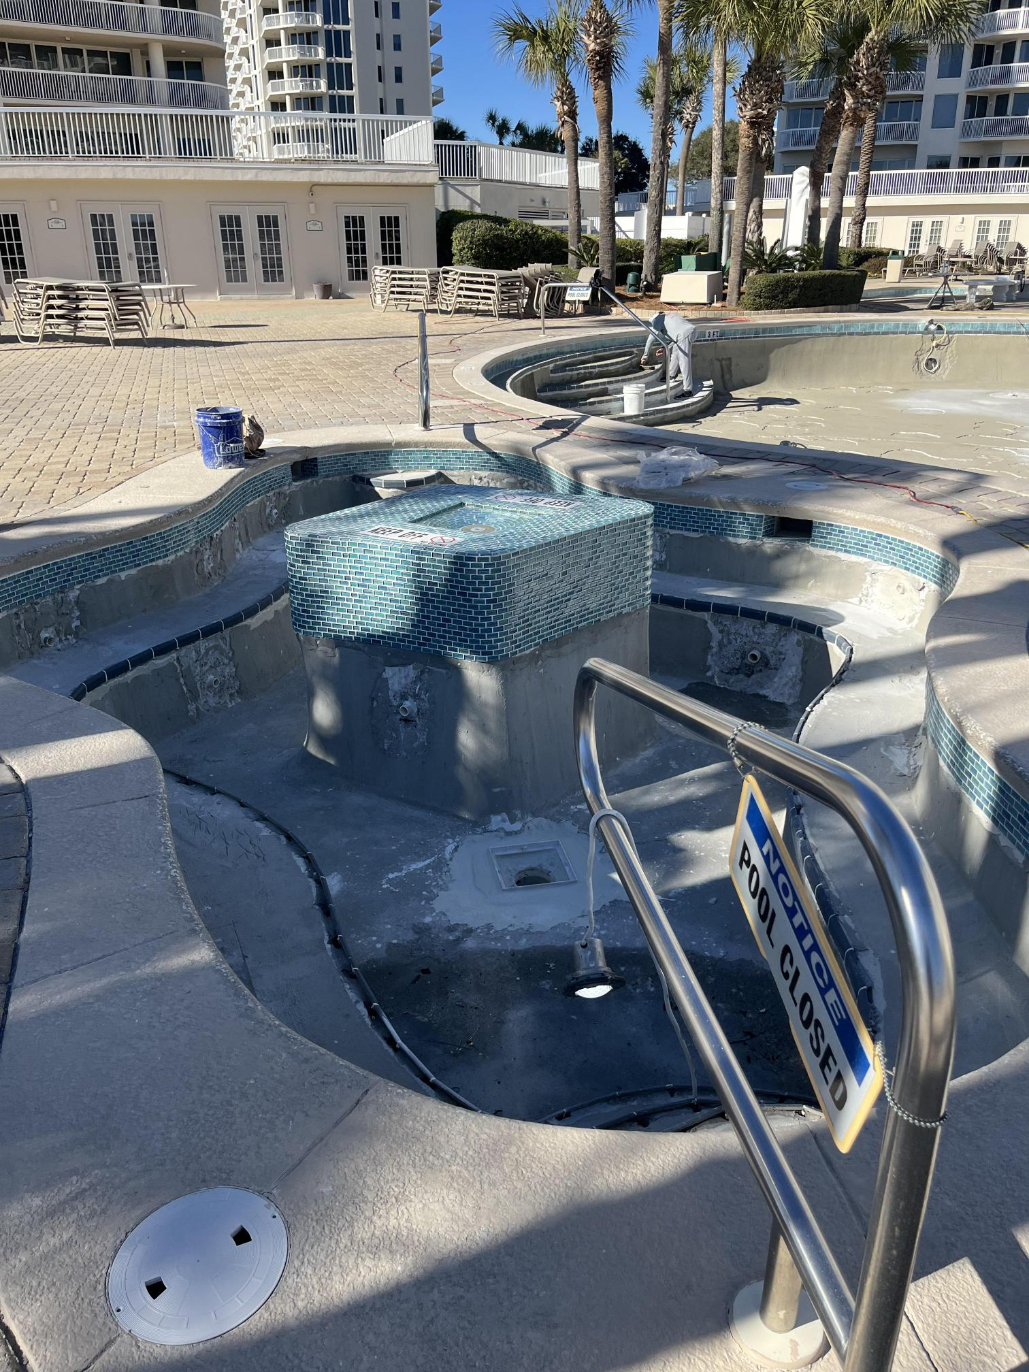

All new pool lights are being installed.

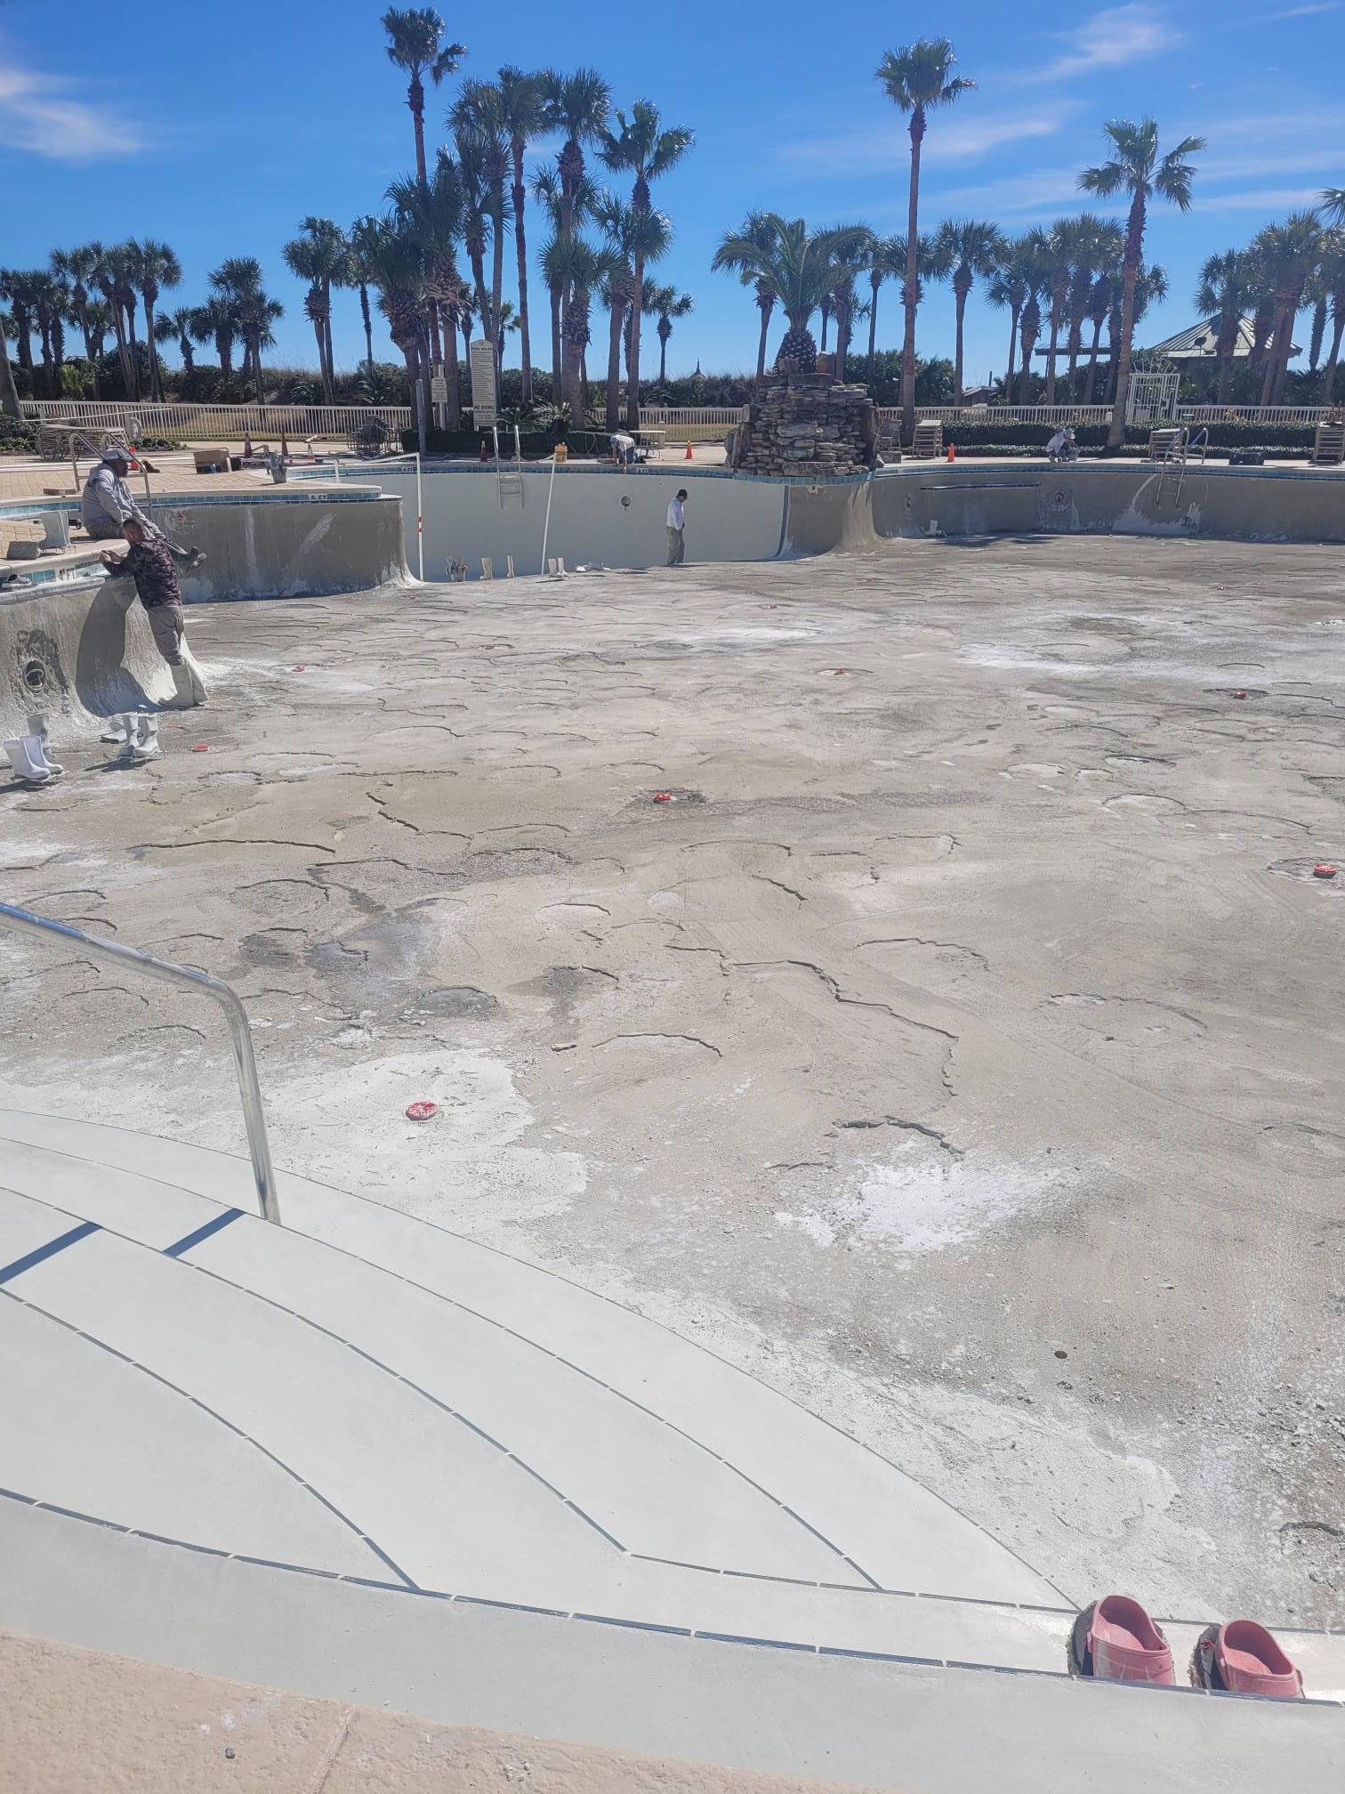

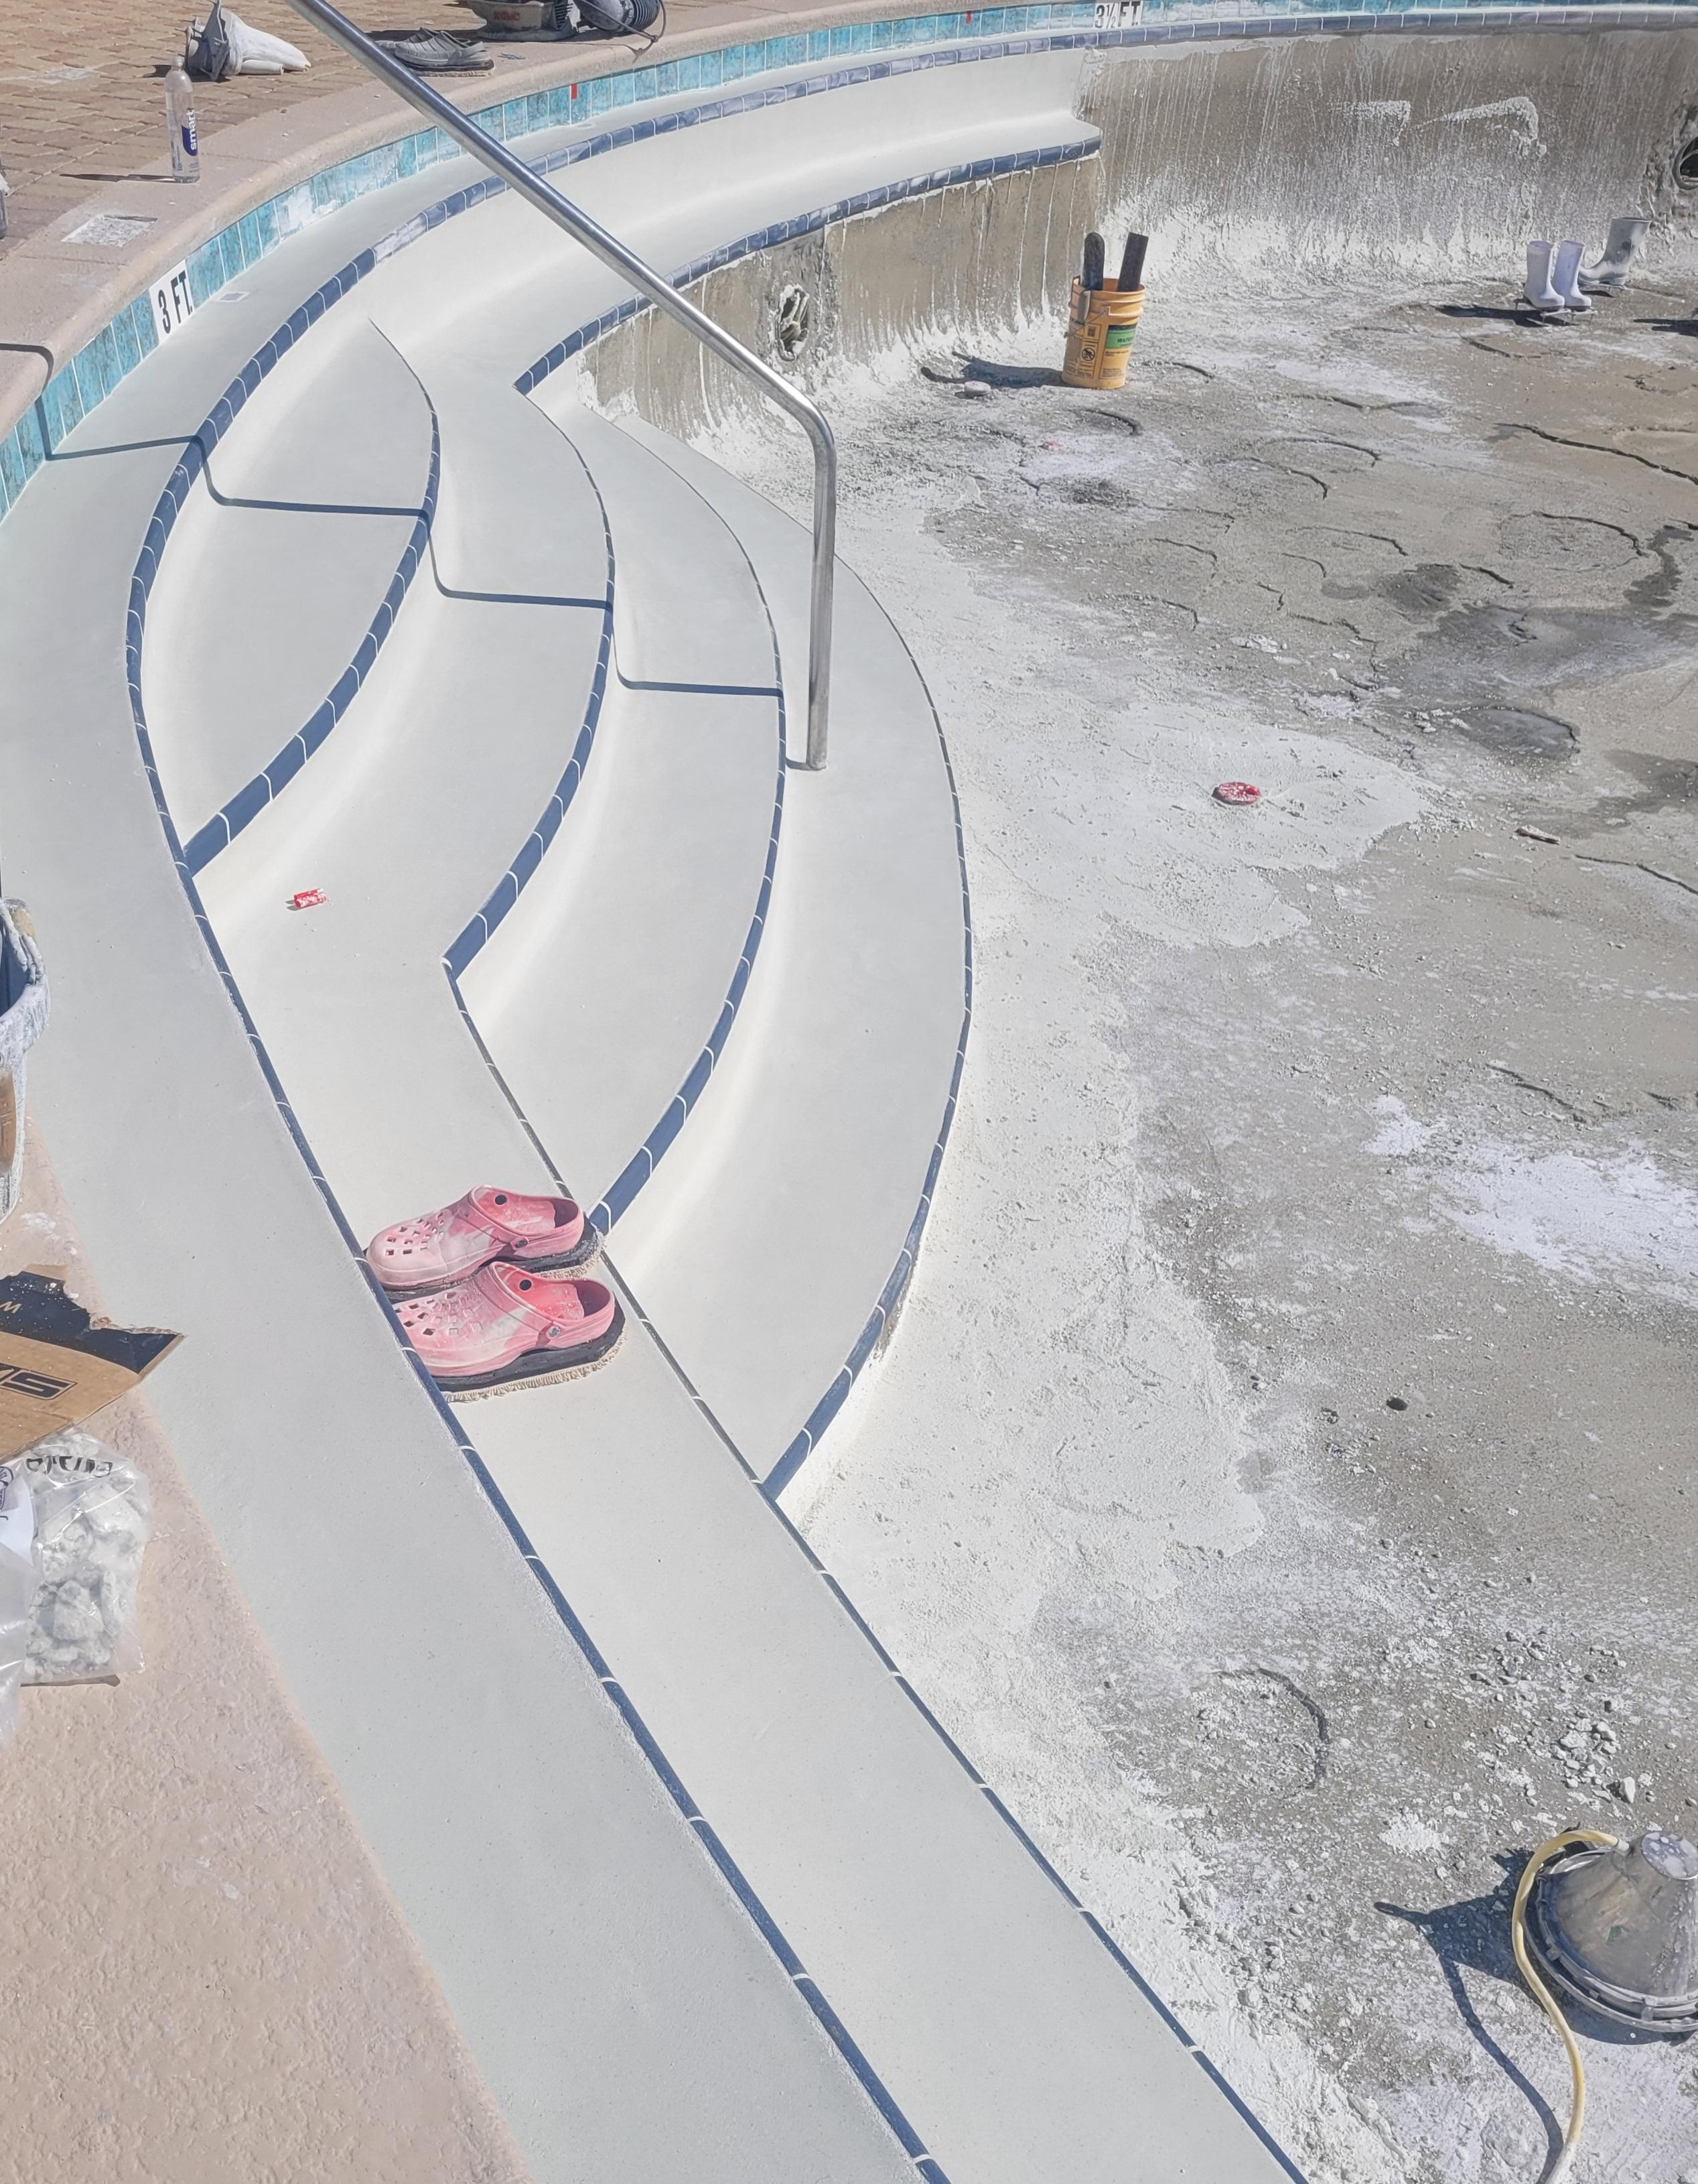
New waterline and bullnose tile has been put down.

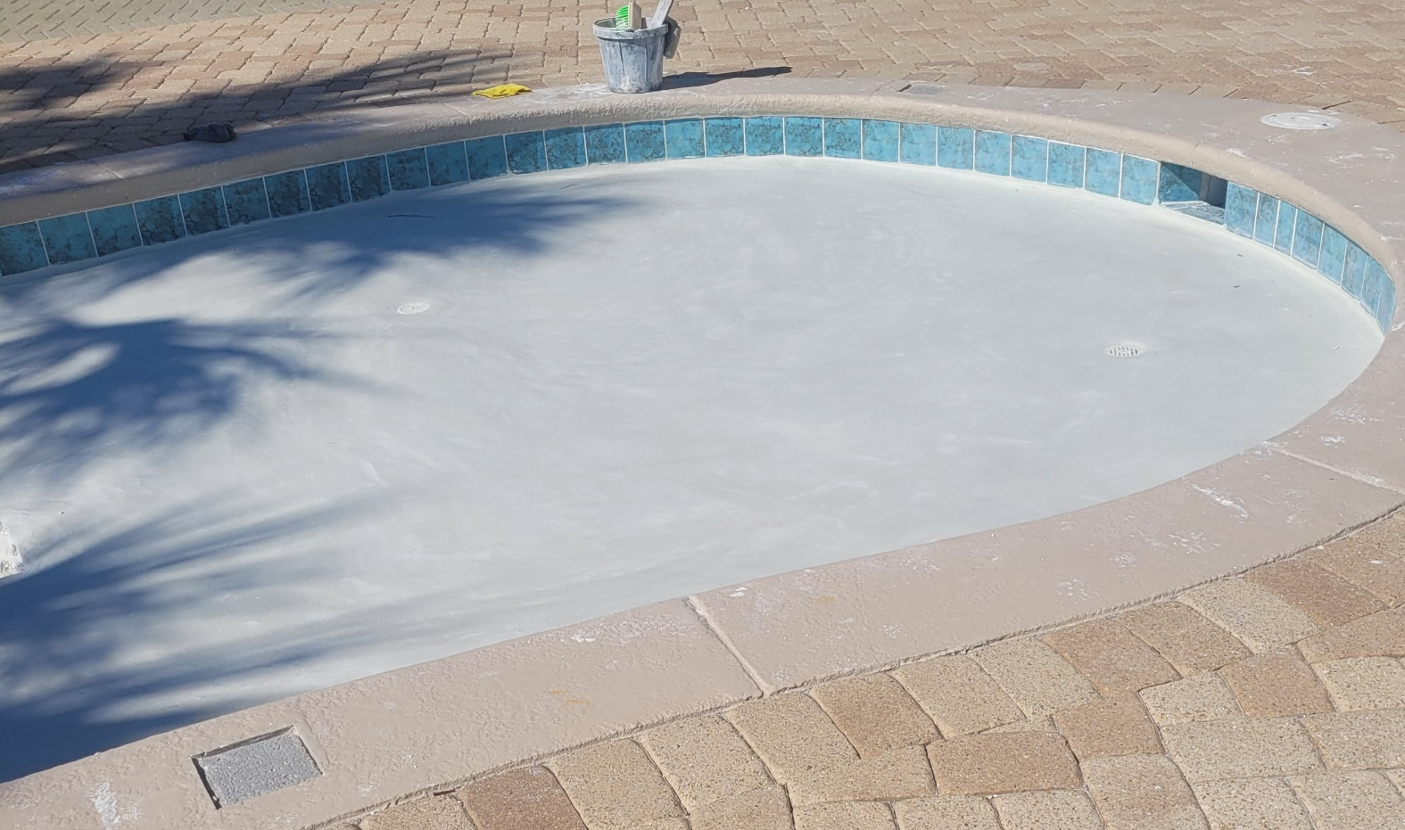
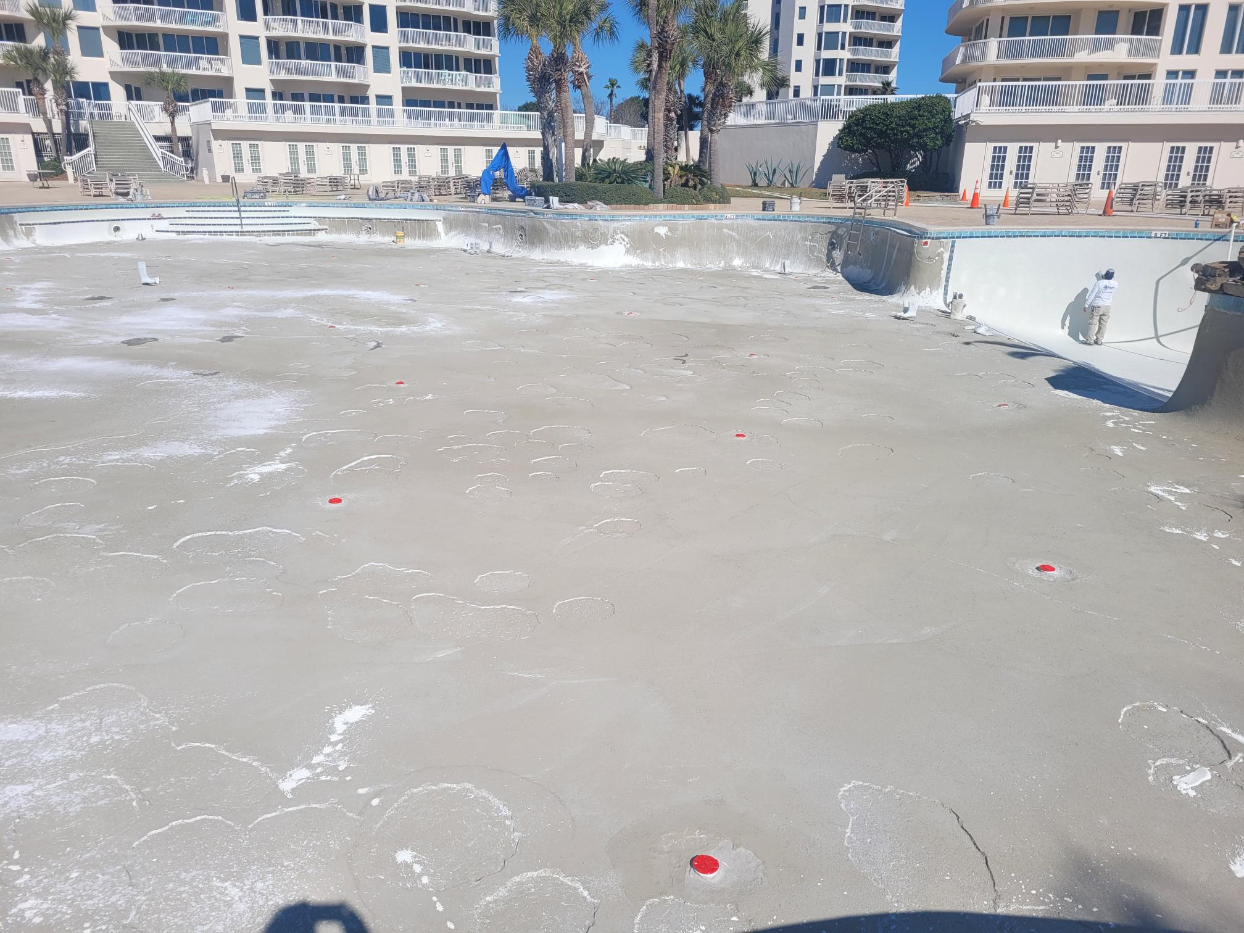

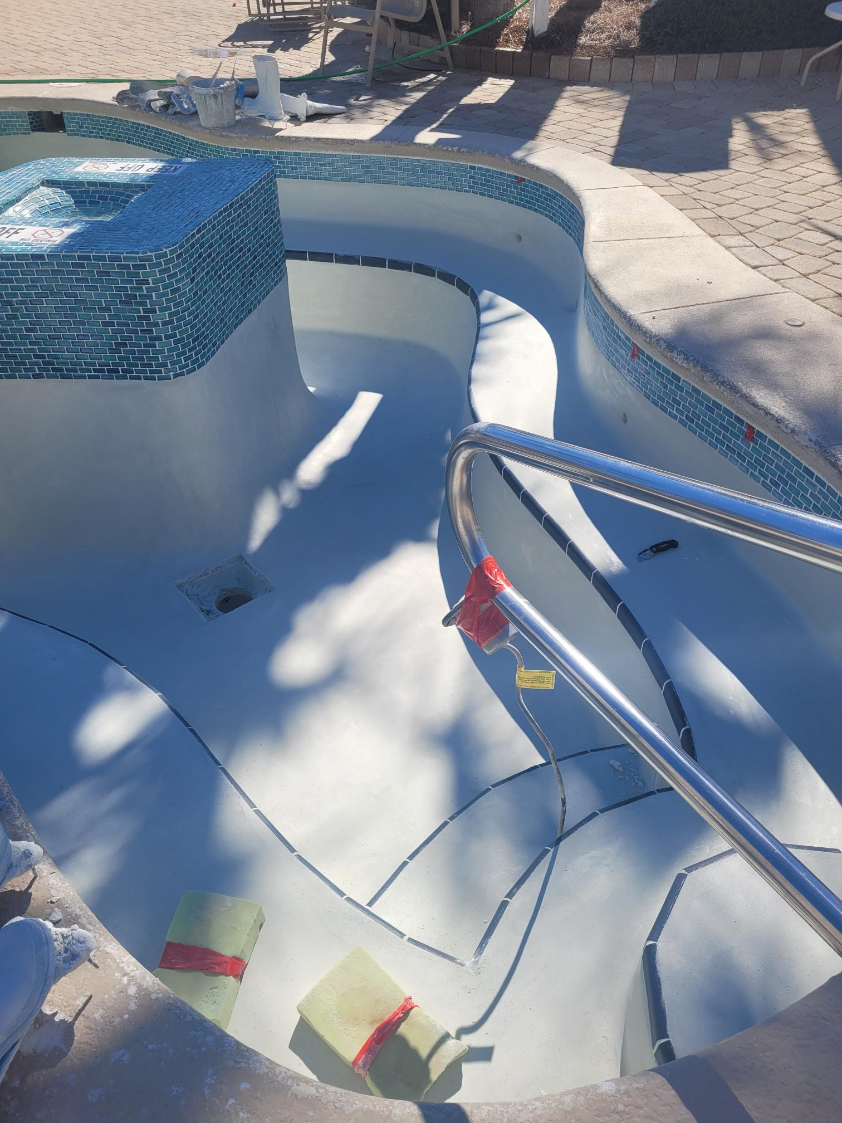
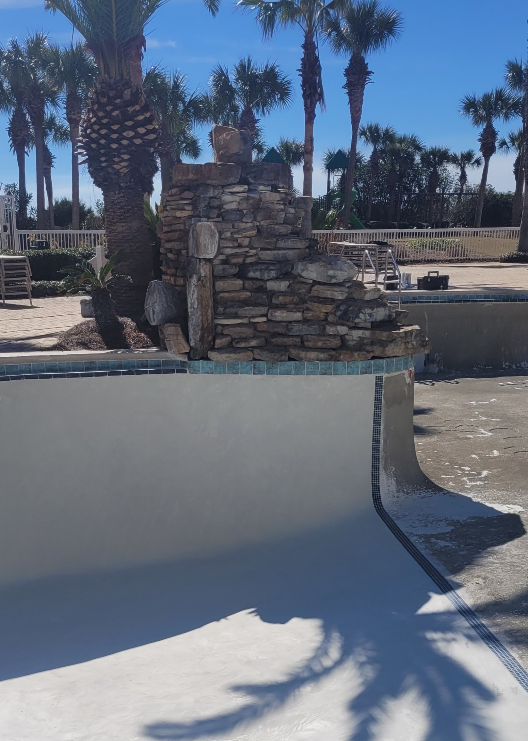

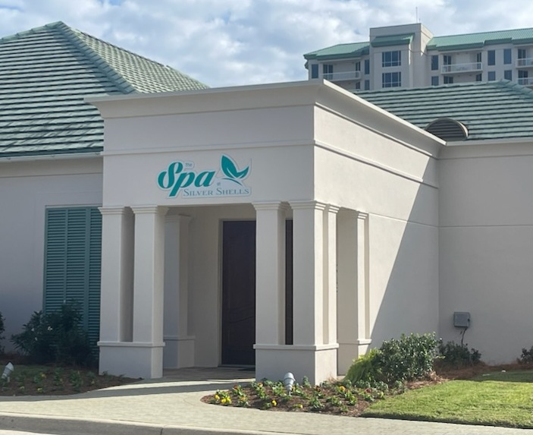
The Spa is open! Darlene Miller is the new owner—she is offering Silver Shells Homeowners exclusive discounts. Jessica Jones is the new spa director, call 850-337-5107 to find out more.

***********************************************************************************************

If you have not registered on the Silver Shells Master Association website, please do. You will find valuable information, documents, news and events. We will continue to add content relevant to your condominium ownership…like financials!
https://silvershellsofdestin.com

Silver Shells Master Association Staff
Josh Lee Candace Coughlin
Director of Operations Assistant General Manager
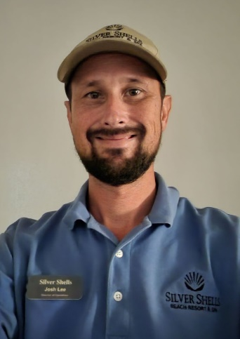

Maintenance Staff
Matt Goff Eric Price Herbert Baker
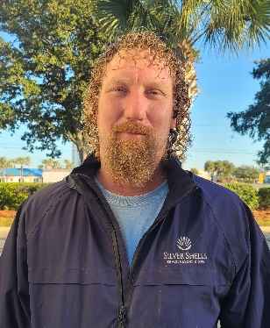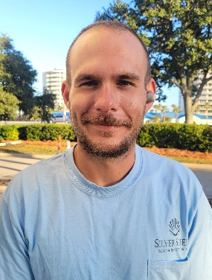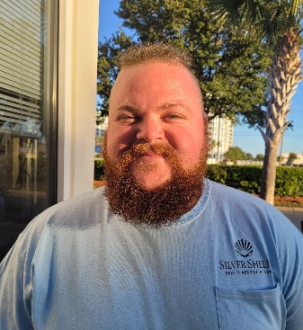

Courtesy Patrol Staff
Brandon Rushton Robert Swafford Clifford Bridgewater Terry salazar
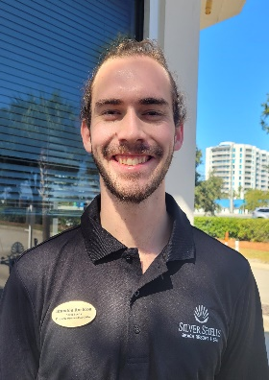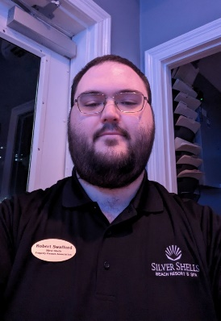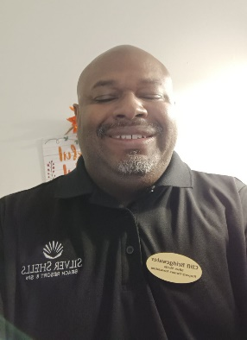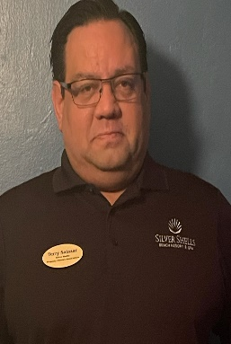

Calvin Rivera Trevor Batson
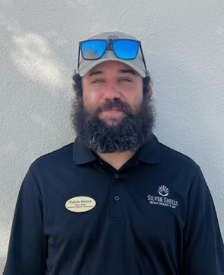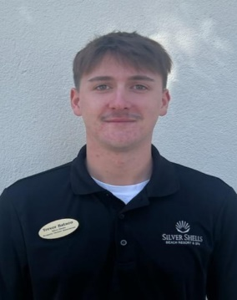

The Sandbar will open early March.
Please get with your building management for your new
2024 Silver Shells Wristbands

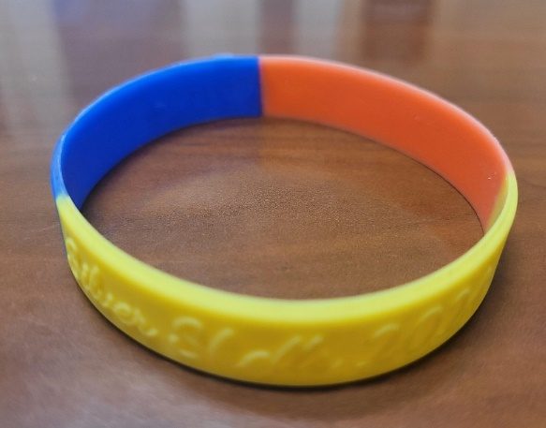

As always, for your benefit, wristbands are required to be worn or visibly on your person by Guests and Owners at the Sandbar, Indoor/Outdoor and Lagoon Pools, Cardio & Fitness Centers, Basketball. Pickleball, and Tennis Courts, and our Beach. Keep them visible; in your bag or at your table are not acceptable.
Please, please, please…help us keep people who do not belong here off the property by wearing your wristband. We do not know every owner by sight…even your Master board wears them!
We appreciate your cooperation!
It is helpful enforcing rules with guests when homeowners lead the way and set the best example—thank you for doing so!

Clubhouse
To gain access to the Fitness and Cardio rooms you must have your key fob/card and a wristband. As a reminder, the fitness and cardio rooms do not open until 6 am and closes at 9 pm. The indoor/outdoor pool opens at 9 am and closes at dusk. Wristbands are required to enter Clubhouse for owners and guests. The door to the weight center is on the south side of the building by the basketball court.
We will do our best to keep you updated on the progress.
Have fun while you are here!

Sincerely,
Eric Anderson, SSPOA, St. Barth, St. Croix and Silver Shells Owner's Club Manager
Josh Lee, SSPOA Director of Operations
Candace Coughlin, SSPOA Assistant General Manager

A message from your Master Association Board President:
Before we purchased the club last year, I estimated it would be a two-year project to repair, renovate, and upgrade the facilities and grounds. Last year we completed big projects. We are not done. We have more to do in 2024. And your feedback and ideas are flowing for us to consider. See you this Spring!

