March 2024, Newsletter
Silver Shells Homeowners,
Spring Break has arrived!
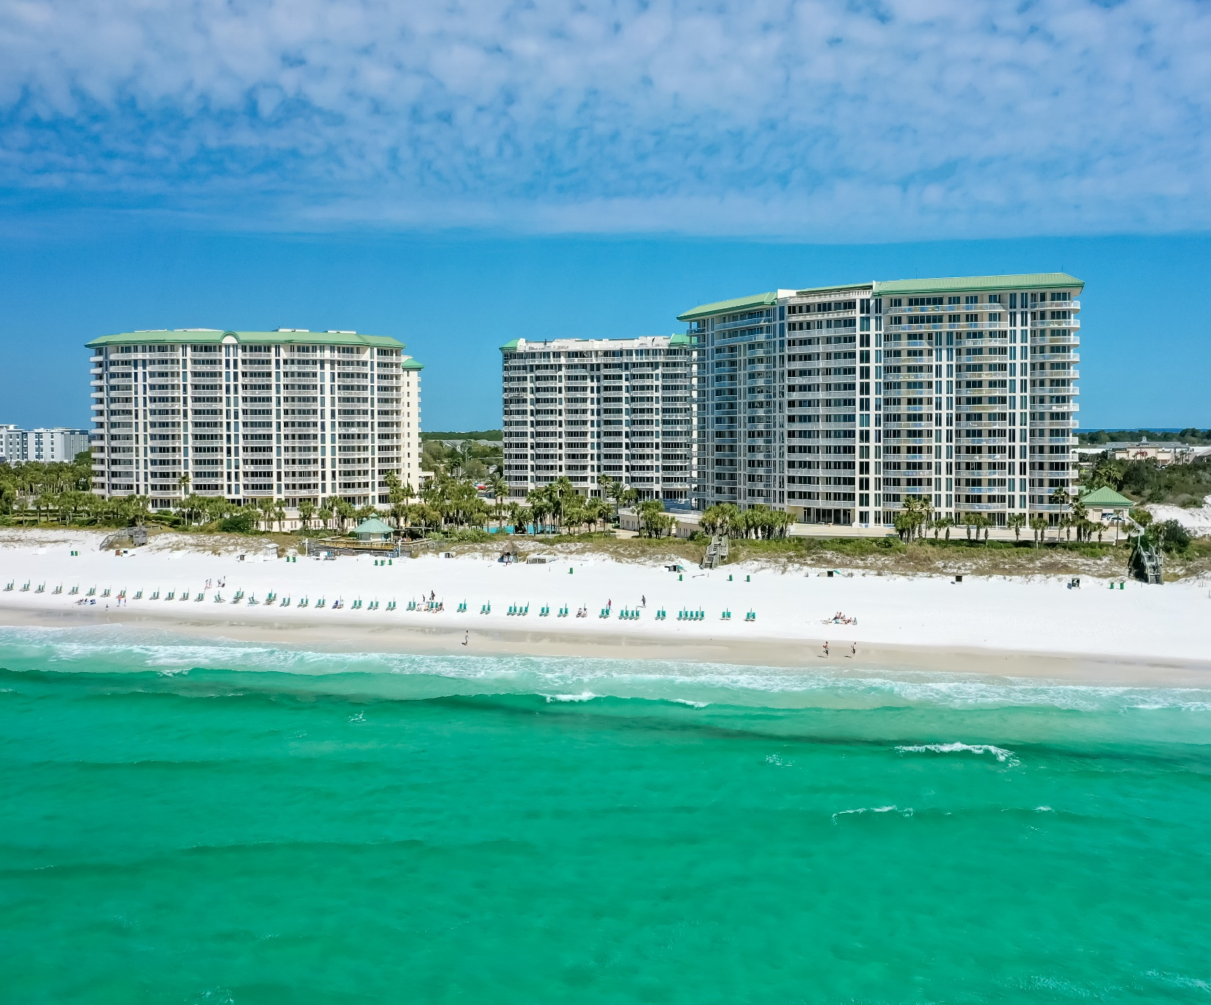

The Lagoon Pool Resurfacing project has been completed and is ready for Spring Break!

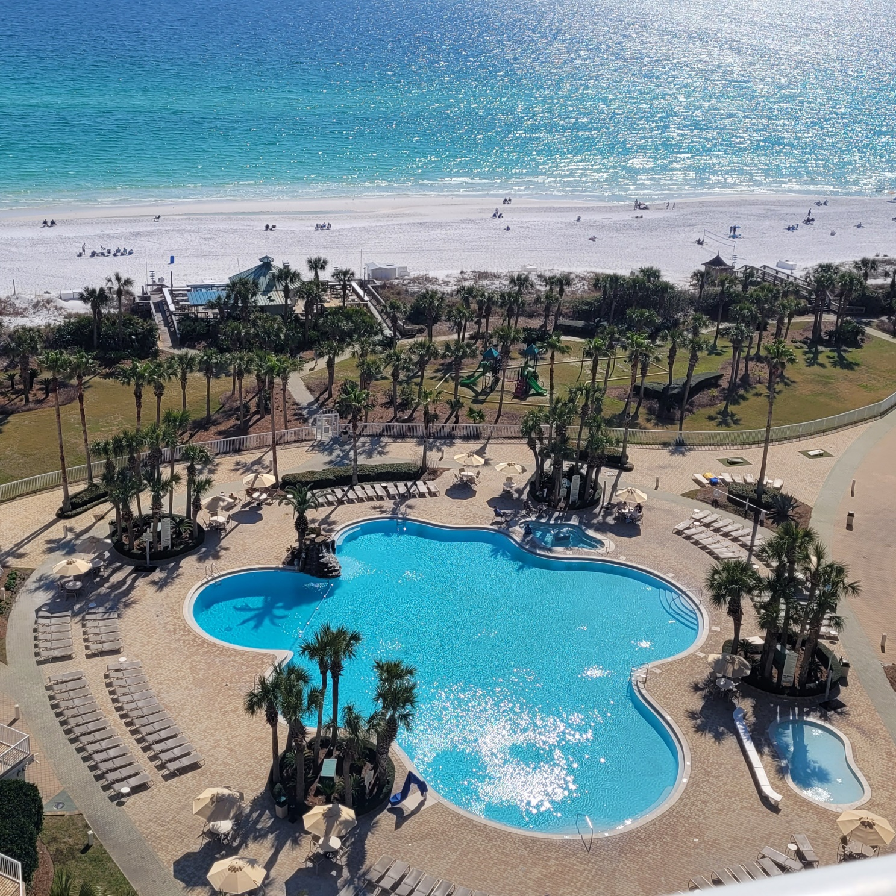

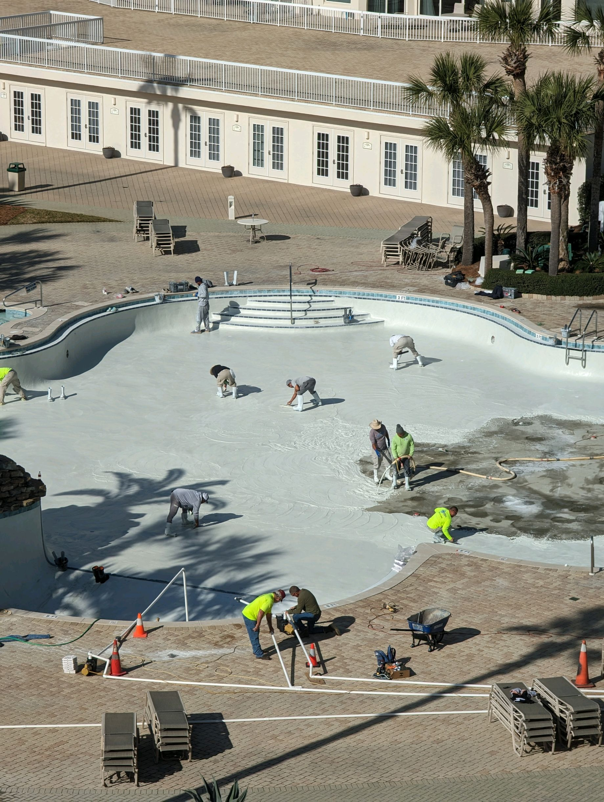
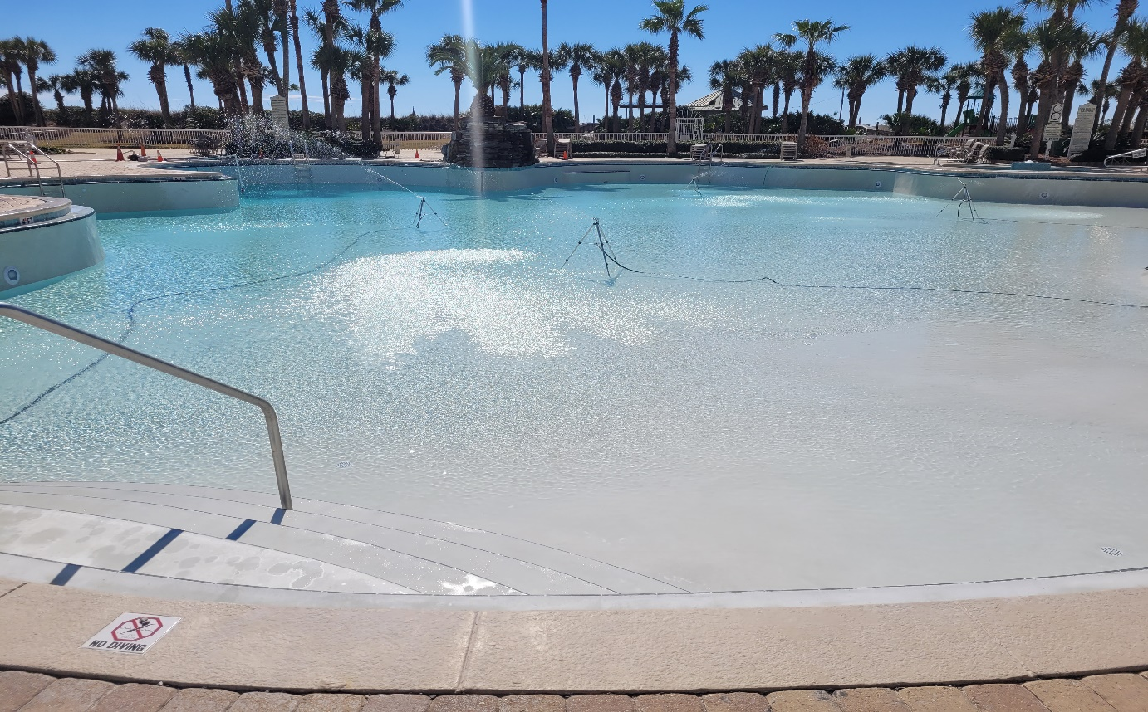
Filling the Lagoon Pool back up took about 3 days.

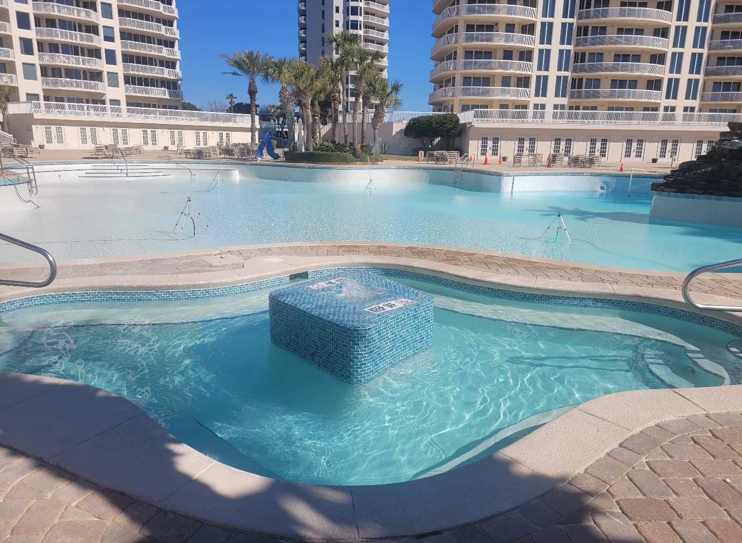

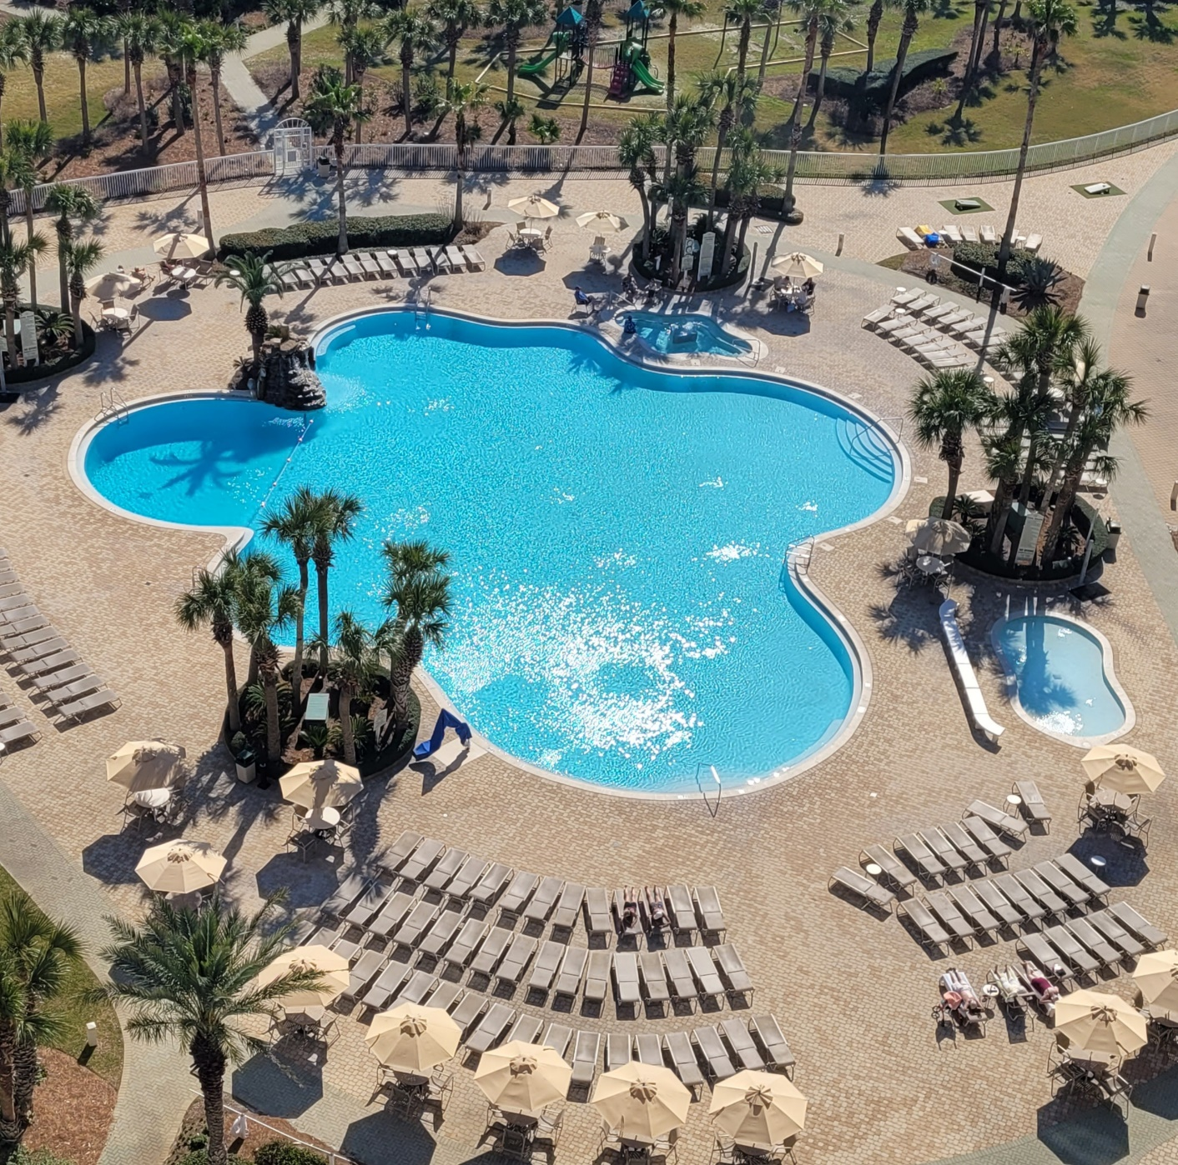

Please come out and enjoy!
The Lagoon Pool will be heated for Spring Break starting March 1st! The Sand Bar will have a soft opening March 1st and it will be completely open and running on March 10th.

Please get with your building management. If you have not received your new 2024 wristbands.
They will be required starting March 9th.

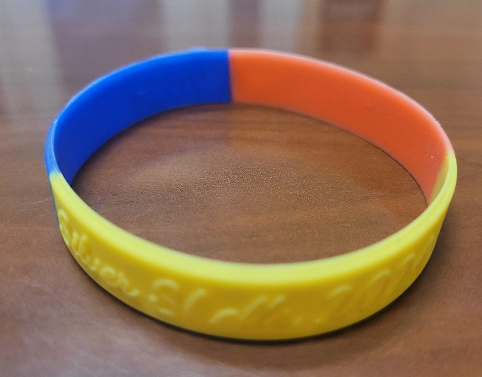

As always, for your benefit, wristbands are required to be worn or visibly on your person by Guests and Owners at the Indoor/Outdoor and Lagoon Pool, Fitness Center, Basketball. Pickleball and Tennis Courts, and our Beach. In your bag or at your table are not acceptable.

Please, please, please…help us keep people who do not belong here off the property by wearing your wristband. We do not know every owner by sight…even your Master board wears them!

We appreciate your cooperation!
It is helpful enforcing rules with guests when homeowners lead the way and set the best example—thank you for doing so!

Clubhouse
To gain access to the Weight and Cardio room you must have your key fob/card. As a reminder, the weight and cardio center does not open until 6 am and closes at 9 pm. The indoor/outdoor pool opens at 9 am and closes at dusk. Wristbands are required to enter Clubhouse for owners and guests. The door to the weight center is on the south side of the building by the basketball court.

The Spa at Silver Shells
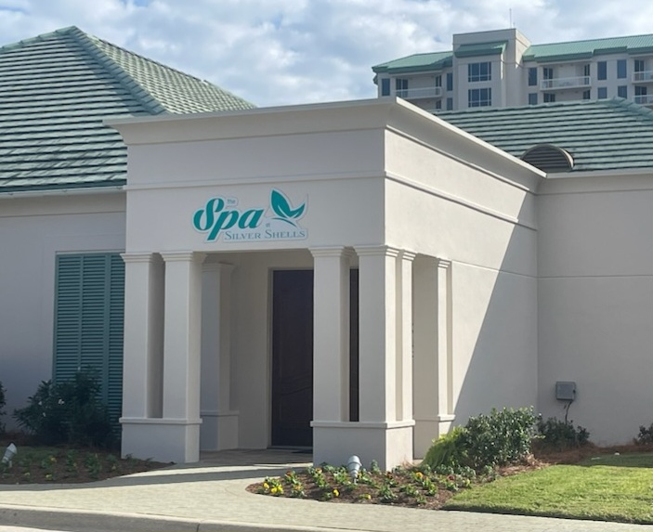

The Spa is open! Darlene Miller is the new owner—she is offering Silver Shells Homeowners exclusive discounts. Call 850-337-5107 to find out more.

Silver Shells Master Association Staff
Josh Lee Candace Coughlin
Director of Operations Assistant General Manager
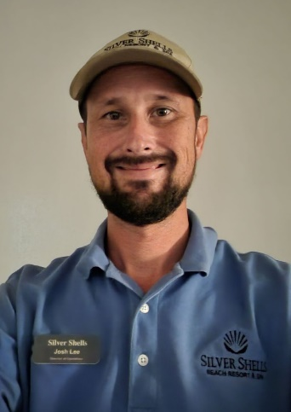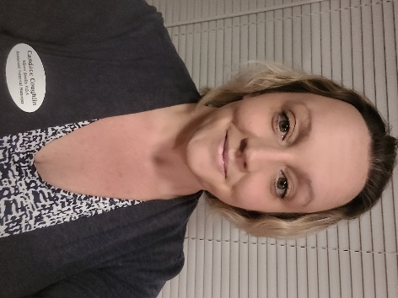

Maintenance Staff
Matt Goff Eric Price Herbert Baker Bessie Lee
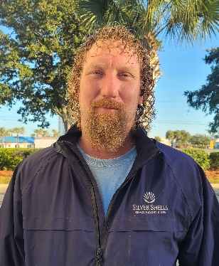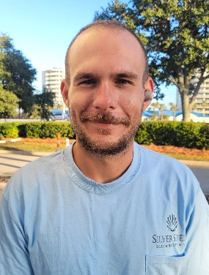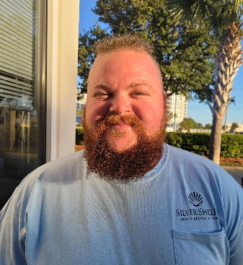

Courtesy Patrol Staff
Brandon Rushton Robert Swafford Clifford Bridgewater Terry salazar
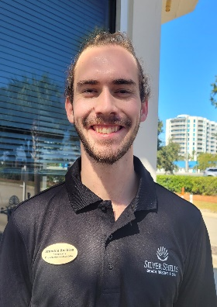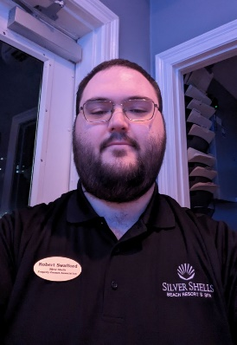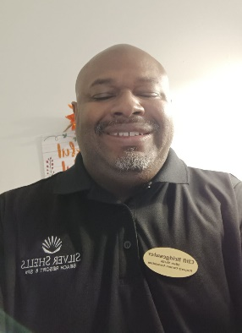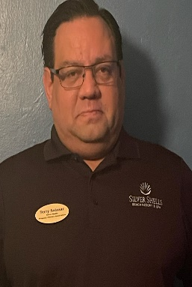

Calvin Rivera Trevor Batson Amanda Boatner
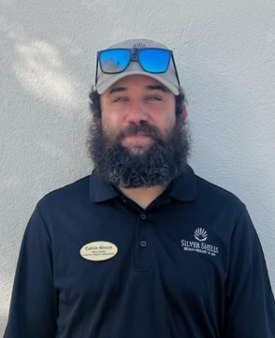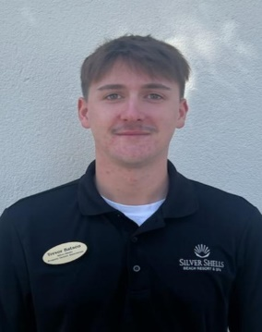
Dear Homeowners,
If you have not registered on the Silver Shells Master Association website, please do. You will find valuable information, documents, news and events. We will continue to add content relevant to your condominium ownership…like financials!
https://silvershellsofdestin.com

To reach your Courtesy Patrol staff please contact the Gatehouse at 850-461-9970 or 850-699-1523
We will do our best to keep you updated on the progress as we continue to keep Silver Shells an amazing place to live and vacation.
Sincerely,
Eric Anderson, SSPOA, St. Barth, St. Croix and Silver Shells Owner's Club Manager
eric@superiorcondomgmt.com
Josh Lee, SSPOA Director of Operations
josh@superiorcondomgmt.com
Candace Coughlin, SSPOA Assistant General Manager
candace@superiorcondomgmt.com
A message from your Master Association Board President:
Spring and Silver Shells come to life for the new season. Your fun, family, and friends await you in Destin!

