April 2024, Newsletter
Hello Silver Shells Homeowners,

We hope you had a wonderful Easter Weekend!

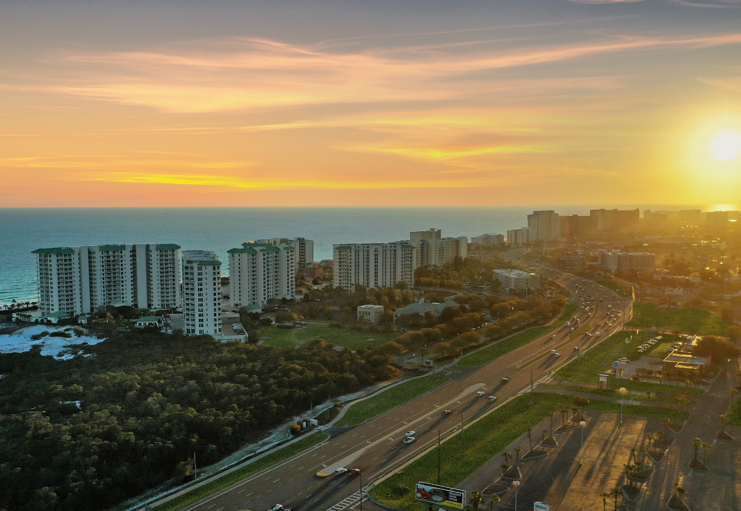

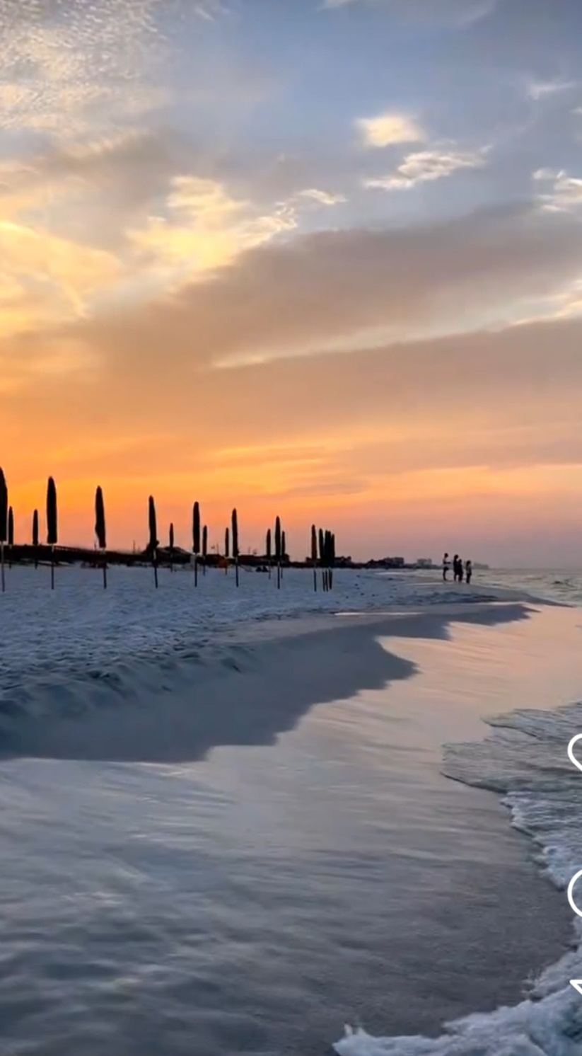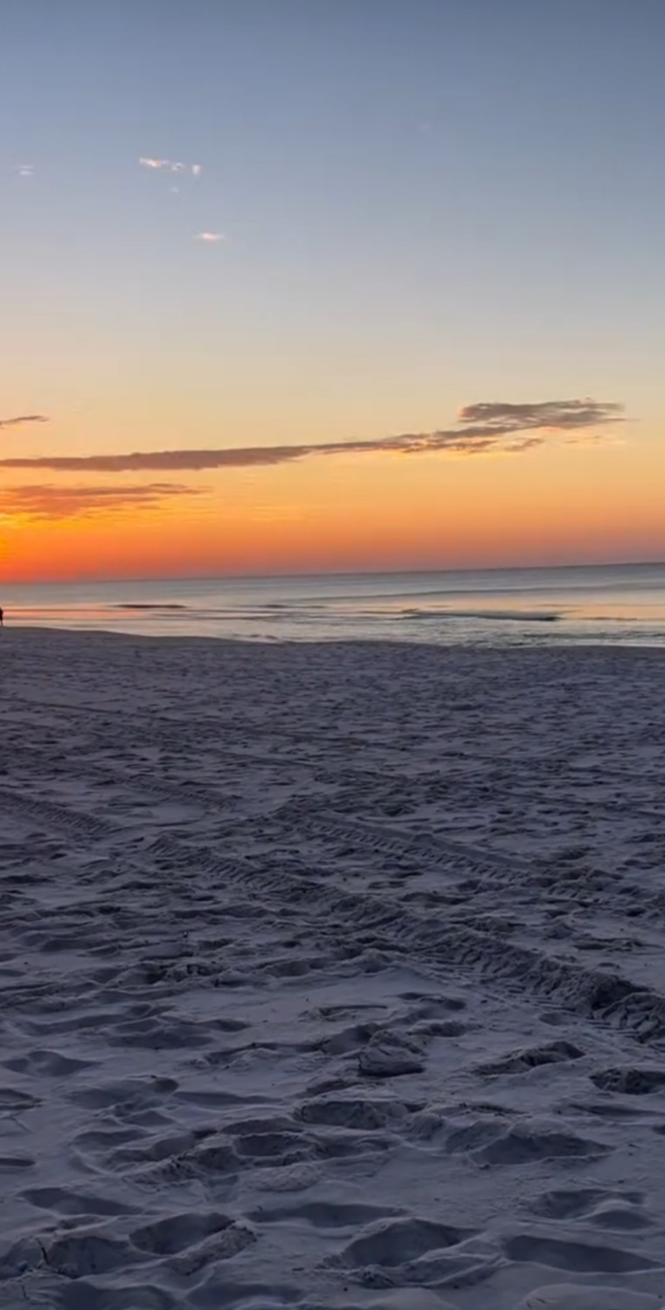

We always enjoy taking a relaxing moment to watch the sunrise on our private beach. It doesn’t get much better than this.

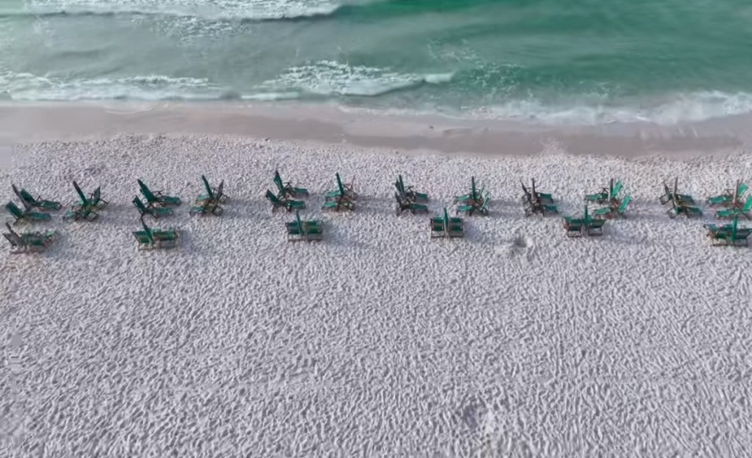
Make your way down to the beach to the Sunrise Tiki Hut and reserve your chairs now! Opens @ 9am
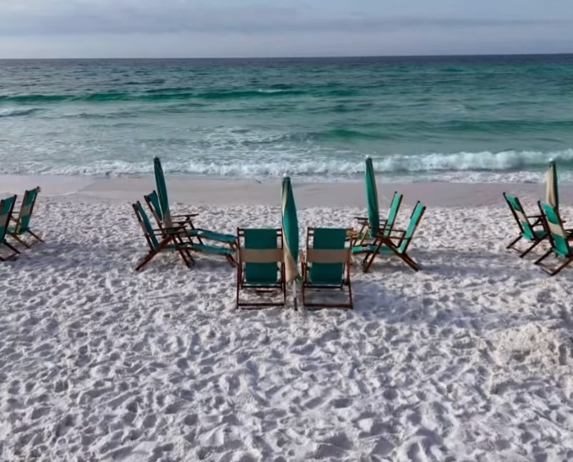

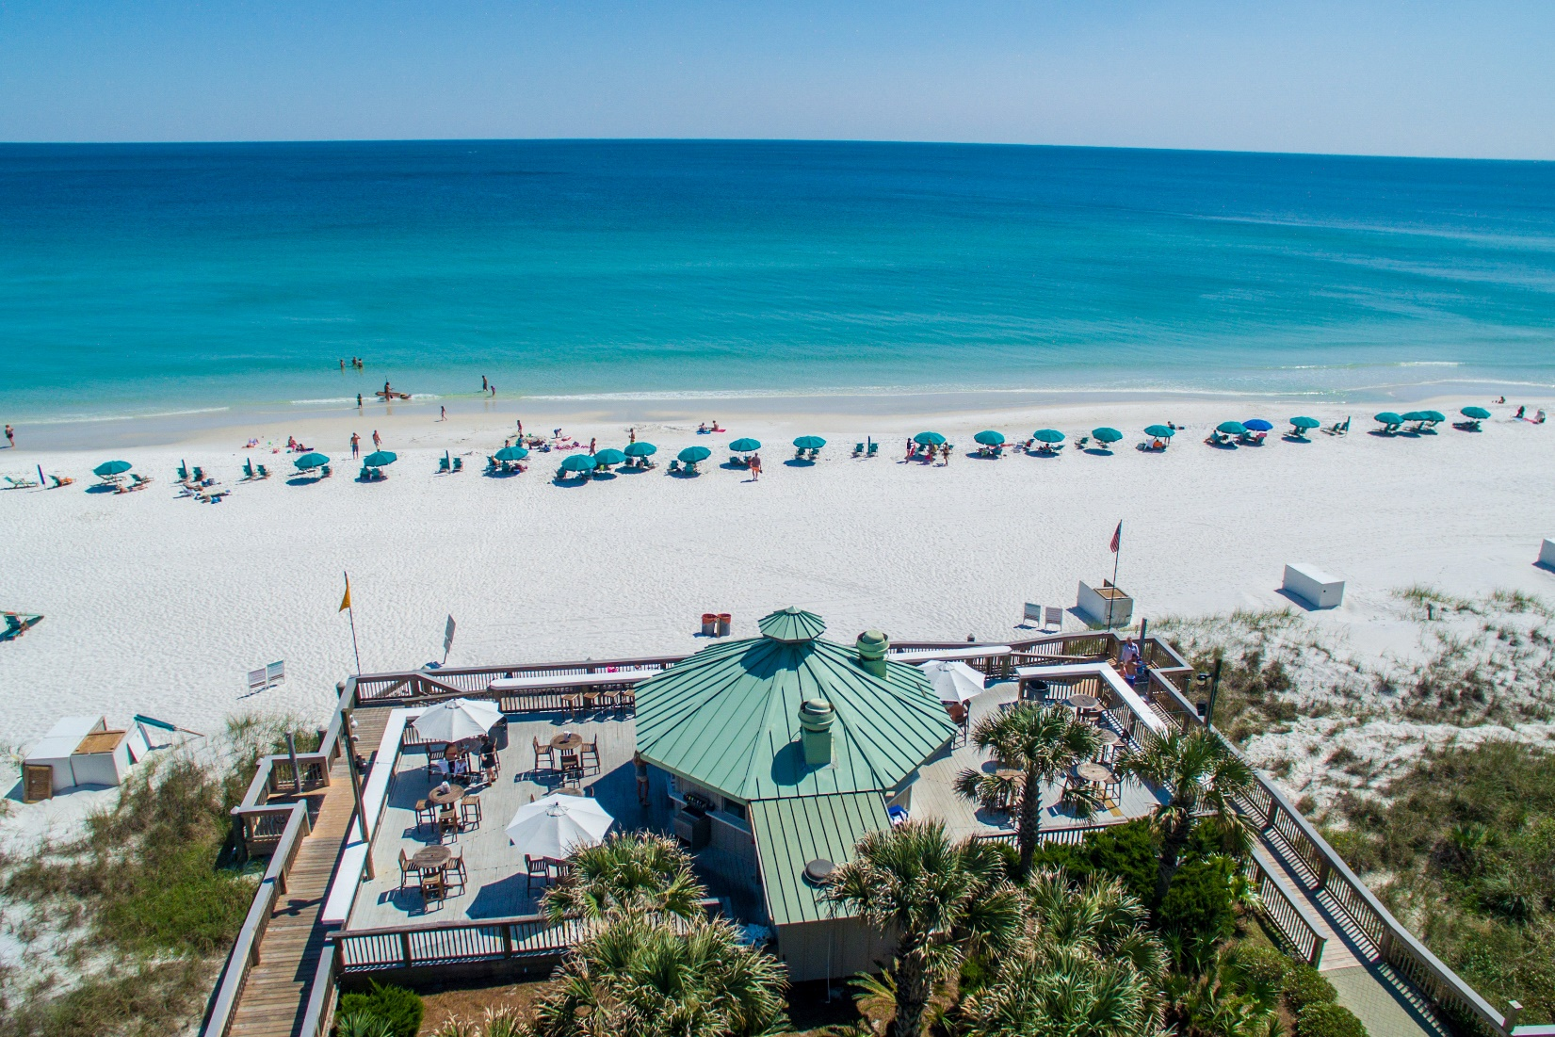
Grab your family and friends and come out and enjoy The Sandbar!
Live Music with Chandler Brown April 4th & 5th and other greats all through the beach season.
For Sandbar updates follow on Instagram
@silversandbar
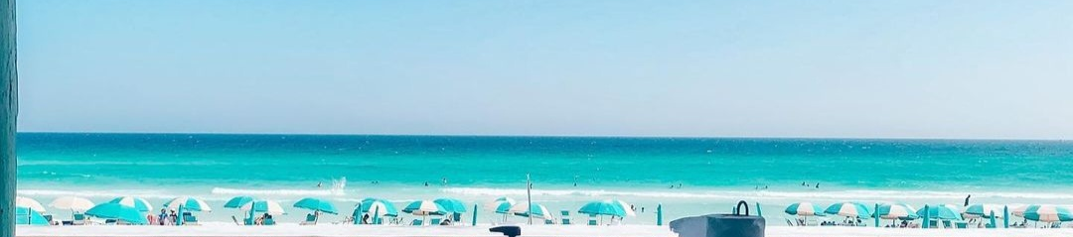

The Sandbar menu
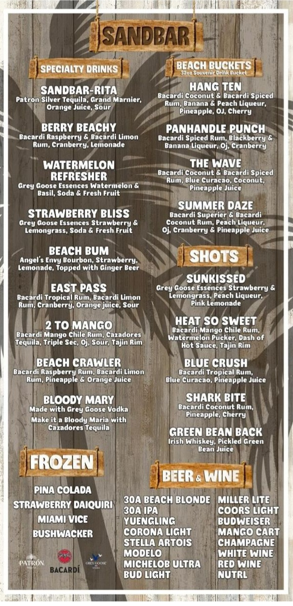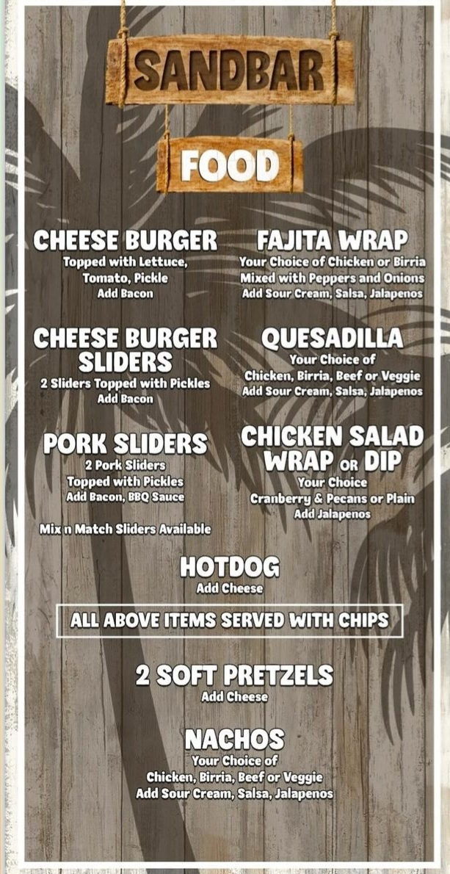
Try the new frozen drink.
THE BUSHWACKER
The boozy milkshake of your dreams!

If you have not received your new 2024 wristbands. Please contact your building management.

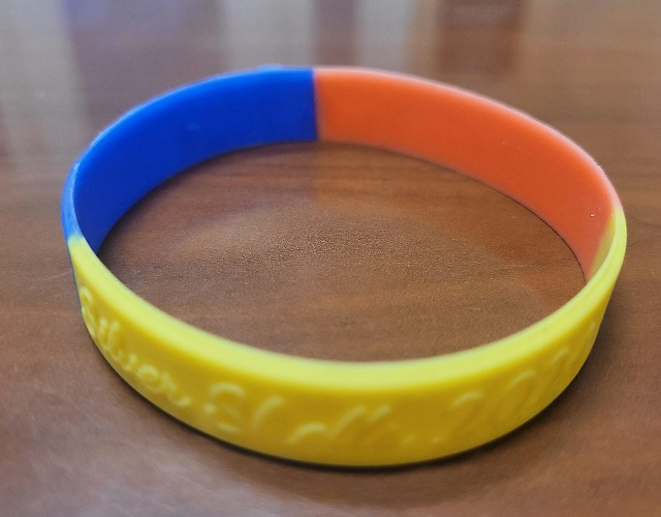

As always, for your benefit, wristbands are required to be worn or visibly on your person by Guests and Owners at the Indoor/Outdoor and Lagoon Pool, Fitness Center, Basketball, Pickleball and Tennis Courts, and our Beach.
In your bag or at your table are not acceptable.

Please, please, please…help us keep people who do not belong here off the property by wearing your wristband. We do not know every owner by sight…even your Master board wears them!

We appreciate your cooperation!
Courtesy Patrol has an easier time enforcing rules with guests when our owners lead the way and set the best example—thank you for doing so!

Clubhouse
To gain access to the Fitness and Cardio rooms you must have your key fob/card. As a reminder, the fitness and cardio rooms do not open until 6 am and they close at 9 pm. The indoor/outdoor pool opens at 9 am and closes at dusk. Wristbands are required for everyone to use the facilities. The door to the fitness room is on the south side of the building by the basketball court.

The Spa at Silver Shells
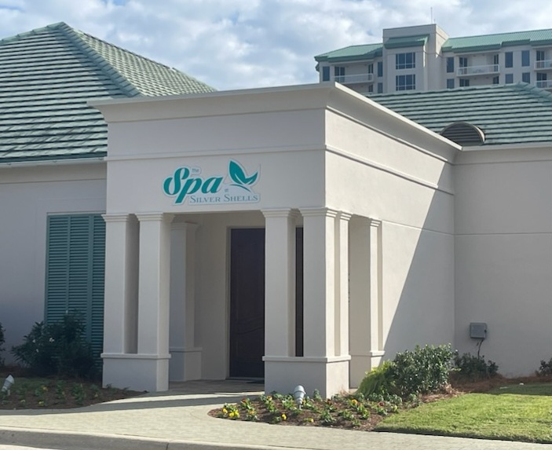

The new Spa is open! Darlene Miller is the new owner—she is offering Silver Shells owners exclusive discounts. Call 850-337-5107 to find out more.

Silver Shells Master Association Staff
Josh Lee Candace Coughlin
Director of Operations Assistant General Manager
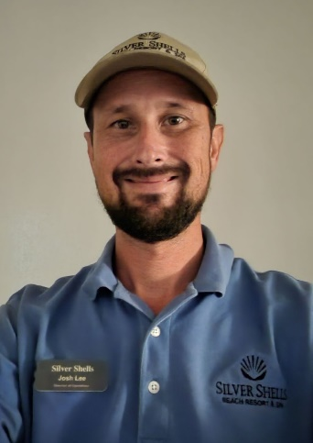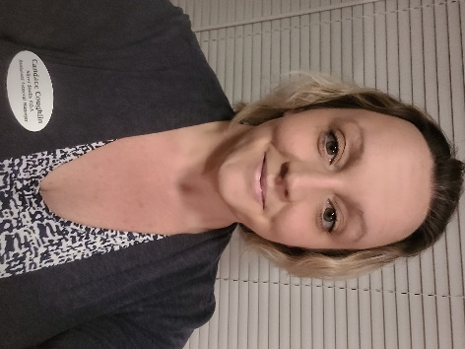

Maintenance Staff
Matt Goff Eric Price Herbert Baker Bessie Lee
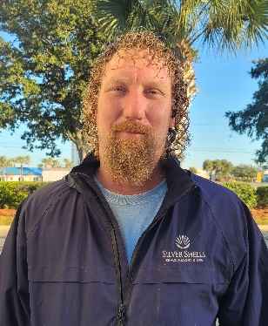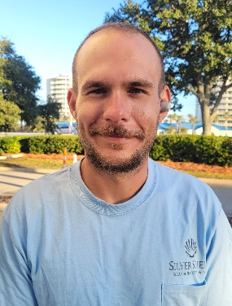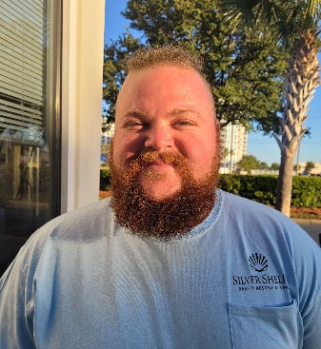

Courtesy Patrol Staff
Brandon Rushton Robert Swafford Clifford Bridgewater Terry salazar
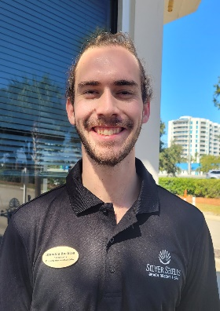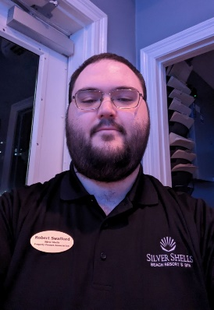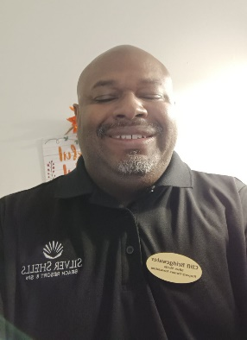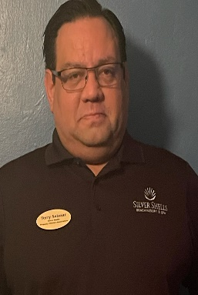

Calvin Rivera Trevor Batson Amanda Boatner
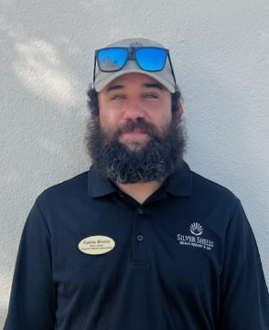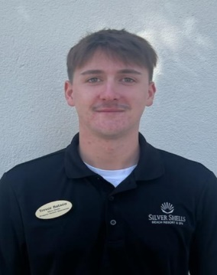
Dear Owners,
We’d like you to register on the new Silver Shells Master Association website. You will find valuable information, documents, news and events. We need your ideas to improve content that you care about.
https://silvershellsofdestin.com

To reach your Courtesy Patrol staff please contact the Gatehouse at 850-461-9970 or 850-699-1523
We will do our best to keep you updated on the progress as we continue to keep Silver Shells an amazing place to live and vacation.
Sincerely,
Eric Anderson, SSPOA, St. Barth, St. Croix and Silver Shells Owner's Club Manager
eric@superiorcondomgmt.com
Josh Lee, SSPOA Director of Operations
josh@superiorcondomgmt.com
Candace Coughlin, SSPOA Assistant General Manager
candace@superiorcondomgmt.com

